
Lochnorris Primary
Home Learning Month: December Class: P7

Lochnorris Primary Home Learning Month: December Class: P5

- Here are your suggested home learning tasks for this month. Your teacher will discuss each one in class.
- Try to do as many of the tasks as you can and ask your teacher if you need help with any of the tasks.
- At the end of the month, your teacher will go over all of your home learning.
HWB – Fitness Circuits  Develop your fitness and stamina by creating your own circuit cards.  Practice these with your family or friends.  Bring the circuits in and let’s test them out.  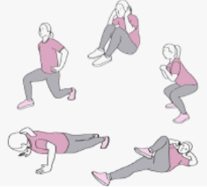 | Numeracy – Multiplication Column Method  Solve these calculations showing your formal column method working.  - 13 x 8 2) 17 x 9 3) 28 x 6  4) 453 x 5 5) 612 x 6 6) 831 x 5  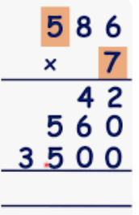 | IDL – Antarctica  Research what tourism is like in Antarctica how would you get there?  How many researchers or scientists temporarily live there?   | Literacy – Novel Study  Complete a summary of the main events of the novel from start to finish.  
Numeracy – Times Tables x 9  We will be revising our x 9. Scan this QR and practise through this hit the button game.   | Literacy – Report Writing  We are creating information report texts  Pick your favourite wildlife – create a report on this creature.  Include the headings  Habitat Diet Exercise Appearance  Life Expectancy Fascinating Fact  Remember only formal language and reliable sources. | Expressive Arts – Xmas Art  Watch this Art for Kidshub Xmas Art tutorial to create a  Winter Wonderland scene.   | Numeracy + Number Talks  Solve these calculations and show all our compensation Number Talks strategy.  1) 4364 + 1319 2) 6643 + 3019  3) 9823 + 1118 4) 6426 + 5139  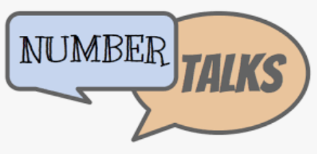
HWB– Act of Kindness  Can you design your own Christmas card and gift it to an elderly relative or neighbour to spread some festive cheer.  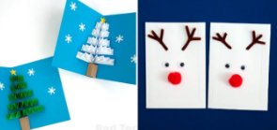 | Literacy – Grammar Homophones  Create a word sketch of all homophones you can think of.  Remember homophones are words which sounds the same but are spelt differently and have different meanings.  For example red and read  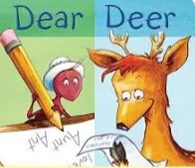 | Numeracy – Subtraction Word Problems  Solve this word problem. Remember what information do you have, what do you need to find out & how can you use maths learning to get there?  The local rugby club hosted an a Christmas fair , 3542 people paid to attend in 2024. There was 1200 less the previous year (2023).  How many people attended the fair in 2023?  Now create 3 of your own subtraction word problems.  Bring into class to challenge us. | Literacy – Research/ RME  Research the Christian story of Christmas. What do Christians believe?  Create a text to retell the main events of the Christian story of Christmas.  

