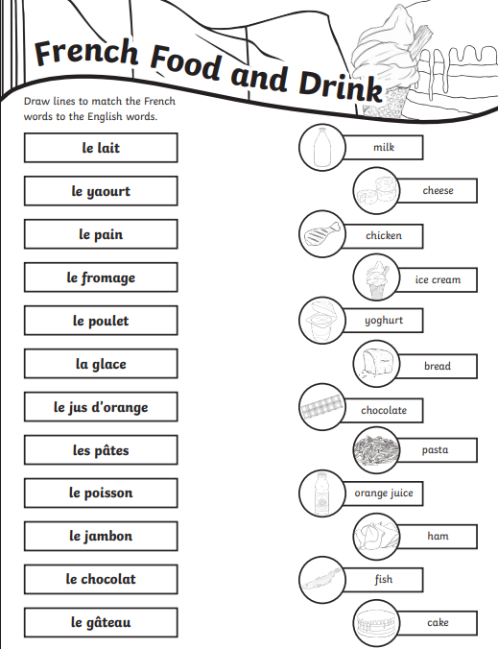Name: _________________________