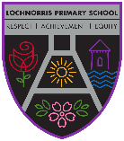
Lochnorris Primary
Home Learning Month: May Class: P6

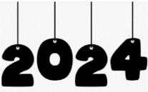
- Here are your suggested home learning tasks for this month. Your teacher will discuss each one in class.
- Try to do as many of the tasks as you can and ask your teacher if you need help with any of the tasks.
- Please ask your teacher if you would prefer a paper copy.

Writing  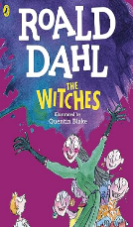  In our class novel Roald Dahl wrote a very detailed description of a witch. Write a detailed paragraph about someone in your family and draw a picture to go along with your description. | Paper Spill Challenge  Can you use your knowledge of paper spills and create something using this technique at home?  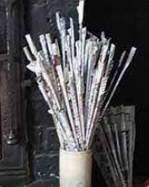 | Birds or Bees  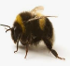  Either create a Sway/Presentation to show to the class about the importance of Bumblebees.  Or  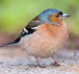  Create a chart about birds you see in your garden or when you are out a walk. Ask for A3 paper for this.
Times Tables  Go onto hit the button and get your highest score on your 8 & 9 times table  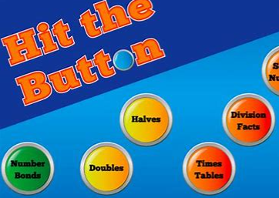  Hit the Button - Quick fire maths practise for 6-11 year olds (topmarks.co.uk) | Art  Observational Drawing.  Cut/slice a piece of fruit and draw it in detail.  You can use colour or just grey pencil.  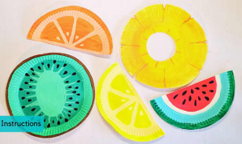 | Go ‘Hit The Button’ Crazy!  Go on Hit the Button as often as you can and practise:  Number Bonds  Tables  Doubles  Halves  Division Facts
Capital Cities  Research which capital cities of your choice belong to which country. Bring in your list of capitals or countries and your teacher will test you. If you can identify 20 or more you can put your name on the Wow Board. The person who can identify the most capitals/countries in the class will win a special prize. | Game Time  Play Dominoes or Connect Four with people in your house. If you don’t have these games play Noughts & Crosses.  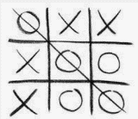  Have a Tournament and find a champion!  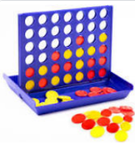  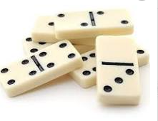 | Numeracy  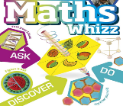  Go on Teams and play the games in the Money and Percentage channels. You can also reinforce your knowledge of other numeracy concepts that we have covered by playing the games in the other channels.

