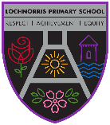
Lochnorris Primary
Home Learning Month: February Class: P6

- Here are your suggested home learning tasks for this month. Your teacher will discuss each one in class.
- Try to do as many of the tasks as you can and ask your teacher if you need help with any of the tasks.
- Please ask your teacher if you would prefer a paper copy.

Writing  Our class novel has lots of vocabulary in it, find the meaning to some of these words.  complicated - doze - aghast - ravenous - quirk - yearn - fetch - mania  faint - poach - rear - filthy - panic - pheasant - disgusted - sheepish | Let Me Entertain You!  Sing our Scottish Song to someone at home  Bacon Roll – to the tune of Living Doll | Share the Love  As it is Valentine’s Day this month do something nice at home to show someone how much you love them.
Times Tables  Go onto hit the button and get your highest score on your 8 times table  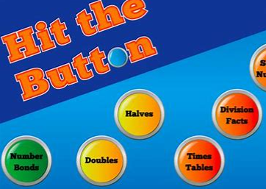  Hit the Button - Quick fire maths practise for 6-11 year olds (topmarks.co.uk) | Art  Chinese New Year  It is the year of the Dragon. Draw or make a dragon! Please bring it in - we can’t wait to see it. | Numeracy  Practise all your tables. Get someone to test you on random tables.  You MUST know your tables to be able to complete work on factors, multiples, fractions and percentages. All of which will be covered this term.
Reading  Read a book of your choice – remember to tell someone all about it!!!  If you can’t find a book in your house use your books on your Bugclub account.  Practising your reading helps with your literacy work. | Talking and Listening  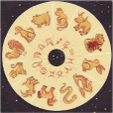  Tell someone at home the story of The Great Race. Remember to mention all the animals of the zodiac. Maybe everyone at home could work out which animal they are and what that means for them. | Numeracy  Go on Teams and play the games about Fractions to reinforce your classroom learning.

