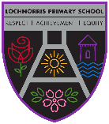
Lochnorris Primary
Home Learning Month: January Class: P6

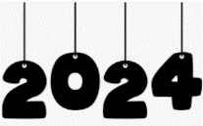
- Here are your suggested home learning tasks for this month. Your teacher will discuss each one in class.
- Try to do as many of the tasks as you can and ask your teacher if you need help with any of the tasks.
- Please ask your teacher if you would prefer a paper copy.

Writing  In our class novel Danny spends loads of time with his Dad – doing different jobs and going out and about in their local woods. Write a small paragraph about something you enjoy doing with someone from your house. Remember to use lots of detail. | Scottish Poetry Performance  Get a head start learning your Scottish poem.  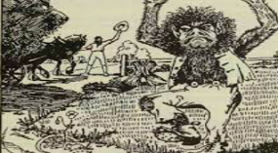  The Bogle P6M/ A Dug A Dug P6T | New Year – New Me  Talk to someone at home about your New Year resolutions. How are you going to choose them and most importantly – stick to them?
Times Tables  Go onto hit the button and get your highest score on your 7 times table  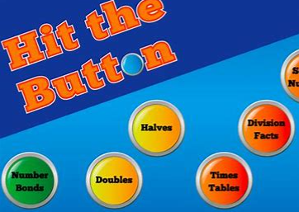  Hit the Button - Quick fire maths practise for 6-11 year olds (topmarks.co.uk) | Art  Perspective Drawing  Using the knowledge of everything you’ve learned in class, create a perspective picture of your choice! Remember to bring it in and show us!  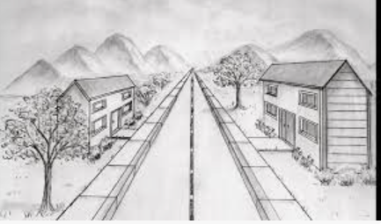 | Numeracy  Practise all your tables. Get someone to test you on random tables.  You MUST know your tables to be able to complete work on factors, multiples, fractions and percentages. All of which will be covered this term.
Reading  Read a book of your choice – remember to tell someone all about it!!!  If you can’t find a book in your house use your books on your Bugclub account.  Practising your reading helps with your literacy work. | Talking and Listening  Tell someone at home the main dangers of smoking and vaping. Make sure to share facts and figures that you have learned in class. | Numeracy  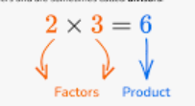  Go on Teams and play the games about Factors and Multiples to reinforce your classroom learning.

