Primary 1 - Have a go board! – December 2024

In Primary 1, we encourage the children to have a go! Below are activities which your child could have a go, when at home this month.

|  |  |
| --- | --- |
| **Literacy**  These are the phonemes we will be working on this month. Have a go at practising them at home.      As part of the Active Literacy program there are periods where we take time to reinforce and consolidate the phonemes previously taught. Please take time over this month to reinforce all the letters. Thank you.  See the accompanying sheet for letter formation. | **Numeracy**  We have been learning to count in 2s up to 30. Challenge your child to have a go!  I spy - 3D shape. Have a go at playing I spy around your house or outdoors with 3D shapes.  Have a go with the 3D shape homework included with this grid.    Counting up to and back from 30. Challenge your child to get counting! |
| **Harmony**  Discuss the seasons. Can your child draw a picture of their favourite season? Can they explain why it is their favourite? | **Phonics**  Playdough spelling – encourage your child to spell 2 or 3 letter words with playdough. Remember to get them to read the word by sounding out, blending then making it. |

**Fun ways to learn**

Put some shaving foam in a tray or on a mat and encourage your child to spell the words.

Spell or write letters in a tray of salt or sand.

Spell or form letters using pipe cleaners.

Have a go!

Here are the common words we are learning.

|  |  |  |
| --- | --- | --- |
| him | to | do |
| so | go | no |

Please practise these at home to help your child with their reading.

Please reinforce the previous phonemes - r, m, d, e, c & k. Many thanks.

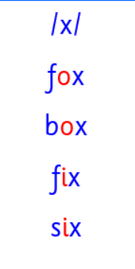

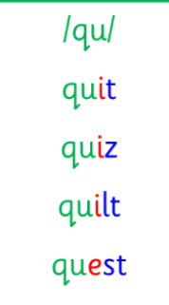

Please encourage your child to spell out a word or words each day, f o x = fox. Have a go!

**Dates for your diary**

Christmas party – Friday 13th of December

Christmas Show – Friday 20th of December

See App for more details

Playing games is a fun way to learn. Look out for the games provided.