Primary 1 - Have a go board! – November 2024

In Primary 1, we encourage the children to have a go! Below are activities which your child could have a go, when at home this month.

|  |  |
| --- | --- |
| **Literacy**  These are the phonemes we will be working on this month. Have a go at practising them at home.              See the accompanying sheet for letter formation. | **Numeracy**  Use the number line provided to reinforce before, after & in between.    Play a hide & seek game with numbers 10 to 20. Write numbers on pieces of paper and hide them around a room. Let your child find them and say the number. Can they order them?  Play I spy and find different 2d shapes (circle, square, rectangle & triangle) in the world around you.  Go for a walk and look for patterns in our world. Can you create a repeating pattern using items in your house or items from the outdoors? |
| **Harmony**  For a couple of days discuss and draw the weather. | **Phonics**  Write letters on pieces of paper and encourage your child to put them together to make a 2 or 3 letter word by saying the word, breaking it up e.g. c-a-t, making the word, blending & then reading the word to you. |

Here are the common words we are learning.

**Dates for your diary**

Our **Parents evening** is on **Thursday 7th of November.** Please school app to book an appointment.

**Our literacy afternoon** is on **Monday 11th of November at 1.30pm in your child's classroom**. Come along and learn more about reading and how you can support your child in their learning. Come and participate in fun reading activities with your child.

|  |  |  |
| --- | --- | --- |
| get | let | for |
| on | of | but |
| up | be | me |

Please practise these at home to help your child with their reading.

The first week in November will be a consolidation week. Please reinforce the previous

phonemes - r, m, d, e, c & k. Thanks.

Week 2 Week 2 Week 3 Week 3 Week 4 Week 4

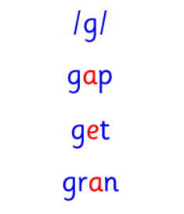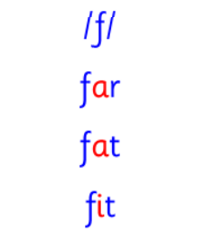

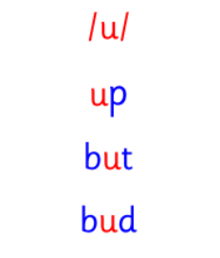

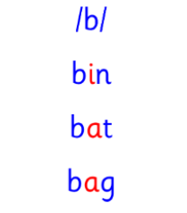

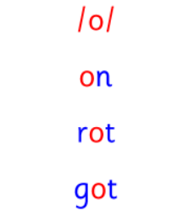

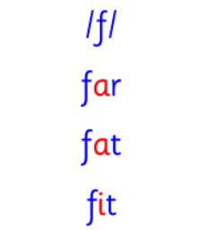

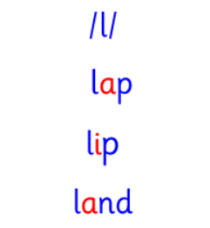

Please encourage your child to spell out a word or words each day, l e t = let. Have a go!

Playing games is a fun way to learn. Look out for the games provided.