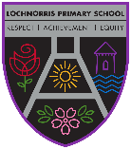
Lochnorris Primary
Home Learning Month: October Class: Primary 5M

- Here are your suggested home learning tasks for this month.
- A paper copy is available in class and on Teams.
Maths  Login to 99math and aim to spend 20 to 30 minutes a week working on maths skills.  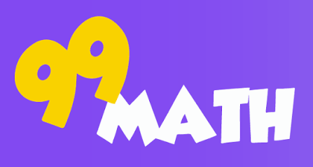 | IDL    As we are reading Titanic Detective Agency, create your own junk model of the Titanic. Or you could do a labelled drawing of the Titanic. | ICT  Log into our class Teams on Glow. Post information about what you will be doing at Halloween.  
Reading  Read a minimum of one book per week on Bug Club. Also, read for enjoyment whenever you can! | 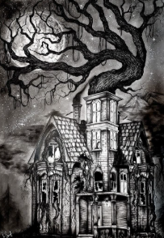  Art & Design  As it is Halloween  this month, draw a detailed spooky picture. | French  Practice your colours in French.  gris vert rouge  noir marron bleu  orange blanc jaune  rose violet
Writing  Write a short spooky story, making sure to describe your main character and setting in detail.  | HWB  Write down 5 things that help you to relax your mind.   | Maths  Complete the Chilli Challenge subtraction questions on the next page.  