
Lochnorris Primary
Home Learning Month: March Class: Primary 5/6

- Here are your suggested home learning tasks for this month.
- A paper copy is available in class and on Teams.
Upskilling our Stories  We have been continuing to work on direct speech in class. Either make up a conversation or write an actual conversation that has taken place at home. Your conversation can be more than 2 people talking.  Remember and take a new line every time someone different is speaking! | BSL  Sign Language Week is an awareness week which is held on an annual basis in the month of March to celebrate the anniversary of the recognition of BSL.  Use the link below to practise Greetings.  https://www.youtube.com/watch?v=BGp2Lef7yL0 | ICT  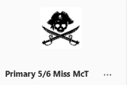    Send me a cat meme in Teams on the channel - Cats!
  We will be celebrating Neurodiversity Week starting on March 16th. Get a head start by checking out this short clip.  https://youtu.be/ZSTLQk9bB8I?si=R6JQNSwDqTxL_vvJ | Art & Design  As we are learning to draw portraits in class – draw a portrait of yourself or someone at home.  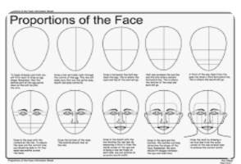  Remember the rules!! | Class Talk  As part of the curriculum – listening & talking – you are required to prepare a speech to present to the class. The speech should last no less than 1 minute and no more than 2 minutes. You can use cue cards to help you remember your speech. You can decide what your speech is about. Start preparing at home.  We will spend time going over this in class.
Rock Stars Num Bots  Numbots builds fluency in addition and subtraction and number bonds through engaging games.  Use your Rockstars log in.  5 + 8 14 – 9 13 + 5 23 + 17 | Rights Respecting Schools  The school focus for the month of February is Article 15: A child’s right to freedom of association, meaning they can choose their own friends and join or set up groups or organisations, provided it doesn't harm others or prevent others from enjoying their rights. Schools promote this right by allowing clubs and extracurricular activities.  Create a poster showing this message.  Mirha did another excellent poster for last month’s article. Mrs Keen snapped it up once more! | Times Tables Rock Stars  https://ttrockstars.com  Log in to your account at home and practise your times tables.  

