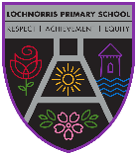
Lochnorris Primary
Home Learning Month: February Class: Primary 5/6

- Here are your suggested home learning tasks for this month.
- A paper copy is available in class and on Teams.
Upskilling our Stories  We have been working on direct speech in class. Instead of using the word said use the words below in a sentence, using direct speech, for each word. | Chinese New Year    We will be celebrating Chinese New Year the week beginning 16th February. Dig out any chopsticks you might have or simply use a couple of pencils. YouTube how to use them and practise for ‘The Great Chinese Chopstick Challenge’. | ICT  Go onto our class Teams and type a joke in the ‘Class Jokes’ channel  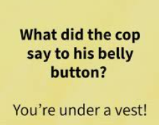
  squealed | growled
  whispered | screamed
  complained | gasped
Kite Making  Design your own kite at home. You can either draw your design or actually make a kite using the skills from class.   | Art & Design  Keeping with shading, complete a pencil drawing of your pet, showing the different shading techniques you have learned in class.  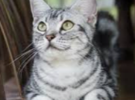  If you don’t have a pet draw your favourite animal or any animal! | Fractions  In class, we are continuing to learn about fractions. Find the channel on fractions in our class Teams and play the fraction games to reinforce your knowledge about fractions.
Rock Stars Num Bots  Numbots builds fluency in addition and subtraction and number bonds through engaging games.  Use your Rockstars log in.  5 + 8 14 – 9 13 + 5 23 + 17 | Rights Respecting Schools  The school focus for the month of February is Article 42: Knowledge of Rights  Governments must actively work to make sure children and adults know about the Convention.  Create a poster showing this message.  Mirha did an excellent poster for last month’s article. Mrs Keen ‘borrowed’ it to showcase it! | Times Tables Rock Stars  https://ttrockstars.com  Log in to your account at home and practise your times tables.  

