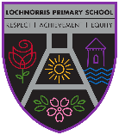
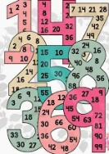
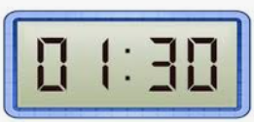

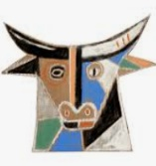


Have a very, merry Christmas. 
Here are your suggested home learning tasks for this month.
A paper copy is available in class and it is posted on Teams and Glow.

Lochnorris Primary
Home Learning Month: December Class: Primary 5/6

Reading helps you with your spelling. It helps you with punctuation when you are writing stories, letters, etc. It also helps your imagination to develop.

Reading
On the back of Reading Week, you are being encouraged to read more at home.
Read the book you choose from the school library.
You can easily practise your times tables with an adult at home, in the car/bus or out walking. Same for your number bonds.
You can also Google Hit the Button and games will be provided for you.
Hit the Button and other games are on your Teams to
reinforce your knowledge.
your
knowledge
on Teams.
Tables/Number Bonds
As always I cannot stress enough the importance of learning your times tables and knowing the number bonds up to 10/20.
ly openers | Time connectives
Nervously, | Later on,
Frantically, | Eventually,
Luckily, | After a while,
Carefully, | Earlier that day,
Quietly, | Finally,

Upskilling Sentence Openers
In class we will be looking at how to upskill our sentences when writing. To do this we will be practising writing sentences that begin with a word that ends in ly or a time connective.
Use these words to start sentences of your own.

Play the time games on your Teams page. Some of the games allow you to set your own level.

Time
We are learning to tell the time using both digital and analogue clocks. Practise telling digital times in words like this –
7.40am – twenty to eight in the morning.
9.15pm – quarter past nine at night.
We are also going to be learning the 24hr clock.

Christmas Art Idea
I thought this would be a great idea for an art lesson but can’t find anything to suit. Therefore, you are the creators of a new piece of art!
I want you to draw Rudolph in the style of Picasso like the Dracula pictures we did! Use these ideas to help.

kjkjkjkkj

