
Lochnorris Primary
Home Learning Month: November Class: Primary 5/6

- Here are your suggested home learning tasks for this month.
- A paper copy is available in class and it is posted on Teams and Glow.
of & off  Write 5 sentences for each of these confusing words.  OR  Write 5 sentences in total – each sentence must contain both of the confusing words!  Note – You shouldn’t use off of together in a sentence. | Being Grateful  Thinking about things you are grateful for boosts happiness and resilience. It is good for your mental health & wellbeing.  Create a gratitude poster – draw/write things that you are thankful for.  You could start a gratitude jar and get everyone in your family to write down things they’re grateful for on small slips of paper and pop them in. | ICT  Send me an email about whether fireworks at home should be banned and why/why not!  
Reading  Read a book or comic for 15/20 minutes 2 or 3 times a week. Remember you could log on to BugClub for books you have read in class. | Art & Design    As it is Firework Night  this month, design a  firework picture or  create a 3-D firework. | Telling the Time  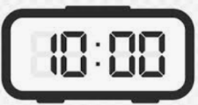  In class, we are learning to tell the time in digital. Reinforce your learning by playing the games on Teams.
Number Bonds  Practise speeding up your number bonds to 10, 20 and 50. Use ‘Hit the Button’ to help you learn your number bonds.  5 + 8 14 – 9 13 + 5 23 + 17 |   Write a set of instructions, explaining how to make our class Christmas Fair craft idea. Remember to use imperative verbs at the beginning of each instruction. | Times Tables  Revise and learn 2,3,4,5 10,11 and 9 times table. Practise your tables by playing Hit the Button.  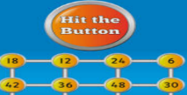

Make sure you can tell the time using an analogue clock.

