Lochnorris Primary
Home Learning Month: April Class: P5

Lochnorris Primary Home Learning Month: December Class: P5

- Here are your suggested home learning tasks for this month. Your teacher will discuss each one in class.
- Try to do as many of the tasks as you can and ask your teacher if you need help with any of the tasks.
- At the end of the month, your teacher will go over all of your home learning.
Literacy - Reading  New books will be allocated this month. Work your way through your books and complete your bugs. | Mathematics – Grid Coordinates  y  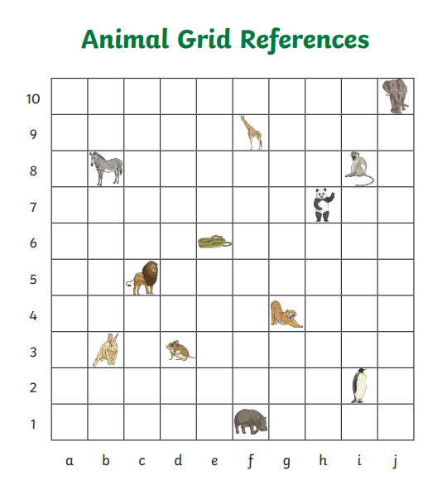x  Remember (x,y)  Example – elephant (j,10)  Write the co-ordinates of  1)lion 2) zebra 3) panda 4) penguin | IDL/Expressive Arts – Spring Art  Scan the QR code to access a spring art tutorial.  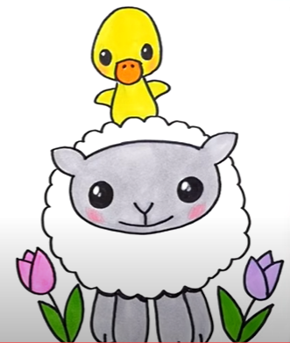 | Literacy – Novel Study  The Miraculous Journey of Edward Tulane  Complete a character profile on Pellegrina (Abilene's grandmother).  List everything we know so far about her. What does she look like? What can we infer about her personality traits?  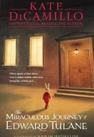
Numeracy ÷ 10, ÷100,  Can you solve these calculations and show off our place value grid strategy for ÷ 10 and÷ 100.  ( 10 jumps one place to the right,  100 jumps two places to the right).  - 130 ÷ 10 2) 240 ÷ 10  3) 940 ÷ 10 4) 2300 ÷ 100  5 990 ÷ 100 6) 8700 ÷ 100  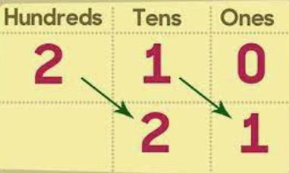 | Literacy – Instructional Writing  Pick something you are passionate about.  Ideas could be – riding your horse, playing your favourite game or scoring a goal.  Write a list of clear of equipment and a step by step method. Remember a method is a list instructions detailing every step you would need to take to complete this task.  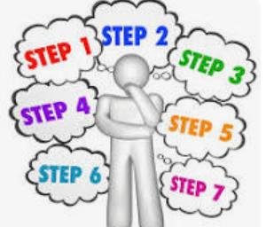 | HWB– Travel Safety  We are learning about travel safety.  Can you pick a mode of travel for example car, plane, bike or boat and create an information poster to provide health & safety advice.  Remember our posters need to be eye catching, clear and informative.  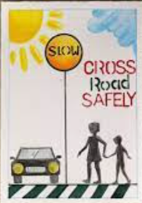 | Numeracy + Number Talks  Can you solve these calculations and show every Number Talks strategy that you might use.  - 72+29 2) 38+61  3)242 + 155 4) 436 +229  5) 1263 + 2629 6) 6349 + 3285
Numeracy – Times Tables x8  We will be revising our x8. Scan this QR and practise these through this hit the button game. | Literacy – Grammar - Direct Speech  Can you correctly punctuate and write these sentences of direct speech.  (Example - “Give me ten laps of the pitch!” shouted the football coach.  - Stop there is a car shouted the lollipop man.  - Harry Styles sung in this world, it's just us, You know it's not the same as it was.  - I am the best ever proclaimed Ronaldo. | Numeracy - Multiplication Arrays  Solve these calculations using our array strategy.  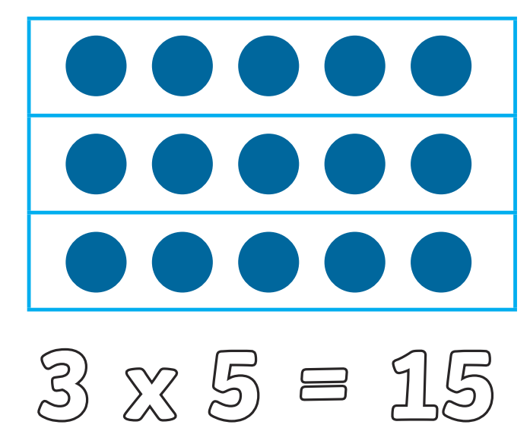  3 x 9 8 x 5 8 x 6 10 x 7 | Literacy – Spelling  Use our phoneme grid and common word list to choose your spelling words. Practise these using your spelling menu tasks.  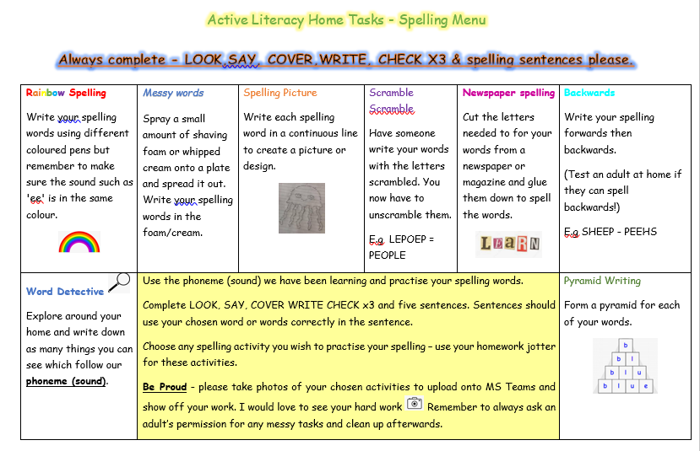
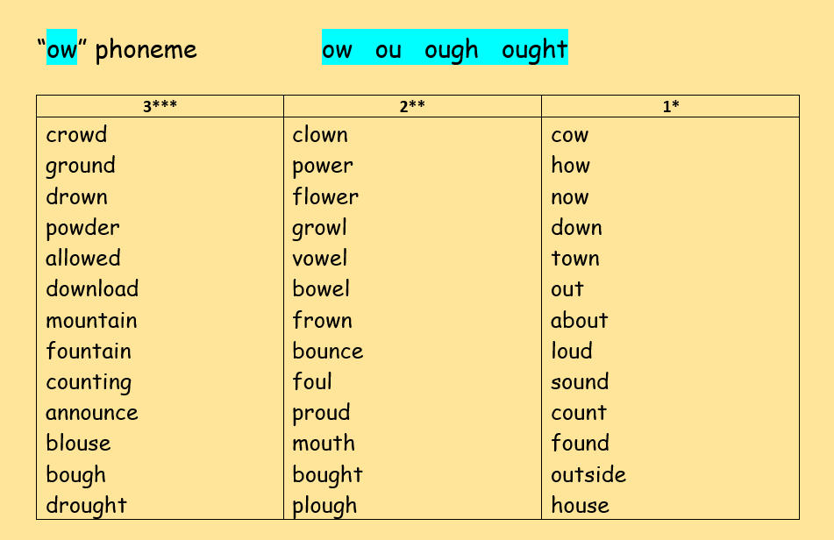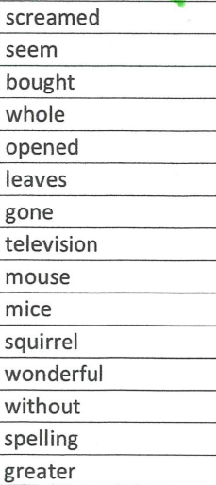
Common Words

