Lochnorris Primary
Home Learning Month: February Class: P5

Lochnorris Primary Home Learning Month: December Class: P5

- Here are your suggested home learning tasks for this month. Your teacher will discuss each one in class.
- Try to do as many of the tasks as you can and ask your teacher if you need help with any of the tasks.
- At the end of the month, your teacher will go over all of your home learning.
Literacy - Reading  New books will be allocated this month. Work your way through your books and complete your bugs.  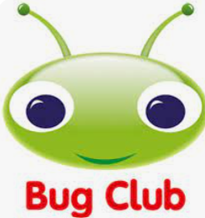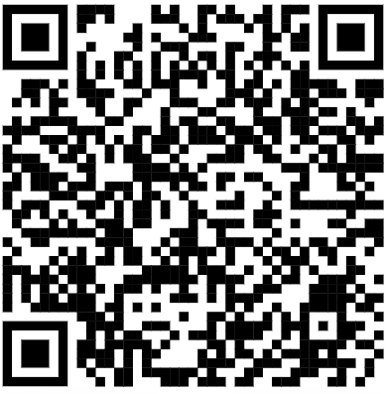 | Mathematics – Perimeter & Area Problem Solving  Use your perimeter and area learning to problem solve and draw these 2d shapes. You are given the perimeter and area. You must work out what the length and breadth could be.  - Perimeter = 16cm Area = 16cm2  - Perimeter= 26cm Area = 40cm2  - Perimeter = 50cm Area = 144cm2 | IDL/Expressive Arts – Iceberg Fine Line Drawing  Scan the QR code to access a tutorial on a fine line drawing of an iceberg.  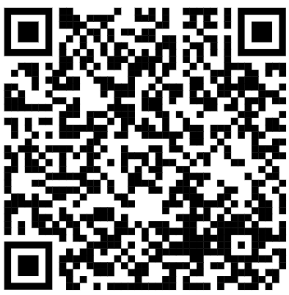 | Literacy – Create Inferential ?s  Create your own inferential questions based upon chapter 1 and 2 of our novel.  Remember inferential questions require the reader to dig deeper and read the author’s clues.  Example: What might uncle Patrick be feeling about Grace arriving? You can access chapters on BugClub.
Mathematics – Measurement  Look around your home, list what tools you find which measure?  Use a measuring tool to measure the length of living room.  Use a measuring tool to measure how much you weigh?  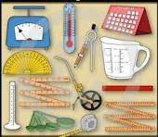 | HWB/Literacy –Information poster  It is Word Mental Health Week.  We will explore lots of good ways to keep good mental health.  Create an information poster to explain why it is important to look after your mental health.  Display good ways to look after your mental health. | HWB– Act of Love  Can you pick an act of love to show your adult at home how much you appreciate them?  Ideas: Make your adult a cuppa’  Offer to wash the dishes for them.  Make them a thank you card.  Sit and watch a film with them (adult chooses the film). | Numeracy – Number Talks  Can you solve these calculations and show every Number Talks strategy that you might use.  92-79 185-112 8924-6549  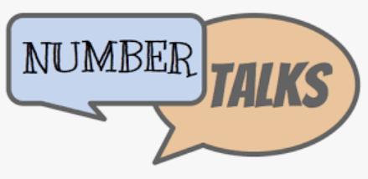
Numeracy – Times Tables x4 x8  Revise our x4 times tables.  We will be starting our x8. Scan this QR and practise these through this hit the button game.  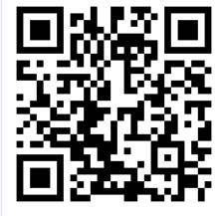 | Literacy – Grammar – Apostrophe  Show the correct use of the apostrophe in these possession examples.  (Remember ’ to show something belongs to someone/something E.g. a bottle belonging to Tom = Tom’s bottle).  - The water bowl belongs to the dog  - A schoolbag that belongs to Lisa  - The pen that belongs to the teacher  - The bike that belongs to Sam  - The glasses that belong to Harry Potter | Numeracy x Number Talks  Solve these calculations using our repeated addition strategy.  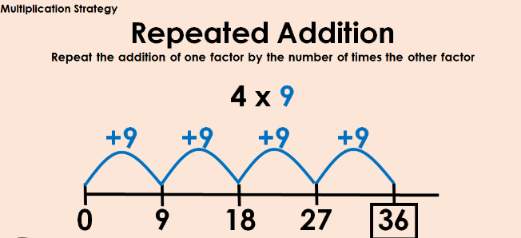  2 x 5 5 x 5 8 x 4 9 x 6 | Literacy – Spelling  Use our phoneme grid and common word list to choose your spelling words. Practise these using your spelling menu tasks.  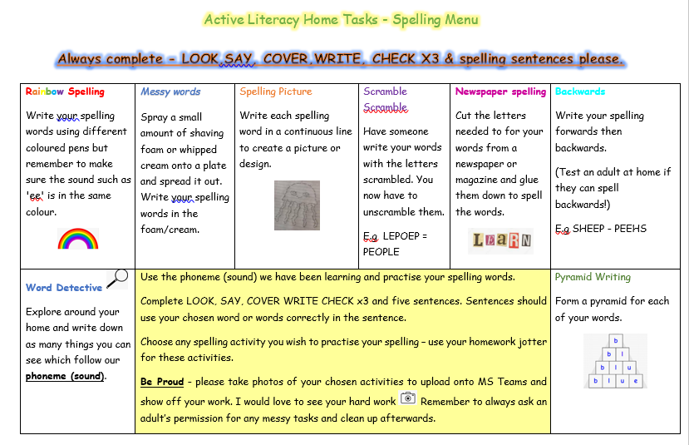
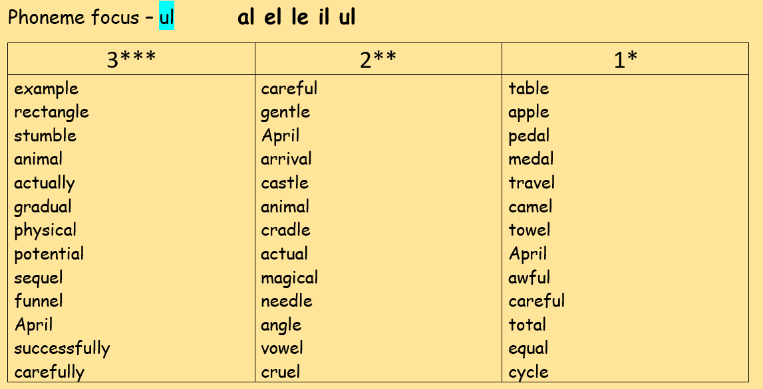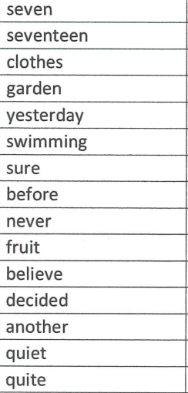
Common Words

