HWB New Year – New Goals  Think of something you would like to achieve outside of school. Examples drink more water, walk to school or get more sleep. Keep a monthly log and see if you are on your way to achieve this! | Literacy – Novel Study & Writing  We finished Iron Man last term, can you write a short sequel (a follow up story) to Iron Man. Consider how the novel ended. What would you change? Would Iron Man help the SBAG? Would there be different characters? | Numeracy – Number Talks x  Using our repeated addition strategy complete these calculations. Show your working on a number line.  - 3 x 6 2) 6 x 7 3) 7 x 3 4) 6 x 9  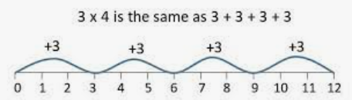
Literacy – Reading & Spelling  New books are allocated for this month. Please complete your bugs.  Our spelling phoneme is “u” please complete your spelling menu for spelling tasks (words overleaf). | Numeracy – Multiplication x  Please practise your x2, x4, x5 and x10. We will be moving onto division and fractions soon!  Get your adult to test you in a quick fire round. Take advantage of these opportunities. In the car? During a dog walk? Visiting family? | Mathematics – Calculate perimeter & area  Calculate the perimeter and area of these two shapes. (Remember perimeter add all sides together, area length x breadth).  - 4cm  - 8cm  2cm
Mathematics – 2d shape & 3d objects  Can you sketch a building design using only 2d and 3d shapes.  Can you label the shapes you’ve used? | Literacy – Grammar  We will explore synonyms. By checking an online thesaurus, please list all the alternative words you have found for:  - nervous 2) sad 3) good 4) fun
Lochnorris Primary
Home Learning Month: January 2024 Class: 5M & 5R

Remember to challenge yourself.

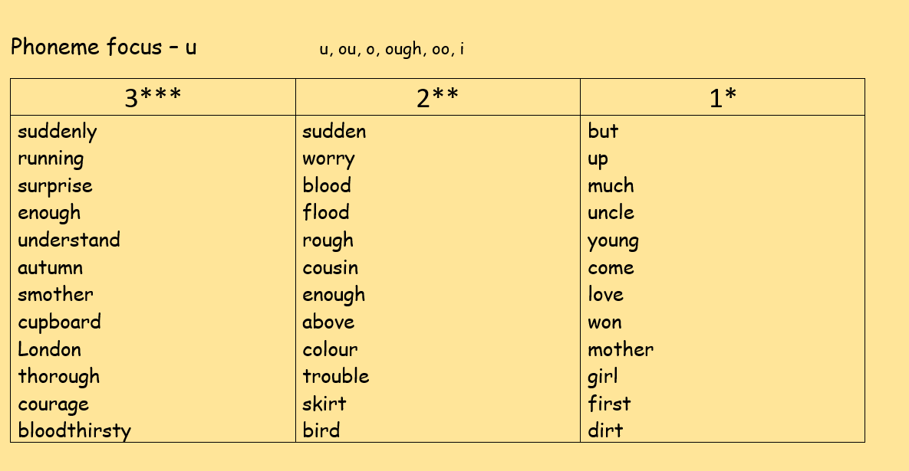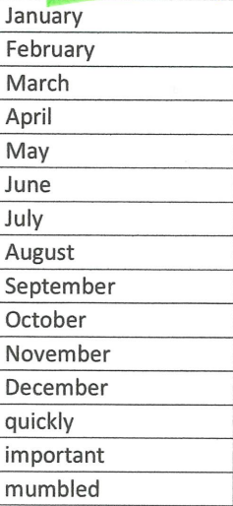
Common Words

