
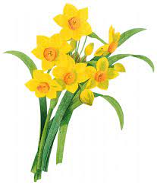Lochnorris Primary
Home Learning Month: March Class: P4

- Here are your suggested home learning tasks for this month. Your teacher will discuss each one in class.
- Try to do as many of the tasks as you can and ask your teacher if you need help with any of the tasks.
- At the end of the month, your teacher will go over all of your home learning.
- Please ask your teacher if you would prefer a paper copy.

Make an animal fact file on a device or paper about an animal found in the Scottish Woodlands.  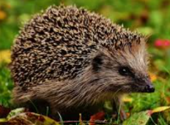 | We are focusing on the basics of writing. Please watch a short clip of your choice and write 3 accurate sentences about it.   |   Choose a book to read for enjoyment and practise reading with expression.
  World Book Day is this month. Can you choose your favourite book character – draw them and label the picture with facts about them. | 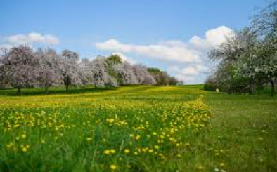 | 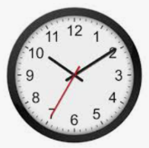    We are learning to tell the time – Please practise telling the time with someone at home or using the following games.
Make sure you are fluent in your 8 times tables!  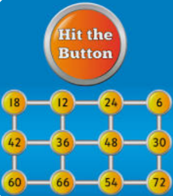  Play online games or test a parent to help you! | We are leaning about how we grow and learn – please look at photos of yourself growing up and learning new things. Please send a baby photo in for the week beginning 09.03.26   | 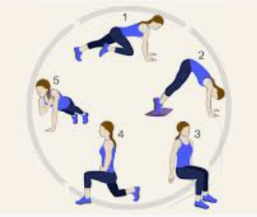  We are working on our fitness in P.E. Try each day to go a brisk walk or do a mini fitness circuit using objects at home.

