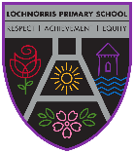
Lochnorris Primary
Home Learning Month:February Class: P4

- Here are your suggested home learning tasks for this month. Your teacher will discuss each one in class.
- Please complete as many of the tasks as you can and ask your teacher if you need help with any of the tasks.
- Please ask your teacher if you would prefer a paper copy.
Reading  This month choose a book you are interested in reading and complete the attached book review when finished – Due end Feb 26.   | Handwriting    We are now beginning to join our handwriting – read aloud some simple sentences for your child to write like this. | Singing  We will be singing Touch the Sky by Julie Fowlis – entertain your family by singing along at home.  Touch the Sky
Times Tables  Go onto hit the button and get your highest score on your 7 times table  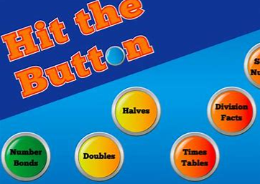  Hit the Button - Quick fire maths practise for 6-11 year olds (topmarks.co.uk) | Art    Can you create a woven heart – follow this link to find out how  HEART | Numeracy  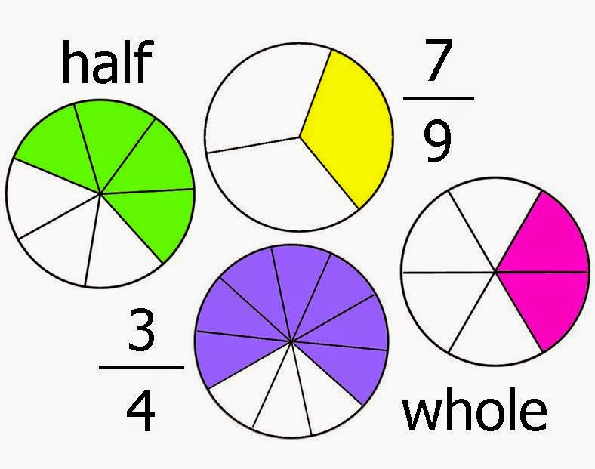  We are learning all about fractions – click on the links below to play some fraction games at home.  Fraction Game 1  Fraction Game 2
Spelling    Please see the spelling homework jotter on a weekly basis to complete some spelling tasks to help your child learn their words. | Romans    We are learning all about the Ancient Romans – Can you design your own armour that you would wear to fight a gladiator. | Writing  Can you show off your poetry writing skills by writing a poem about a family member or friend.  

