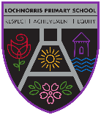
Lochnorris Primary
Home Learning Month: January Class: P4

- Here are your suggested home learning tasks for this month. Your teacher will discuss each one in class.
- Please complete as many of the tasks as you can and ask your teacher if you need help with any of the tasks.
- Please ask your teacher if you would prefer a paper copy.
Reading    Each week your child will be given a bug club book to read, please listen to them read this book aloud each week. | Handwriting    Practise your handwriting by writing a list of your New Year’s resolutions! | Poetry  We will be learning ‘Mrs Nae Offence’ by Gregor Steele for our Scots poem competition. I will put a paper copy in school bags for children to learn!
Times Tables  Go onto hit the button and get your highest score on your 6times table  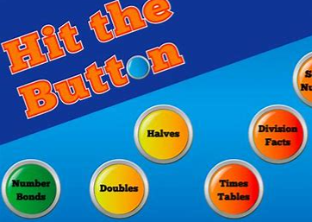  Hit the Button - Quick fire maths practise for 6-11 year olds (topmarks.co.uk) | Art    Be creative and create your own Tartan. Think about colours and lines- thick and thin and what pattern you are going to put them in. | Numeracy    We are learning how to divide. Please see blog for some extra worksheets!
Spelling    Please see the spelling homework jotter on a weekly basis to complete some spelling tasks to help your child learn their words. | Music  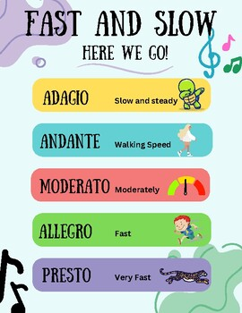  We are looking at dynamics in music. Have a listen to some songs and decide what tempo (speed) they are! | Writing  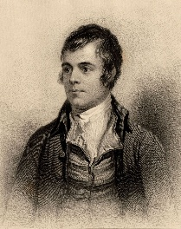  We are looking at Scots poetry this month. Can you think of any rhyming Scots words?

