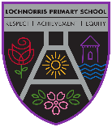
Lochnorris Primary
Home Learning Month: December Class: P4

- Here are your suggested home learning tasks for this month. Your teacher will discuss each one in class.
- Please complete as many of the tasks as you can and ask your teacher if you need help with any of the tasks.
- Please ask your teacher if you would prefer a paper copy.
Reading    Each week your child will be given a bug club book to read, please listen to them read this book aloud each week. | Handwriting  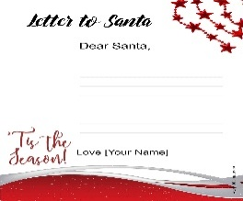  Practise your handwriting by writing a letter to Santa in you neatest writing!  This Photo by Unknown Author is licensed under CC BY-SA | Christmas  Try this Problem-solving game online – How quickly can you ‘light up’ Christmas  Ask an adult at home to beat your time!    https://www.transum.org/ChristMaths/Light_Up.asp
Times Tables  Go onto hit the button and get your highest score on your 6 times table  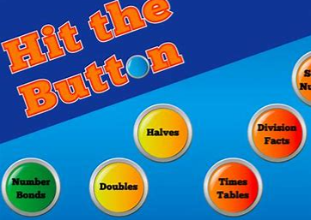  Hit the Button - Quick fire maths practise for 6-11 year olds (topmarks.co.uk) | Art  Be creative and create your own Christmas Decoration to spread some Christmas cheer! | Numeracy  We are learning how to Subtract – Please see attached Christmas worksheets to give a go!  
Spelling  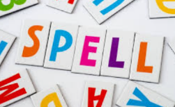  Please see the spelling homework jotter on a weekly basis to complete some spelling tasks to help your child learn their words. | Singing  Entertain everyone at home with some Christmas tunes of your choice!   | Writing    We are looking at instructional writing. Write some instructions on how you might wrap a present or make a Christmas cards.

