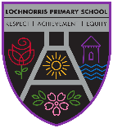
Lochnorris Primary
Home Learning Month: November Class: P4

- Here are your suggested home learning tasks for this month. Your teacher will discuss each one in class.
- Please complete as many of the tasks as you can and ask your teacher if you need help with any of the tasks.
- Please ask your teacher if you would prefer a paper copy.
Reading    Each week your child will be given a bug club book to read, please listen to them read this book aloud each week. | Handwriting    Can you write a short story about something you have done in November in your best handwriting? | Rainforest  See attached enterprise task!
Times Tables  Go onto hit the button and get your highest score on your 3 and 4 times table  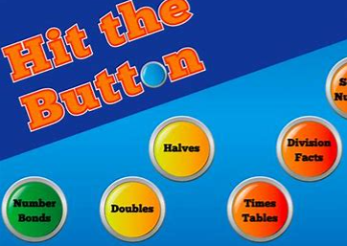  Hit the Button - Quick fire maths practise for 6-11 year olds (topmarks.co.uk) | Art  Can you design a poster to advertise our Christmas Fayre Stock – ask your teacher for prices and items being sold.  | Numeracy  We are learning how to add and subtract using a variety of strategies. Make your number bonds strong by playing games on this link  https://mathsframe.co.uk/en/resources/category/9/addition-and-subtraction
Spelling    Please see the spelling homework jotter on a weekly basis to complete some spelling tasks to help your child learn their words. | P.E  Now that you are a Rain Dance Pro – Can you teach someone at home the dance steps to make them a pro too!   | Writing  We are learning all about similes  Can you make a simile up about the following nouns  1. Coin  2. diamond  3. mountain  4.car  5. sea

