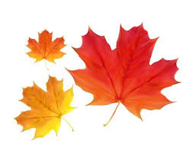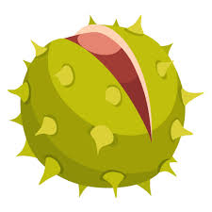=

**Lochnorris Primary**

**Home Learning Month: September Class: P4/5**

* Here are your suggested home learning tasks for this month. Your teacher will discuss each one in class.
* Try to do as many of the tasks as you can and ask your teacher if you need help with any of the tasks.
* At the end of the month, your teacher will go over all of your home learning.
* Please ask your teacher if you would prefer a paper copy.

|  |  |  |
| --- | --- | --- |
| Your phonemes this month are “a” and “ae”. Please check the back of this grid.  Practice these in any way you choose.  C:\Users\lochprstaffordi\AppData\Local\Microsoft\Windows\INetCache\Content.MSO\D4D33364.tmp | We are exploring place value in class. Ask a family member to give you a 2, 3 or 4 digit number and try to build it using place value arrows.  edxeducation Student Place Value Flip ...<https://ictgames.com/mobilePage/arrowCards/index.html> | You have been assigned a new set of Bug Club books. These are available to be worked through at your own pace!  C:\Users\lochprstaffordi\AppData\Local\Microsoft\Windows\INetCache\Content.MSO\87CEA90C.tmp |
| We are exploring basketball in PE this month. Make a poster all about the different basketball skills!  C:\Users\lochprstaffordi\AppData\Local\Microsoft\Windows\INetCache\Content.MSO\94527E39.tmp | We are exploring our different emotions. Can you write an example of each different emotion?  C:\Users\lochprstaffordi\AppData\Local\Microsoft\Windows\INetCache\Content.MSO\9DA09EB3.tmp | C:\Users\lochprstaffordi\AppData\Local\Microsoft\Windows\INetCache\Content.MSO\4B6335AF.tmpWe are exploring how plants grow and change throughout the seasons. Can you go on a walk and see what signs of Autumn you can see? |
| Can you look around your house for 3D objects? Can you count how many faces, edges and corners they have?  C:\Users\lochprstaffordi\AppData\Local\Microsoft\Windows\INetCache\Content.MSO\85F41E6B.tmp | C:\Users\lochprstaffordi\AppData\Local\Microsoft\Windows\INetCache\Content.MSO\D07F5EB.tmpWe are learning BSL in class. Can you learn these food and drink items?  <https://www.youtube.com/watch?v=HtIE0IgeegQ> | Can you draw a self-portrait?  C:\Users\lochprstaffordi\AppData\Local\Microsoft\Windows\INetCache\Content.MSO\E32ABA95.tmp |

