Lochnorris Primary – Home Learning – April Grid – P4HT
There are less tasks this month due to the Easter Break.

Numeracy  We are going to recap strategies we have learned for addition, subtraction, multiplication and division. Practice different calculations – can you remember different strategies you have learned? Describe what you are doing to an adult. | Literacy  We are going to learn about narrative writing (stories). Take time to read a story/stories at home. Can you identify the characters? The setting(s)? The plot? Most stories have a problem and a resolution. Can you find these in the stories you read? Which genre of story is your favourite? Action? Adventure? Fairy tale? | HWB  We are learning about the Eat well Plate. Identify the different food groups and give your adult examples of different foods which belong to each food group. Can you remember why each food group is important to us? Can you plan a healthy and delicious meal which includes food from each food group?
IDL  We are going to learn about different animal classifications: mammals, birds, fish, reptiles and amphibians. Conduct some personal research to identify the features of each classification. | Reading Bug Club  All groups are allocated a new book on a Monday. All groups remember to read your Bug club book at home. We are doing assessments at the end of each level and so it is important to read your book regularly to become familiar with new vocabulary.  The books are getting harder.  You are now allowed to do the bugs in school. | Maths  Data Handling  We will be learning that surveys are when we collect information about something, study the results of that information and display it.  We will be using tally marks to gather our information.  Have a think at home about a graph you would like to make in school. We will collect data in class to help you make a graph. It could be……favourite cereals, crisps or eye or hair colour.  Can you think which graph you would like to draw?

Spelling words Green Group Choose a different activity each week to practise your spelling words.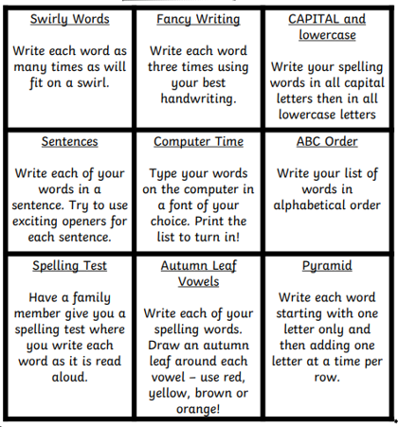
Green Group word list
counting
idea
liked
mile
music
river
running
speechless
outside
twelve
thirteen
money
inside
interesting
said

Spelling words-Purple Group Choose a different activity each week to practise your spelling words.
Purple Group word list
fly
bring
two
five
time
life
line
home
school
take

Spelling Words-Blue Group Choose a different activity each week to practise your spelling words.
Blue Group word list

this
that
then

with
us
so

much
of
or

