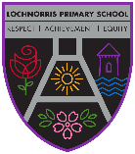
Lochnorris Primary – Home Learning – March Grid – P4HT

Numeracy  We have learned how to multiply. We can multiply a 2d x 1d eg 46 x 3 =.  - Continue to practise calculations like this each week.  - Link known multiplication and division facts through fact families. | Numeracy  Use the mental maths train online game to practise division. https://www.topmarks.co.uk/maths-games/mental-maths-train  You can also use this to recap your prior learning in addition, subtraction and multiplication. | Literacy  We are learning how to write an effective description. We use description bubbles to help us to organise our writing. Descriptions contain a variety of adjectives. Write a description of a wild animal. Ask your grown up to guess which animal you have described. Focus on different sentence openers too.
Literacy  A synonym is a word that means almost the same as another word. For example, shut means almost the same as close. How many synonyms can you think for the words below:  Cold happy big fast beautiful | Health and Wellbeing  We are learning about food, food groups and healthy eating. Ask your adult if you can be involved in planning & preparing a healthy meal. Talk to your grown up about the ingredients you have chosen. Which food group do they belong to? What makes the meal healthy? | IDL – Challenge!  For our Romans topic, please make a shield or sword and bring it into school to be used in our class led assembly.  More information to follow on this.
Reading Bug Club  All groups are allocated a new book on a Monday. All groups remember to read your Bug club book at home.  Every group has moved up a level to the next colour so it is important to read your book regularly to become familiar with new vocabulary.  The books are getting harder.  You are now allowed to do the bugs in school. | British Sign Language  BSL  We have been learning BSL for a few weeks now.  It would be super if you could show your parents, grandparents or Carer what we have been learning. You are now the teacher!  We have covered  Greetings and family members  Show your adult at home how to say  Hello Goodbye Good Morning  Good Afternoon and Good Night.  How are you? Please and Thank you. | TIME  In March we will be learning:  . to tell the time using hours and minutes.  .Explain that there are 30 minutes in ½ hour.  · Explain that there are 15 minutes in a ¼ of an hour.  Match analogue and digital time for quarter to and quarter past times.  Tell the time half an hour before/after.  Task- Make or draw a clock and practise the following times o’clock, half past, quarter to and quarter past.

Spelling words Green Group Choose a different activity each week to practise your spelling words.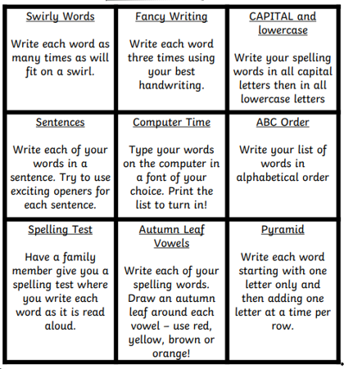
Week 1
seven seventeen clothes garden

Week 2
yesterday swimming sure before

Week 3
never fruit believe decide

Week 4
another quiet quite

Spelling words-Purple Group Choose a different activity each week to practise your spelling words.
Week 1
what many soon book

Week 2
how where now too

Week 3
round found wish men

Week 4
who after hand right

Spelling Words-Blue Group Choose a different activity each week to practise your spelling words.
Week 1
have just to

Week 2
you by only

Week 3
she come from

Week 4
are Dad not

