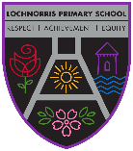
Lochnorris Primary
Home Learning Month: January Class: P4N

- Here are your suggested home learning tasks for this month. Your teacher will discuss each one in class.
- Try to do as many of the tasks as you can and ask your teacher if you need help with any of the tasks.
- At the end of the month, your teacher will go over all of your home learning.
- Please ask your teacher if you would prefer a paper copy.

Spelling 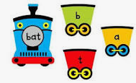  High frequency word practise – use your grid to look, cover, say and write.  When you can successfully spell a word correct on 3 occasions, highlight this and move onto the next one. | Reading 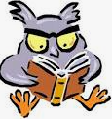  Read a story to a family member.  Think about what you liked about the story and what you didn’t like?  Who is your favourite character and why?  Was it fiction or non fiction? | Numeracy/Maths  Splashlearn Practise Tasks  Class code – YKTZCV  Password – pink15
Harmony Project 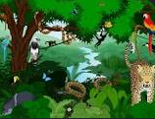  What interesting facts can you find out about the Romans?  Did the Romans live anywhere near your house when they invaded Britain? | Health and Wellbeing  We will be learning about healthy eating and food hygiene.  Help keep the kitchen nice and safe by helping your grownups with the dishes and cleaning. | Spelling  Spelling dice game using this week’s spelling words (see Novembers grid for instructions).  Baseball spelling game – draw 4 bases (or use cushions and move yourself round them). Your partner will give you a word to spell, if you spell it correctly you move round one base. If you don’t spell it correctly you stay still. First person to get a home run wins.
Numeracy  Practise 2, 3, 5, 6 and 10 times tables | P.E (Fitness) 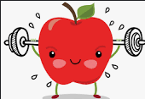  Practise your chest passing for basketball. It doesn’t have to be a basketball, any kind of ball will do to practise the technique (W hands to drive the ball forward and ready to receive). Can you and a partner keep it going without dropping it? What’s your record number of passes in a minute? | Health and Wellbeing 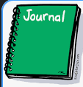  Write all about it! Try keeping a journal for a week. Jot down things about your day, your thoughts and how things made you feel. You may want to illustrate with some pictures.
Music  Practise your assembly songs for our class led assembly 😊 | Art  Can you create a piece of Roman art? What does a Roman wear? Can you draw a Roman shield? | Reading 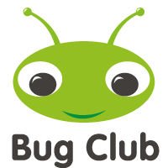  Bug Club.  Work through allocated books. For further reading there is the reading corner in “My Stuff.”.

