Lochnorris Primary – Home Learning – January Grid – P4HT

Numeracy  We are going to be learning how to multiply. Continue to practise skip counting in 2s, 3s, 4s, 5s, 6s and 10s.  Each week, ask your grown up to give you 10 multiplication calculations to solve eg 5x5, 3x4, 6x3. | Numeracy  Use the mental maths train online game to practise multiplication. https://www.topmarks.co.uk/maths-games/mental-maths-train  You can also use this to recap your prior learning in addition and subtraction. | Literacy  We have been learning about the difference between a fact and an opinion.  Tell your adult a fact or an opinion – ask them to figure out which one it was. For example, cats are the best animal is an opinion. The titanic sank in 1912 is a fact.
Literacy  We are learning how to write instructions. Write a set of instructions for how to play your favourite game. Remember a How To title, step by step, suitable openers (first, next, then etc) and ensure your instructions are in a logical sequence. | Health and Wellbeing  We are learning about emergency situations.  - Name the 3 main emergency services  - Say what number you call in an emergency.  - Make sure you know your address and postcode. | IDL  We are going to be learning about The Romans. Talk to your adult and conduct some personal research about The Romans. Aim to learn one or two simple facts about them. Be prepared to share these with others during class learning.
Reading: Bug Club  All groups are allocated a new book on a Monday. The Lions have a 32 page book so we read the first half to p16 one week and complete it the following week. All groups remember to read your Bug club book at home.  You are now allowed to do the bugs in school.  Please discuss the book at home. Did you enjoy the story?  What did you like or dislike about it? | Money  We will be looking at recognising all coins and notes to £20.  Addition and subtraction of money to at least £1.  We will learn to give change from 20p, 50p and £1.  We will be learning that amounts under £1 can be written in decimal notation e.g. £0.07 =7p.  We will be paying for goods using the least amount of coins. | Scots Competition  Scots Poem  We will be learning  Breakin Rainbows – Janet Paisley  Please look over the poem at home and try to learn a little part of it each night.  We will also be learning the poem in class.

Spelling words Green Group Choose a different activity each week to practise your spelling words.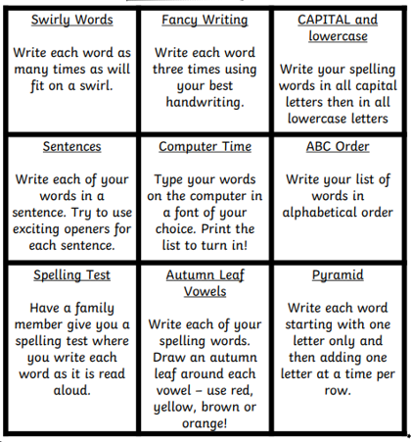
Week 1:
Christmas Easter season birthday

Week 2:
centre circle square triangle

Week 3:
rectangle different satisfied juice

Week 4:
stopped heard their

Spelling words-Purple Group Choose a different activity each week to practise your spelling words.
Week 1:
blue best number other

Week 2:
very took fast there

Week 3:
their some then last

Week 4:
because week keep when

Spelling Words-Blue Group Choose a different activity each week to practise your spelling words.

Week 1:
go got get

Week 2:
if for on

Week 3:
be but you

Week 4:
was went his

