

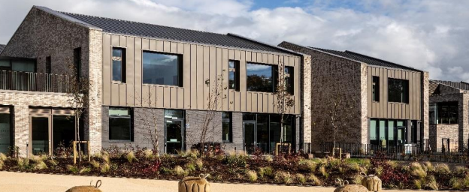
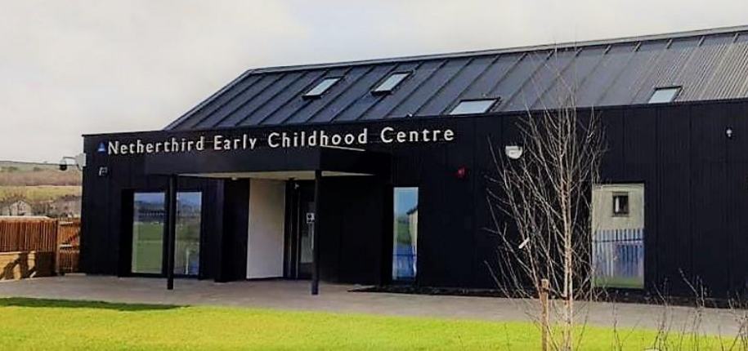

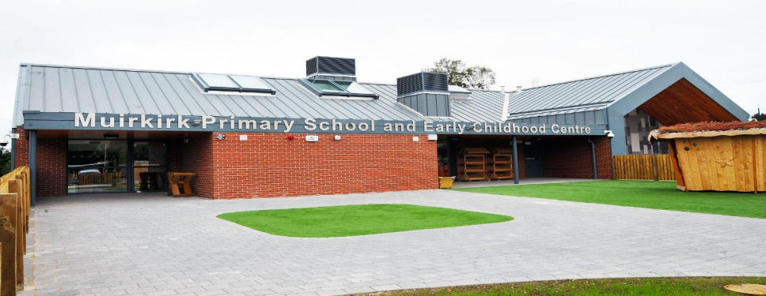
Establishment:
Littlemill PS & ECC
Establishment
Improvement
Plan
2025-26
East
Ayrshire
Council
Education
Service
ECC Improvement Plan | Littlemill Primary School and Early Childhood Centre
Head Teacher/Head of Centre | Simon Leitch
Date Submitted | Submitted to Chief Education Officer on: 20th August 2025

School / Centre  Vision and Values | Our vision is to “dig deep and build together.” At Littlemill, friendship is the mortar that holds together the building blocks of lifelong learning. We celebrate our history and rural heritage while also preparing our children for a bright, ambitious future. We aim to cultivate a learning environment where all children are supported to thrive academically, socially, and emotionally.  Our values of Friendship, Positivity and Aspiration underpin every aspect of school life.  We promote these through assemblies, curriculum planning, and everyday interactions. Our core aims include:  • working together as a learning community,  • sharing resources and expertise,  • striving for excellence, and  • fostering a culture where every gain, no matter how small, is a victory.  Through a relentless hunger for improvement, we challenge ourselves, and our learners to exceed expectations.

Checklist

In line with the Standards in Scotland’s Schools etc. Act 2000 (amended 2016), the following checklist is designed to assist Heads of establishment with whole school/centre improvement planning that fulfils statutory duties in accordance with the Act. This must be completed prior to submission.

SIP Consultation included the following stakeholders: | Complete |  | Content of plan | Complete
Children and Young People |  |  | Takes account of strategic priorities outlined in the Education Service Improvement Plan. https://www.east-ayrshire.gov.uk/Resources/PDF/E/Education-Service-Improvement-Plan.pdf
Parent Council and Forum |  |  | HGIOS 4 and QIF (Early Years) are used as the frameworks to inform the content of SIPs. Where appropriate.  https://education.gov.scot/media/v5sh3dqt/frwk2_hgios4.pdf  https://education.gov.scot/inspection-and-review/inspection-frameworks/quality-improvement-framework-for-the-early-learning-and-childcare-sectors/
Teachers, practitioners and ALL school/centre staff |  |  | There is clear focus throughout the plan on measures to reduce of inequalities of outcome as a result of socio-economic disadvantage.  PEF: https://www.gov.scot/publications/pupil-equity-funding-national-operational-guidance-2023/documents/  CEF: https://www.gov.scot/publications/care-experienced-children-young-people-fund-operational-guidance-2023-24/documents/  SEF: https://www.gov.scot/publications/strategic-equity-funding-national-operational-guidance-2023/documents/
Volunteers/ Community partners |  |  | Appropriate cognisance has been made of the links between the plan and the working time agreement for teaching staff.
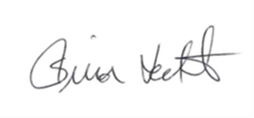  Head Teacher / Head of Centre Signature: |  |  | An accessible summary of the SIP is available and contained in this document and will be provided to parents, children and young people.
Pupil and parental strategic involvement

For session 2025-26, please describe below how children and young people will be involved in decisions relating to the operation of the school/centre | For session 2025-26, please describe below how parents will be involved in decisions relating to the operation of the school/centre
- Children’s voice – Class and ECC councils, learner conversations and pupil leadership groups shape our priorities; they identified further opportunities for outdoor learning and digital skills and asked for more say in planning learning | - Parents/carers – Termly workshops, surveys and coffee mornings gathered feedback on the curriculum, transitions and wellbeing. Parents highlighted the need for clearer communication on additional support needs (ASN) and requested more opportunities to engage in outdoor learning.  - Partners – we will continue to work with the digital learning team, community association and UWS (for meta‑skills enquiry) to broaden experiences.  This engagement will inform the improvement priorities and will continue through participation in working groups, parental focus sessions and regular communication. Children and parents will take lead roles in working groups (e.g., digital learning champions, eco committee, STEM club) and will evaluate impact through surveys and focus groups.

Community Plan East Ayrshire  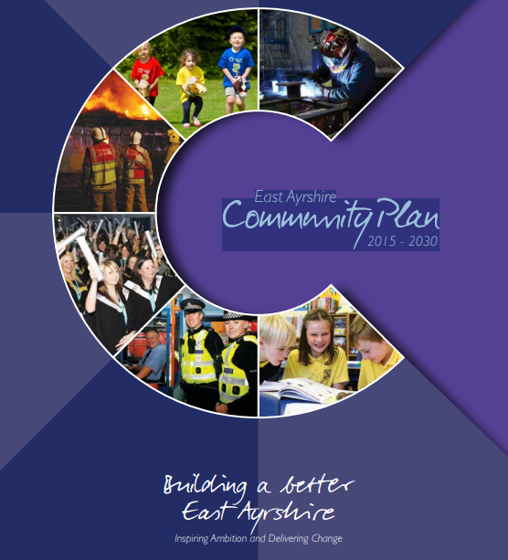  2015 - 2030 | Together, in achieving our Vision, Partners will demonstrate:  Effective leadership  We will provide clear leadership in Community Planning and engage effectively with our employees and communities  Collective ownership  We will take collective ownership for delivering on the Community Plan, the associated Single Outcome Agreement and the Community Plan Delivery Plans, and work hard to improve outcomes for local people and communities  Good governance  We will implement clear operating arrangements to support effective strategic direction, scrutiny and accountability  Democratic accountability  We will measure and report on the impact of our activities to demonstrate how effectively we are improving outcomes for local people and communities, and all partners will be held to account for their contribution.
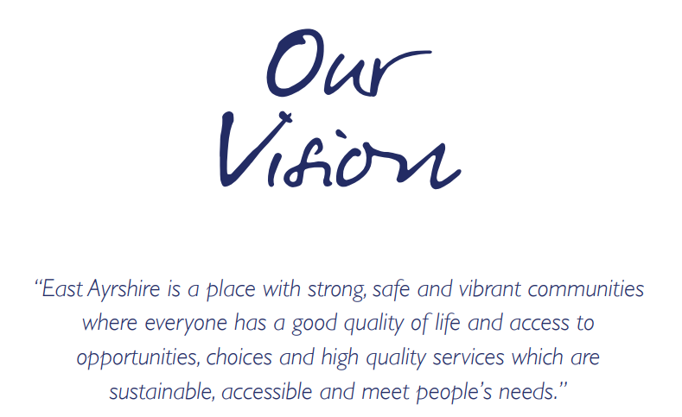  Our Partnership will continue to work to meet the needs of the people who live in our communities. Our guiding principles will be reflected in all that we do and should be evident for all to see. |  | We will:  - Promote lifelong learning.  - Promote equality and tackle inequality;  - Adopt a preventative approach;  - Ensure effective community engagement in the planning and delivery of local services;  - Utilise the strengths and resilience within communities;  - Drive efficiency and performance improvement;

National and Local Priorities
The Scottish Government’s vision for education in Scotland:  - Excellence through raising attainment and improving outcomes  - Achieving equity  - Placing the human rights and needs of every child and young person at the centre of education  - Improvement in children and young people’s health and wellbeing  - Closing the attainment gap between the most and least disadvantaged children and young people  - Improvement in skills and sustained, positive  school-leaver destinations for all young people  - Improvement in attainment, particularly in literacy and numeracy | NIF drivers of improvement in the outcomes achieved by children and young people are:  - School and ELC leadership  - Teacher and practitioner professionalism  - Parent/carer involvement and engagement  - Curriculum and assessment  - School and ELC improvement  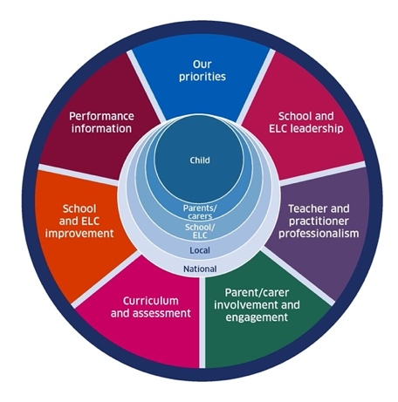  - Performance information | Scottish Attainment Challenge (SAC)  Scottish Attainment Challenge: framework for recovery and accelerating progress  Scottish Attainment Challenge Logic Model – Tackling the Poverty-Related Attainment Gap – Our Theory of Change  SAC organisers:  - Learning and teaching  - Leadership  - Families and communities

East Ayrshire Plans
Key Priorities | Education Service Improvement Plan: | Children’s Services Plan: | Community Learning and Development Plan:
1: Our Leadership | We actively support, promote and enact leadership at all levels. Our young people are supported to be leaders on their learning in our centres, schools and wider life experiences. All staff have ready access to appropriate CLPL and experiences to promote leadership in every classroom and centre. | Priorities for 2023-26:  - Our children and young people feel respected, listened to and influence change  - We are working collaboratively, reducing the impact of social and economic poverty on our children and young people  - Our children and young people feel safe  - Our children and young people have the best start in life  - Our children and young people’s mental health is improving | Outcomes:  - Growth  - Wellbeing  - Fairness  - Sustainability  Action areas  - Youth voice and participation  - Lifelong learning and skills development  - Empowering communities  - Wellbeing and inclusion
2: Teaching and Learning Together | Our young people should experience a teaching, learning and curriculum offer that meets their needs, and those of our local and national context. All staff should be supported to deliver in new and innovative ways by accessing CLPL relevant to their needs and those of our young people.
3: Our Wellbeing and Belonging | We want all of our young people to feel supported by people who know them well, and feel included in all of our schools and centres. Our staff need to be supported in their working with our young people, especially in times of adversity. As a key universal service, it is our vision that all young people attend our establishments on a full-time and regular basis to support them in their development at all stages.
4: Our Attainment, Destinations and Achievements | We want the very best for all of our young people in East Ayrshire. We aim to ensure all young people secure a positive destination through excellent achievement and attainment at all levels.

Our Leadership: We will strengthen distributive leadership, meta‑skills and practitioner agency through professional enquiry and cluster collaboration
Rationale
- Analysis of our data and feedback highlights the need to strengthen leadership at all levels in Littlemill Primary School and Early Childhood Centre. During our 2024 Standards & Quality review we judged Leadership of change as very good for the ECC and good for the primary school. However, the Education Scotland inspection in June 2024 reported that policies and processes designed to raise attainment were not consistently embedded. Inspectors graded Learning, teaching and assessment as satisfactory and raising attainment and achievement as weak and recommended that senior leaders support staff to use assessment data more effectively and improve teaching across the school and ECC.

- Beyond inspection evidence, our own consultation shows that staff are eager to take on greater leadership responsibilities but have limited opportunities to do so. The school’s small size and multi‑composite structure mean that distributed leadership and peer collaboration are essential to sustain improvement. Pupil voice data also indicates that only about two‑thirds of learners feel involved in school decisions; learners want more say in what and how they learn.

Barriers and gaps
- Inconsistent implementation of policies: Inspection feedback noted variation in how well policies, such as those for assessment and moderation, are implemented across classes.
- Limited distributive leadership: With a small staff, leadership responsibilities often fall to a few individuals. This restricts professional growth and reduces collective efficacy.
- Under‑developed use of data: Staff use a range of assessments but need support to analyse data to plan next steps and interventions; a gap highlighted by both inspectors and our own moderation activities.
- Pupil participation: While relationships are strong, learners are not always active participants in decision‑making or self‑evaluation, limiting their ownership of learning.

Evidence informing the priority
- Inspection findings: Education Scotland identified the need to embed policies and processes to raise attainment and to improve the use of assessments and data.
- Self‑evaluation: Leadership of change is a strength, but there is scope to improve distributive leadership and staff agency.
- Stakeholder feedback: Staff surveys reveal a desire for more leadership roles and professional enquiry; pupil surveys highlight limited learner voice; parents seek clearer communication and involvement.
Contextual factors:
- Littlemill is a small rural school with multi‑composite classes and significant socioeconomic challenges. Effective leadership is critical to coordinate support, drive improvement and ensure high expectations for all.
NIF key drivers: | School & ELC leadership |  |  | School & ELC improvement |  |  |  | Performance information |  |  | Parent/carer involvement & engagement
QIF ELC: | Learning, teaching and assessment ES |  | Leadership of continuous improvement ES |  | Children's progress ES |  |  | Leadership and management of staff and resources CI |  | Staff skills, knowledge, values and deployment CI |  |  | Leadership of continuous improvement ES
ESIP key priorities: | N Teaching & Learning |  |  |  |  |  |  | N Our Wellbeing |  |  | N Our attainment
Outcomes for our learners |  | Our actions/Approaches/Interventions |  |  |  | PEF | Who |  | Measures |  |  | Review/milestones
Learners benefit from empowered and reflective practitioners who lead change.  By June 2026, all staff will engage in collaborative professional enquiry, leading to improved pedagogy.  Pupil participation, and at least 80 % of pupils will report feeling involved in decisions about their learning. |  | Develop distributive leadership and meta‑skills  - participate in the ASPE/UWS Collaborative Enquiry project to build teacher capacity in peer observation, feedback and meta‑skills progression across the curriculum.  - Staff will lead small‑scale enquiries to enhance learning in literacy, numeracy and health & wellbeing. |  |  |  |  | HT/PT & UWS lead |  | School leadership; professional learning; HGIOS 1.3  Evidence of practitioner enquiry projects; staff self‑evaluation shows increased confidence; improvements in targeted pedagogy observed; 100 % of teaching staff participate in a professional enquiry by June 2026. |  |  | August 2025:  baseline staff survey on leadership confidence; agree enquiry themes; secure UWS support.  September–December 2025:  staff engage in enquiry cycles and peer observations; monthly check‑ins with HT.  January 2026:  mid‑year reflection meeting to share findings; adjust focus of enquiries.  April 2026:  second cycle of peer observations; gather evidence of impact.  June 2026:  final showcase of enquiry projects; evaluate staff survey data; report outcomes to stakeholders.
 |  | Pupil leadership and learner voice  - establish a Learning Council where mixed‑age groups plan and evaluate aspects of teaching & learning.  - Introduce child‑friendly improvement planning in the ECC. |  |  |  |  | DHT /Early Years lead |  | Parental & pupil engagement; HGIOS 1.1, 1.3  Council minutes show children influencing decisions; evaluations show at least 80 % of pupils (across P1, P4 and P7) report feeling involved in decisions about their learning by June 2026 |  |  | August 2025  elect council members and agree remit; introduce ECC child‑friendly planning.  September 2025 onward council meets monthly; gather pupil feedback on teaching and school life.  January 2026  review progress with council; plan pupil‑led evaluation activities.  May 2026:  council conducts end‑of‑year evaluation; findings inform SIP 2026‑27.
 |  | Parental engagement strategy  - run workshops on curriculum and ASN  - co‑create improvement plan tasks with parents  - pilot a digital parent forum to gather ongoing feedback. |  |  |  |  | SLT/ Parent champion |  | Parental engagement; HGIOS 2.5  Increased participation at workshops (attendance rising to at least 60 % of families); positive parental survey results with at least 75 % reporting that they feel informed and involved; contributions to action plans. |  |  | September 2025:  hold initial curriculum/ASN workshop; launch digital parent forum.  Termly (Nov, Feb, May): deliver workshops and gather feedback; monitor participation rates.  March 2026:  review digital forum engagement and refine communication methods.  June 2026:  evaluate parental involvement survey; summarise contributions to improvement actions.
 |  | Enhance self‑evaluation  - refine our quality assurance calendar  - include regular learner conversations  - staff peer observations and moderation sessions.  - Use data dashboards to track progress against targets |  |  |  |  | HT & self‑evaluation group |  | Performance & improvement; HGIOS 1.1, 1.2  QA calendar implemented; moderation minutes evidence consistency; attainment data used to inform next steps; annual surveys show at least 85 % of staff feel confident using data to drive improvement. |  |  | August 2025  finalise QA calendar; share with staff; set targets.  October 2025:  first peer observations and learner conversations; record findings.  January 2026:  moderation event and data analysis session; adjust plans.  April 2026:  second round of peer observations; review improvements.  June 2026:  comprehensive review of QA activities; update self‑evaluation summary.

Teaching and Learning Together: Improvement Priority: We need to enhance assessment and moderation in multi‑composite classes, broaden digital and outdoor learning, and improve planning across the levels.

Rationale
- Analysis of our inspection feedback, attainment data and self‑evaluation reveals that improving the quality of learning and teaching must remain central to our improvement journey. The Education Scotland inspection of June 2024 graded Learning, teaching and assessment as satisfactory for both the primary school and ECC. Inspectors recommended that senior leaders continue to improve teaching across the school and ECC so that children can lead their own learning and understand their next steps. Our attainment data shows that 71 % of P1, 73 % of P4 and 100% of P7 learners achieved the expected Curriculum for Excellence (CfE) levels in 2024/25, leaving room for improvement and highlighting a need for greater consistency and challenge.
- The Early Years identified key areas—outdoor learning, storytelling, STEM and creativity—that are not yet fully embedded across the whole school. In staff surveys, practitioners reported variability in assessment and moderation approaches, particularly in multi‑composite classes. Pupils and parents expressed a desire for more engaging, real‑world learning experiences, including increased digital and outdoor learning opportunities.

Barriers and gaps
- Inconsistent pedagogy: Teaching quality varies across classes, and some lessons lack pace, differentiation and opportunities for pupils to lead learning.
- Assessment and moderation: Staff need greater confidence in using holistic assessment and moderation, especially in composite settings, to ensure accurate judgments and progression.
- Curriculum enrichment: Outdoor learning, digital literacy, STEM and creative experiences are not consistently planned or evaluated, limiting engagement and development of higher‑order skills.
- Use of data: Teachers collect a range of assessments but require support to analyse and act on this data to personalise learning and set high expectations.

Evidence informing the priority
- Inspection findings: Satisfactory evaluations for learning, teaching and assessment indicate the need to raise standards.
- Attainment data: P1, P4 and P7 attainment levels are below national averages, and there are inequities linked to deprivation.
- Early Years: Outdoor learning/forest school, storytelling/literacy, STEM and creativity were highlighted as key areas for development
- Self‑evaluation: Staff and stakeholder feedback highlight gaps in assessment and moderation practices, and the need for clear progression pathways for composite classes.
NIF key drivers: | Teacher & practitioner professionalism |  |  | School & ELC leadership |  |  |  | Curriculum & assessment |  |  | School & ELC improvement
QIF ELC: | Learning, teaching and assessment ES |  | Children experience high quality spaces CI |  | Play and learning CI |  |  | Leadership and management of staff and resources CI |  | Staff skills, knowledge, values and deployment CI |  |  | Children's progress ES
ESIP key priorities: | N Our Leadership |  |  |  |  |  |  | N Our Wellbeing |  |  | N Our attainment
Outcomes for our learners |  | Our actions/Approaches/Interventions |  |  |  | PEF | Who |  | Measures |  |  | Review/milestones
Children experience consistently high‑quality, play‑based experiences and learning teaching across the ECC and school.  We will move our Education Scotland evaluation of learning, teaching and assessment from satisfactory to good by June 2026.  Moderated teacher judgements will show that at least 75 % of learners achieve expected national CfE levels in literacy and numeracy (with P1 → 80 %, P4 → 78 %, P7 → 60%)  Children will engage confidently with digital technologies and outdoor learning. |  | Improve assessment and moderation  - continue cluster moderation work, develop holistic assessment tools for multi‑composite classes  - use progression frameworks across all levels |  |  |  |  | DHT/PT & cluster lead |  | Assessment & curriculum; HGIOS 2.3, 3.2  Moderated evidence shows increased consistency; teacher judgements align with SNSA & standardised data; by June 2026 teacher judgements for P1, P4 and P7 will match standardised scores within ±10 percentage points |  |  | August 2025:  agree assessment calendar; develop holistic tools for composite classes.  September–December 2025:  carry out formative assessments; participate in cluster moderation; maintain evidence folders.  January 2026:  analyse assessment data; adjust progression frameworks.  February 2026:  cluster moderation event; cross‑evaluate samples; provide feedback.  June 2026:  finalise moderated judgements; compare against standardised data.
 |  | Enhance planning for composite and early level contexts  - implement new planning frameworks that support responsive play‑based learning  - evaluate using observations and learner feedback. |  |  |  |  | SLT/ EEL/ Class Teachers |  | Curriculum & pedagogy; HGIOS 2.2, 2.3  Plans show progression across levels; observations evidence improved differentiation; feedback from learners and parents positive; mid‑year evaluations show at least 70 % of P1 pupils on track for early level and P3/4 pupils progressing appropriately within first level. |  |  | August 2025:  train staff on new planning frameworks.  Throughout session:  implement responsive planning; gather observations.  November 2025:  first evaluation of plans with learner and parent feedback.  February 2026:  refine planning templates based on feedback.  June 2026:  review impact on progression; record strengths and next steps.
 |  | Embed outdoor learning and forest school within ECC  - embed regular forest school sessions led by an outdoor champion  - develop risk‑benefit assessments; ensure daily access to outdoor play in all weathers  - introduce child‑friendly risk assessments (‘danger detectives’); host family sessions once per term. |  |  |  |  | Outdoor champion & Forest school partner |  | Curriculum & health & wellbeing; HGIOELC 2.2, 2.3  Increase in time spent outdoors; learners demonstrate risk awareness; parent feedback indicates improved confidence in outdoor learning; 90 % of pupils report enjoying outdoor learning and at least 80 % of parents attend one outdoor family session. |  |  | August 2025  appoint outdoor champion; review risk‑benefit assessments.  September 2025  onward weekly forest school sessions; daily outdoor play; termly family sessions.  December 2025  gather pupil and parent feedback; adjust activities.  April 2026  review risk assessments; update resources.  June 2026  evaluate outcomes; share impact with community.
 |  | Listening & Attention – stories, books, small‑world play within ECC  - appoint a literacy champion  - create inviting book corners and small‑world areas linked to children’s interests  - provide daily story sessions with props and role‑play  - develop staff capacity using open‑ended questioning and sustained shared thinking  - use talking boxes or story sacks to extend interest at home  - organise parental Bookbug sessions and invite parents/grandparents to read and tell stories |  |  |  |  | Literacy champion & Early Years team |  | Literacy & pedagogy; HGIOELC 2.3, 3.2  Increase in children’s vocabulary and listening skills measured through observations and developmental overviews; positive parental engagement statistics; by June 2026 at least 75 % of children aged 3–5 will achieve age‑appropriate milestones for communication and language. |  |  | August 2025  appoint literacy champion; audit book corners and resources.  September 2025 onward  deliver daily storytelling with props; introduce story sacks; run parental Bookbug sessions each term.  January 2026  monitor children’s language development; provide staff coaching on open‑ended questioning.  May 2026  evaluate impact on vocabulary and listening; adjust resources.  June 2026  report attainment in communication milestones.
 |  | Strengthen STEM learning within ECC  - provide real‑world provocations (ramps, pulleys, magnets, water flow)  - integrate loose parts for construction; support staff in observing and extending STEM play  - plan STEM weeks or focus days linking to the community  - set up a numeracy investigation area in the ECC. |  |  |  |  | STEM champion |  | Numeracy & STEM; HGIOELC 3.3  Children demonstrate increased curiosity and problem‑solving; teacher assessments show improvement in numeracy; STEM week evaluations positive; by June 2026 75 % of P4 & P7 pupils achieve expected numeracy levels and 80 % of ECC children engage weekly in STEM provocations. |  |  | August 2025  designate STEM champion; source loose parts and provocations.  September–December 2025  integrate STEM provocations; staff observe and extend play; plan community STEM  day.  February 2026  host STEM week; involve parents and community.  March 2026  review teacher assessments; adjust provision.  June 2026  evaluate numeracy and problem‑solving outcomes; plan next year’s STEM focus.
 |  | Celebrate creativity within ECC  - offer open‑ended creative resources (clay, charcoal, recycled materials); allocate time for music, dance, art and drama  - document children’s creative processes and display them  - promote sustainability and up‑cycling  - include parents in creative workshops. |  |  |  |  | EEL/ ELCP |  | Creativity; HGIOELC 2.3 & 3.3  Evidence of creative learning displayed; increased use of sustainable materials; parental feedback positive; at least 80 % of children participate in a creative performance or exhibit by June 2026. |  |  | August 2025  audit creative resources; create art/music timetable.  Throughout session  offer regular creative experiences; document children’s processes.  December 2025  hold winter performance/exhibition; gather feedback.  April 2026  develop sustainability/up‑cycling projects with pupils and parents.  June 2026  showcase creative achievements; plan for 2026‑27.
 |  | Enhance digital learning  - expand 1:1 device use for upper stages, provide training for staff on using digital tools for assessment and collaboration  - establish a digital ambassadors group of pupils.  - Gain Digital Schools’ Award |  |  |  |  | Digital lead |  | Digital literacy; HGIOS 2.3, 3.3  Increased digital engagement across stages; improvement in digital skills survey results; by June 2026 at least 70 % of P4–P7 pupils achieve the second level Digital Literacy experiences and outcomes. |  |  | August 2025  identify digital leads and pupil ambassadors; allocate devices.  September 2025 onward  provide staff training on digital tools; pupils use devices for collaborative learning.  January 2026  review digital literacy progress; gather pupil feedback.  April 2026  run digital showcase event; refine device management.  June 2026  assess digital skills outcomes; plan next steps.

Our Wellbeing and Belonging: Improvement priority: Our context has high ASN and economic deprivation; we will strengthen nurturing practice, relationships and partnership working

Rationale
- Wellbeing is the foundation for learning. Littlemill serves a rural community with high levels of socio-economic disadvantage; around 60 % of families live in the lowest three SIMD quintile, and more than half of our children have additional support needs. Although inspectors recognised our positive, caring relationships, our own data shows that a significant number of children require high-level interventions to support their wellbeing. Attendance rates, particularly among vulnerable groups, are below the local authority average and some families face barriers in engaging with the school.
- Our self-evaluation identifies the need to consolidate staged intervention and ASN tracking systems and to ensure that support plans are consistently monitored. Staff wish to strengthen their nurture and trauma-informed practice to better meet children’s emotional needs. Pupil voice surveys reveal that some children feel they lack influence over wellbeing matters and that playground routines could be improved.

Barriers and gaps
- Socio-economic pressures: Poverty, rural isolation and post-pandemic challenges affect children’s wellbeing and attendance.
- ASN and staged intervention: Tracking systems have recently been updated and require consolidation to ensure timely and effective interventions.
- Consistency of nurture practice: Staff need ongoing professional learning and support to embed trauma-informed approaches across all classes and the ECC.
- Family engagement: Some families face barriers to participation, and parents seek clearer communication on support plans and wellbeing initiatives.
- Learner voice: Children want a greater say in wellbeing matters and the design of their environment.

Evidence informing the priority
- Contextual data: High proportion of families in SIMD 1-3 and significant ASN population.
- Inspection findings: Positive relationships were commended but raising attainment and improving learning require a strong focus on wellbeing.
- Self-evaluation: Need to consolidate staged intervention systems and enhance partnership working.
- Stakeholder feedback: Pupils and parents highlight the importance of nurture, respect and inclusion; attendance and engagement data show gaps.

NIF key drivers: | School & ELC leadership |  |  | School & ELC improvement |  |  |  | Parent/carer involvement & engagement |  |  | Performance information
QIF ELC: | Wellbeing, inclusion and equality ES |  | Nurturing care and support CI |  | Safeguarding and child protection CI & ES |  |  | Children's progress ES |  | Staff skills, knowledge, values and deployment CI |  |  | Leadership and management of staff and resources CI
ESIP key priorities: | N Our Leadership |  |  | N Teaching & Learning |  |  |  | N Our attainment
Outcomes for our learners |  | Our actions/Approaches/Interventions |  |  |  | PEF | Who |  | Measures |  |  | Review/milestones
Children experience a nurturing ethos where equity, inclusion and wellbeing are paramount.  By June 2026, wellbeing indicators will show improvement, and the number of children requiring high‑level interventions will reduce through early identification and support. |  | Embed nurture and trauma‑informed practice  - Continue professional learning on nurturing approaches  - Refresh our positive relationships and behaviour policy and use of regulation tracker  - Use Boxall (or alternative) profiling in the ECC and school to track wellbeing  - Run targeted nurture groups when required |  |  |  |  | ASN Coordinator |  | Health & wellbeing; HGIOS 3.1, 2.4  Improved Boxall profiles; fewer behaviour referrals; children report feeling safe and respected; by June 2026 at least 90 % of pupils rate their wellbeing as ‘very good’ or ‘good’ in pupil surveys |  |  | August 2025  schedule professional learning on nurture and trauma‑informed approaches.  September 2025 onward  implement nurture approaches; use Boxall (or similar) profiling termly.  January 2026  review progress of nurture groups; adjust interventions.  April 2026  host staff reflection session on nurture practice; share case studies.  June 2026  analyse Boxall (or similar) data; evaluate improvement in wellbeing surveys.
 |  | Strengthen staged intervention and ASN tracking  - consolidate the new ASN tracking system introduced in 2024‑25 to ensure timely identification, planning and evaluation of interventions  - Continue and refresh training for staff on writing child‑centred targets and evaluating impact; involve parents in review meetings. |  |  |  |  | ASN coordinator |  | ASN & equity; HGIOS 2.4, 3.1  Tracking system used consistently; interventions show measurable impact; positive parental feedback; at least 85 % of intervention plans show progress within planned timescales. |  |  | August 2025  train staff on updated tracking system; baseline all plans.  October 2025  review interventions at staged intervention meetings; involve parents.  January 2026  mid‑year audit of plans; evaluate progress and resource allocation.  April 2026  refine targets; identify learners for additional support or exit from staged intervention.
 |  | Partnership working  - Maintain regular multi‑agency meetings with health professionals, social work and educational psychologists  - Develop personalised support plans for each child with additional needs in line with EAC guidelines and quality assurance.  - Continue signposting families to community supports (e.g., financial inclusion team). |  |  |  |  | SLT/ Home Link |  | Parental engagement; HGIOS 2.5  Increase in families accessing support; improved attendance and punctuality; evidence of partnership impact on outcomes; attendance for SIMD 1–3 pupils improves by 2 percentage points and reduces chronic absence by June 2026. |  |  | Monthly  hold multi‑agency meetings to review individual plans and coordinate support.  December 2025  evaluate referrals to partner services; address gaps.  March 2026  host community information event; gather family feedback.  June 2026  report on engagement statistics and outcomes (attendance, punctuality, wellbeing).
 |  | Promote learner voice in wellbeing  - Introduce a Wellbeing & Equity focus in current leadership groups where pupils evaluate the environment using SHANARRI indicators  - Implement regular wellbeing check‑ins  - Involve children in reviewing lunchtime routines and playground provision. |  |  |  |  | SLT/  Pupil support assistant |  | Health & wellbeing; HGIOS 2.7  Improved pupil survey results; documented changes in routines driven by pupil feedback; fewer playground incidents; by June 2026 85 % of pupils believe the school listens to their views on wellbeing. |  |  | August 2025  establish Wellbeing &  Equity Committee; agree remit and training.  Termly  committee leads SHANARRI evaluations of the environment; report findings to staff and peers.  January 2026  adapt lunchtime routines/playground provision based on pupil feedback.  May 2026  final SHANARRI evaluation; propose improvements for next session.

Our Attainment, Destinations and Achievements: Improvement priority: We must continue closing the poverty‑related gap in literacy and numeracy and increase opportunities for wider achievement

Rationale
- Raising attainment and closing the poverty-related gap is a core national and local priority. In 2024/25 our attainment data showed that 71 % of P1, 73 % of P4 and 100 % of P7 learners achieved the expected CfE levels in literacy and numeracy. Children from SIMD 1-3 performed around five percentage points lower than their peers. Education Scotland graded Raising attainment and achievement for the primary school as weak highlighting the need to embed systems for tracking progress and ensuring interventions have impact. While the Standards & Quality report noted rising attainment and positive trends there remains significant scope to increase the pace of improvement and ensure equity.

- Wider achievement and skills development are equally important. In consultation, pupils expressed enthusiasm for after-school clubs and enterprise projects, yet participation data shows that not all learners access these opportunities. Employers and partners emphasise the need for meta-skills such as self-management, social intelligence and innovation—skills that are nurtured through the ASPE/UWS collaborative enquiry project.

Barriers and gaps
- Attainment gap: Children living in poverty or with additional support needs are less likely to achieve expected levels.
- Data-driven improvement: Teachers need ongoing support to interpret assessment data and target interventions effectively.
- Transition: Children moving from ECC to P1 and from P7 to secondary school require structured support to sustain progress.
- Wider achievements: Participation in clubs and leadership opportunities is inconsistent, limiting the development of meta-skills and employability skills.

Evidence informing the priority
- Attainment data: ACEL and standardised assessment results highlight areas for improvement and gaps between cohorts.
- Inspection findings: Satisfactory evaluation for raising attainment and achievement and recommendations to embed tracking and improve the quality of teaching.
- Self-evaluation: Staff recognise the need for more rigorous tracking meetings and targeted interventions.
- Stakeholder feedback: Pupils enjoy clubs and projects but some groups are under-represented; parents value clear information on progress and next steps.
NIF key drivers: | Performance information |  |  |  |  | School & ELC improvement |  |  |  |  |  |  |  |  |  |  | Teacher & practitioner professionalism |  |  |  | Curriculum & assessment
QIF ELC: | Staff skills, knowledge, values and deployment CI |  |  | Learning, teaching and assessment ES |  |  | Leadership and management of staff and resources CI |  |  |  |  |  |  |  |  | Leadership of continuous improvement ES |  |  | Children's progress ES |  |  |  | Select QI
ESIP key priorities: | N Our Leadership |  |  |  |  |  |  | N Teaching & Learning |  |  |  |  |  |  |  |  |  |  |  | N Our Wellbeing
Outcomes for our learners |  | Our actions/Approaches/Interventions |  |  |  |  |  |  |  |  | PEF |  |  |  | Who |  |  | Measures |  |  |  | Review/milestones
Attainment in literacy and numeracy rises for all learners, the poverty‑related attainment gap continues to close and children access a broad range of wider achievement opportunities.  Using 2024/25 attainment data (P1 = 80 %, P4 = 73 %, P7 = 60 % achieving expected levels), we aim to increase the percentage of children achieving expected CfE levels by at least 5 percentage points overall and at least 8 points for pupils from SIMD 1‑3 by June 2026. |  | Targeted literacy and numeracy support  - Deploy pupil support assistants and PEF‑funded teacher to provide targeted interventions using evidence‑based programmes (e.g., Fresh Start, Number Talks, National Writing Priority)  - Track progress at 6‑week intervals and adjust support accordingly. |  |  |  |  |  |  |  |  |  |  |  | SLT/Teachers/ ELCP/ Support Teacher |  |  |  | Curriculum & assessment; HGIOS 2.3, 3.2  Data shows improvements for targeted learners; gap analysis indicates closing in P1, P4 and P7 data; by June 2026 at least 80 % of P1 and P4 pupils achieve expected reading and numeracy levels and 75 % of P7 pupils achieve second level across literacy and numeracy |  |  |  | August 2025  identify target pupils using ACEL and standardised data; allocate SFL teacher/time.  September 2025 onward  deliver interventions (e.g., Fresh Start, Number Talks); review at 6‑week intervals.  January 2026  mid‑year data meeting to assess progress and adapt interventions.  April 2026  continue interventions; prepare P1, P4, P7 assessments.  June 2026  evaluate attainment data; analyse impact on poverty‑related gaps.
 |  | Stage  (2025-2026) | Reading |  | Writing |  |  |  | L&T |  |  |  | Numeracy |  |  |  |  | Targets June 2026
 |  | P1 (new intake) | _ |  | _ |  |  |  | _ |  |  |  | _ |  |  |  |  | 80% across all areas
 |  | P2 | 83% |  | 83% |  |  |  | 83% |  |  |  | 83% |  |  |  |  | 90%+ across all areas
 |  | P3 | 100% |  | 100% |  |  |  | 100% |  |  |  | 100% |  |  |  |  | Sustain 95 – 100%
 |  | P4 | 75% |  | 50% |  |  |  | 100% |  |  |  | 100% |  |  |  |  | R 85%, W 70%, L&T 95-100%, N 95-100%
 |  | P5 | 78% |  | 67% |  |  |  | 78% |  |  | 56% |  |  |  |  |  | R 85%, W 80%, L&T 85%, N 70%
 |  | P6 | 50% |  | 50% |  |  |  | 50% |  |  | 50% |  |  |  |  |  | R 50%, W 50%, L&T 50%, N 50%
 |  | P7 | 40% |  | 40% |  |  |  | 40% |  |  | 40% |  |  |  |  |  | R 60%, W 60%, L&T 60%, N 60%
 |  | Enhanced transition programmes  - Strengthen transitions into P1 and P7 through joint planning with the ECC and secondary school.  - Include curricular bridging projects, visits and parental sessions; use digital portfolios to showcase learning.  - Ensure consistency of staffing across establishment |  |  |  |  |  |  |  |  |  |  |  |  | DHT & transition team |  |  | Attainment & destinations; HGIOS 2.6  Positive feedback from learners and parents; reduction in anxiety and increased readiness for next stage; in parental surveys at least 85 % rate transitions as ‘very good’ or ‘good’. |  |  |  | August–September 2025  plan transition activities with ECC and secondary colleagues; schedule visits.  November 2025  run P7 secondary school visit and joint learning project; hold P1 information session for parents.  February 2026  implement curricular bridging tasks; share digital portfolios.  May 2026  final transition events; gather pupil and parent evaluations.  June 2026  review transition programmes; identify improvements for 2026‑27.
 |  | Wider achievements and meta‑skills  - Develop a skills award and digital badges for achievements (e.g., in STEM, arts, leadership); support pupil enterprise projects and community involvement;  - Offer after‑school clubs (sports, digital, eco).  - Use the ASPE/UWS inquiry to embed meta‑skills (self‑management, social intelligence, innovation) across the curriculum.  - Collaboration with Dalmellington Primary and Dalrymple Primary along with Skills Development Scotland on Meta-skills |  |  |  |  |  |  |  |  |  |  |  |  | Skills & community lead |  |  | Employability & skills; HGIOS 3.3  Increase in number of pupils achieving awards; qualitative evidence of improved meta‑skills; high participation in clubs; by June 2026 at least 90 % of P5–P7 pupils participate in at least one club or leadership opportunity. |  |  |  | August 2025  design skills award and digital badge framework; promote clubs and leadership roles.  September 2025 onward  run after‑school clubs and enterprise projects; monitor participation.  December 2025  celebrate interim achievements; update digital badges.  March 2026  host skills fair/enterprise showcase; evaluate participation by SIMD group.  June 2026  award final badges/skills certificates; analyse impact on meta‑skills and engagement.
 |  | Data‑informed improvement  - use standardised assessments/ GL Assessment, CfE benchmarks and pupil equity data to set aspirational targets  - Further embed Learning Journal Tracking within ECC and into Primary  - Hold regular attainment meetings with staff  - share data dashboards with pupils and parents in accessible formats. |  |  |  |  |  |  |  |  |  |  |  |  | HT & SLT |  |  | Assessment; HGIOS 1.1, 2.3  Accurate data informs next steps; attainment meetings show evidence of target setting; parents feel informed; 90 % of parents report understanding their child’s progress and next steps. |  |  |  | August 2025  set attainment targets using ACEL, SNSA/GL Assessment and teacher judgement; train staff on data dashboards.  October 2025  first attainment meeting with each teacher/ELCP; review progress and adjust teaching.  January 2026  mid‑year attainment meetings; share data snapshots with parents via newsletters and workshops.  March 2026  refine interventions based on latest data; prepare for final assessments.  June 2026  final attainment meetings; update parents/carers; use data to plan SIP 2026‑27.
Summary of Improvement Plan directly linking to Education Service Improvement Plan
Our Leadership | Teaching and Learning Together
We will strengthen distributive leadership, meta‑skills and practitioner agency through professional enquiry and cluster collaboration  We want everyone at Littlemill to feel that they can make a difference. To do this we will:  - Support staff to learn and lead together. Teachers and practitioners will take part in a project with the University of the West of Scotland to observe and learn from each other, helping them to improve teaching.  - Give children a stronger voice. A new Learning Council will let pupils plan and evaluate aspects of school life. In the early years centre, children will be involved in choosing topics and activities.  - Work with parents. We will run workshops about the curriculum and additional support needs and set up a digital forum so you can share ideas and ask questions.  - Check how we are doing. We will use regular conversations with learners, visits to classrooms and data about progress to make sure policies are being followed and children are getting the support they need. | We need to enhance assessment and moderation in multi‑composite classes, broaden digital and outdoor learning, and improve planning for early level  Our aim is to make learning fun, challenging and suited to the needs of every child. We plan to:  - Use assessments better. Teachers will work together with colleagues from other schools to agree standards and track children’s progress in our mixed‑age classes.  - Plan learning carefully. Staff will use new planning frameworks to make sure lessons build on what children already know and provide the right amount of challenge.  - Spend more time learning outdoors. Our outdoor champion will lead regular forest school sessions and children will play outside every day in all weathers. Parents and carers will be invited to join in.  - Develop early literacy and stories. We will create cosy book corners, tell stories with props and encourage parents and grandparents to read with their children at home.  - Explore science, technology and creativity. Children will investigate ramps, pulleys, water and magnets, play with loose parts and recycled materials, and enjoy music, art and drama. A STEM week will involve the whole community.  - Improve digital skills. Older pupils will have more access to devices, staff will use digital tools for learning and we will set up a group of digital ambassadors.
Our wellbeing and belonging | Our Attainment, Destinations and Achievements
Our context has high ASN and economic deprivation; we will strengthen nurturing practice, relationships and partnership working  Happy and healthy children learn best. We will:  - Embed nurture and wellbeing. Staff will continue training in nurturing and trauma‑informed approaches and run small groups to support children’s emotional needs.  - Track additional support needs. A new system will help us keep track of support plans and make sure children get the help they need quickly. Parents will be involved in regular reviews.  - Work with partners. We will hold monthly meetings with health professionals and other services. A family support worker will help families access support with finance, wellbeing and attendance.  - Listen to children. A Wellbeing & Equity Committee will let pupils assess how safe, healthy, achieving, nurtured, active, respected, responsible and included (SHANARRI) they feel and suggest improvements. | Although attainment trends are positive, we must continue closing the poverty‑related gap in literacy and numeracy and increase opportunities for wider achievement  We want all children to achieve as highly as possible and be ready for the next stage in their education. To do this we will:  - Provide extra help in reading, writing and maths. Teachers and support staff funded by the Pupil Equity Fund will run targeted programmes for children who need a boost.  - Support transitions. We will work closely with our early years centre and secondary school to make moving between stages smooth and positive. Parents will be invited to transition events and information sessions.  - Celebrate wider achievements. Children will be able to earn skills awards and digital badges and take part in clubs, enterprise projects and leadership opportunities. We will work on a project to develop meta‑skills like self‑management and working with others.  - Use data to make decisions. Teachers will meet regularly to look at assessment information and adjust teaching. We will share clear and accessible reports with parents about how your child is doing and what their next steps are.

