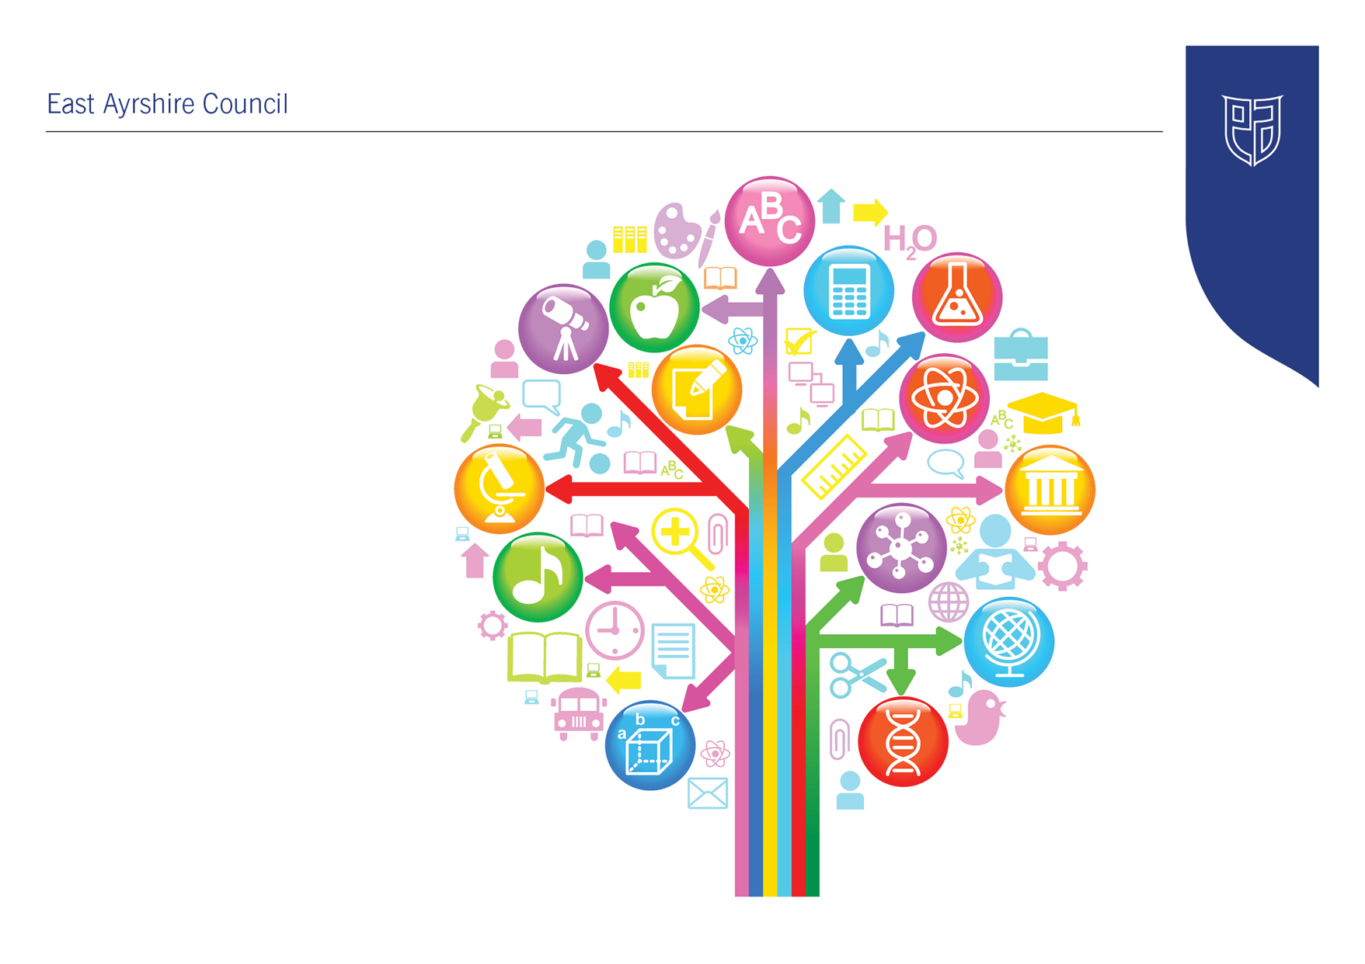
Standards and Quality Report
2024-25

Littlemill Primary & Early Childhood Centre


Establishment Context
Littlemill Primary School and Early Childhood Centre is a small, rural school in the village of Rankinston, East Ayrshire. It is part of the Doon Learning Community and has strong community ties. The school building is over 100 years old, situated in a unique geographical location with surrounding natural resources such as woodland, the River Doon and nearby farms, all of which are used to support outdoor learning and interdisciplinary projects.

The school roll currently sits at 28 across two multi-composite classes: P1–3 and P4–7. The ECC, operating on a term-time basis from 9:00am to 3:00pm, is registered for 18 children and currently supports 12 learners aged 3–5 years. The school has a significant percentage of children with additional support needs (over 50%) and operates in a SIMD 3 area. Around 60% of families fall within the lowest three SIMD quintiles, with a small number in quintile 1.

Staffing has stabilised in 2024–25 following a period of change. The school is led by a Head Teacher supported by a Depute Head Teacher and Principal Teacher. The ECC is led by the same SLT, with two full-time ELC practitioners and additional support from an Equity and Excellence Lead Practitioner. Support staff also provide targeted assistance across both the school and ECC.

Census Rolls  (#) | 2019/20 | 2020/21 | 2021/22 | 2022/23 | 2023/24 | 2024/25
Census Rolls  (#) | 23 | 24 | 30 | 27 | 28 | 28

Stage | P1 | P2 | P3 | P4 | P5 | P6 | P7
Total (#) | 6 | 2 | 4 | 8 | 2 | 5 | 1
% each pupil accounts for | 17 | 50 | 25 | 13 | 50 | 20 | 100
# Males | 4 | 1 | 1 | 6 | 1 | 3 | 1
# Females | 2 | 1 | 3 | 2 | 1 | 2 | -
# ASN | 3 | - | 1 | 1 | 2 | 4 | 1
% ASN | 50 | 0 | 25 | 13 | 100 | 80 | 100
EA % ASN | 10 | 17 | 23 | 27 | 28 | 31 | 29

SIMD Profile
SIMD Decile | 1 | 2 | 3 | 4 | 5 | 6 | 7 | 8 | 9 | 10 | N/A
P1 (#) | - | - | 6 | - | - | - | - | - | - | - | -
P2 (#) | - | - | 2 | - | - | - | - | - | - | - | -
P3 (#) | - | - | 4 | - | - | - | - | - | - | - | -
P4 (#) | - | - | 8 | - | - | - | - | - | - | - | -
P5 (#) | - | - | 1 | 1 | - | - | - | - | - | - | -
P6 (#) | - | - | 4 | 1 | - | - | - | - | - | - | -
P7 (#) | - | - | 1 | - | - | - | - | - | - | - | -
Total (#) | - | - | 26 | 2 | - | - | - | - | - | - | -
% of Roll | - | - | 93 | 7 | - | - | - | - | - | - | -
East Ayrshire % | 17 | 17 | 12 | 12 | 9 | 9 | 7 | 8 | 6 | 4 | 1

Attendance | 2019/20 | 2020/21* | 2021/22 | 2022/23 | 2023/24
All Pupils (%) | 93 | 88* / 84** | 92 | 92 | 84
SIMD 1&2 Pupils (%) | - | -* | - | - | -
SIMD 3 – 10 (%) | 93 | 88* | 92 | 92 | 84
Education Group (%) | 93 | 93* | 90 | 90 | 91
East Ayrshire (Sector %) | 94 | 94* /93** | 91 | 91 | 91
East Ayrshire SIMD 1&2 (Sector%) | 92 | 92* | 88 | 89 | 89
East Ayrshire 3-10 (Sector %) | 95 | 95* | 92 | 92 | 93
National (%) | - | 94** | - | 92 | -
*Local data – full year / **National data – schools open

Attendance
Attendance at Littlemill Primary School has fluctuated over the past decade. The school maintained strong attendance rates between 2015 and 2019, averaging above 94%. However, a significant decline occurred in 2020 (88.0%) likely due to COVID-19 disruptions. While rates recovered to 93.8% in 2022, they dropped again to 84.0% in 2024. The declining trend in the most recent year is a point of concern and may warrant targeted interventions.

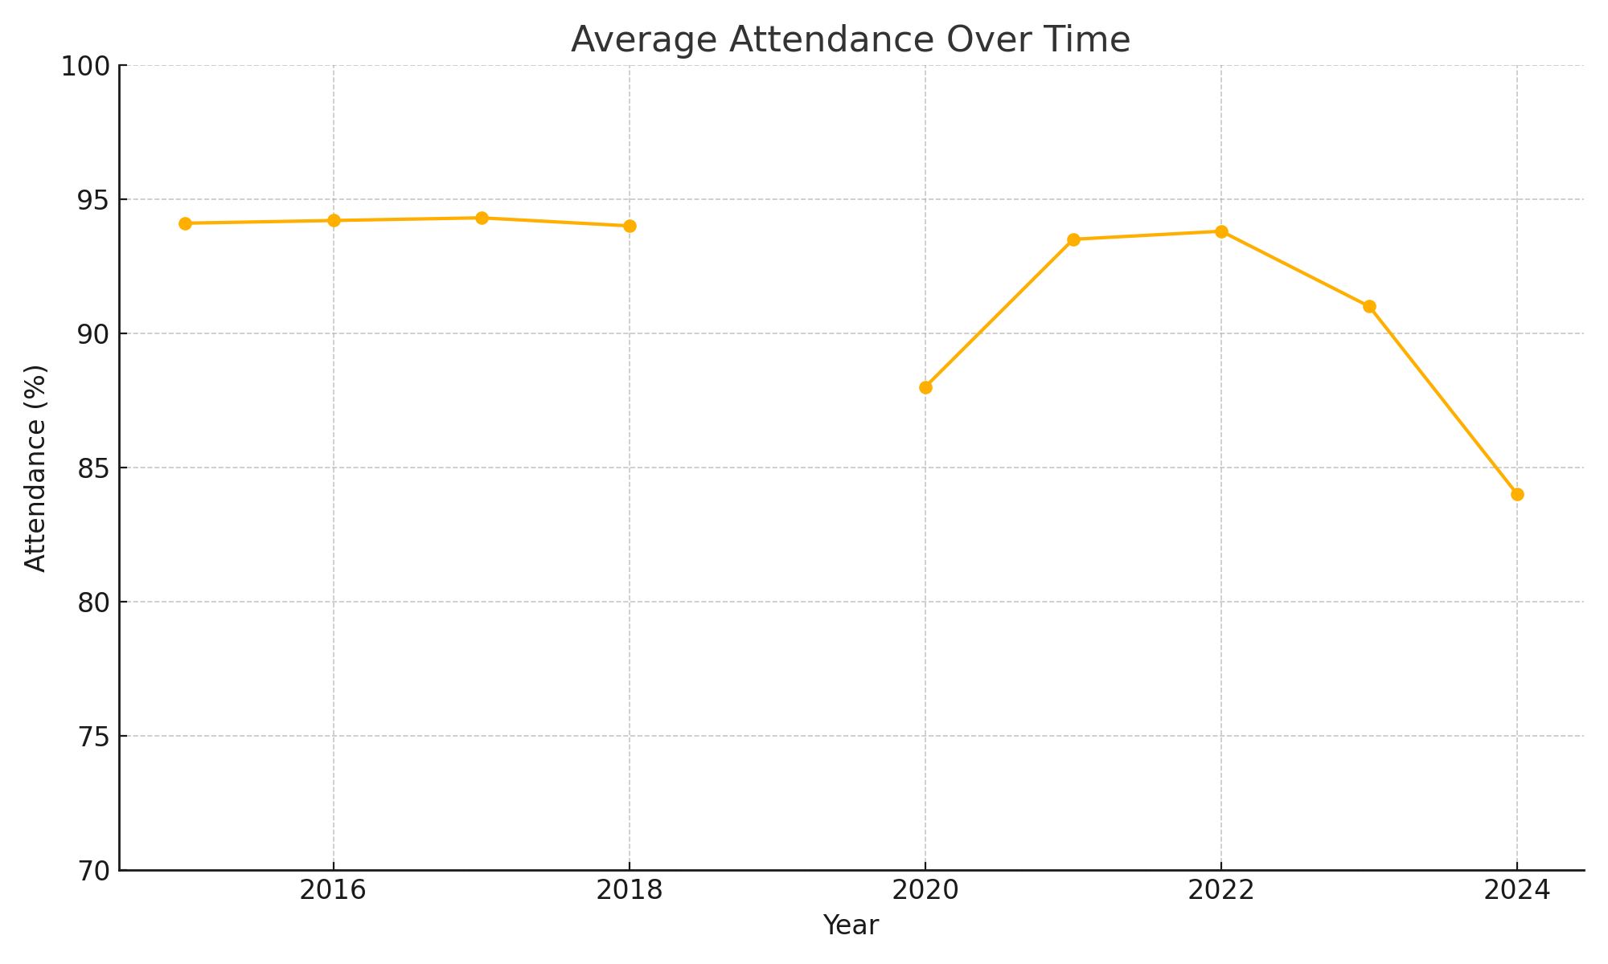

Exclusions
There were no exclusion incidents from 2015 through 2023. In 2024, however, there were 7 exclusion incidents involving 2 pupils. This sudden increase indicates a notable shift and suggests a need for closer examination of behaviour management, inclusion strategies, and pupil wellbeing supports.

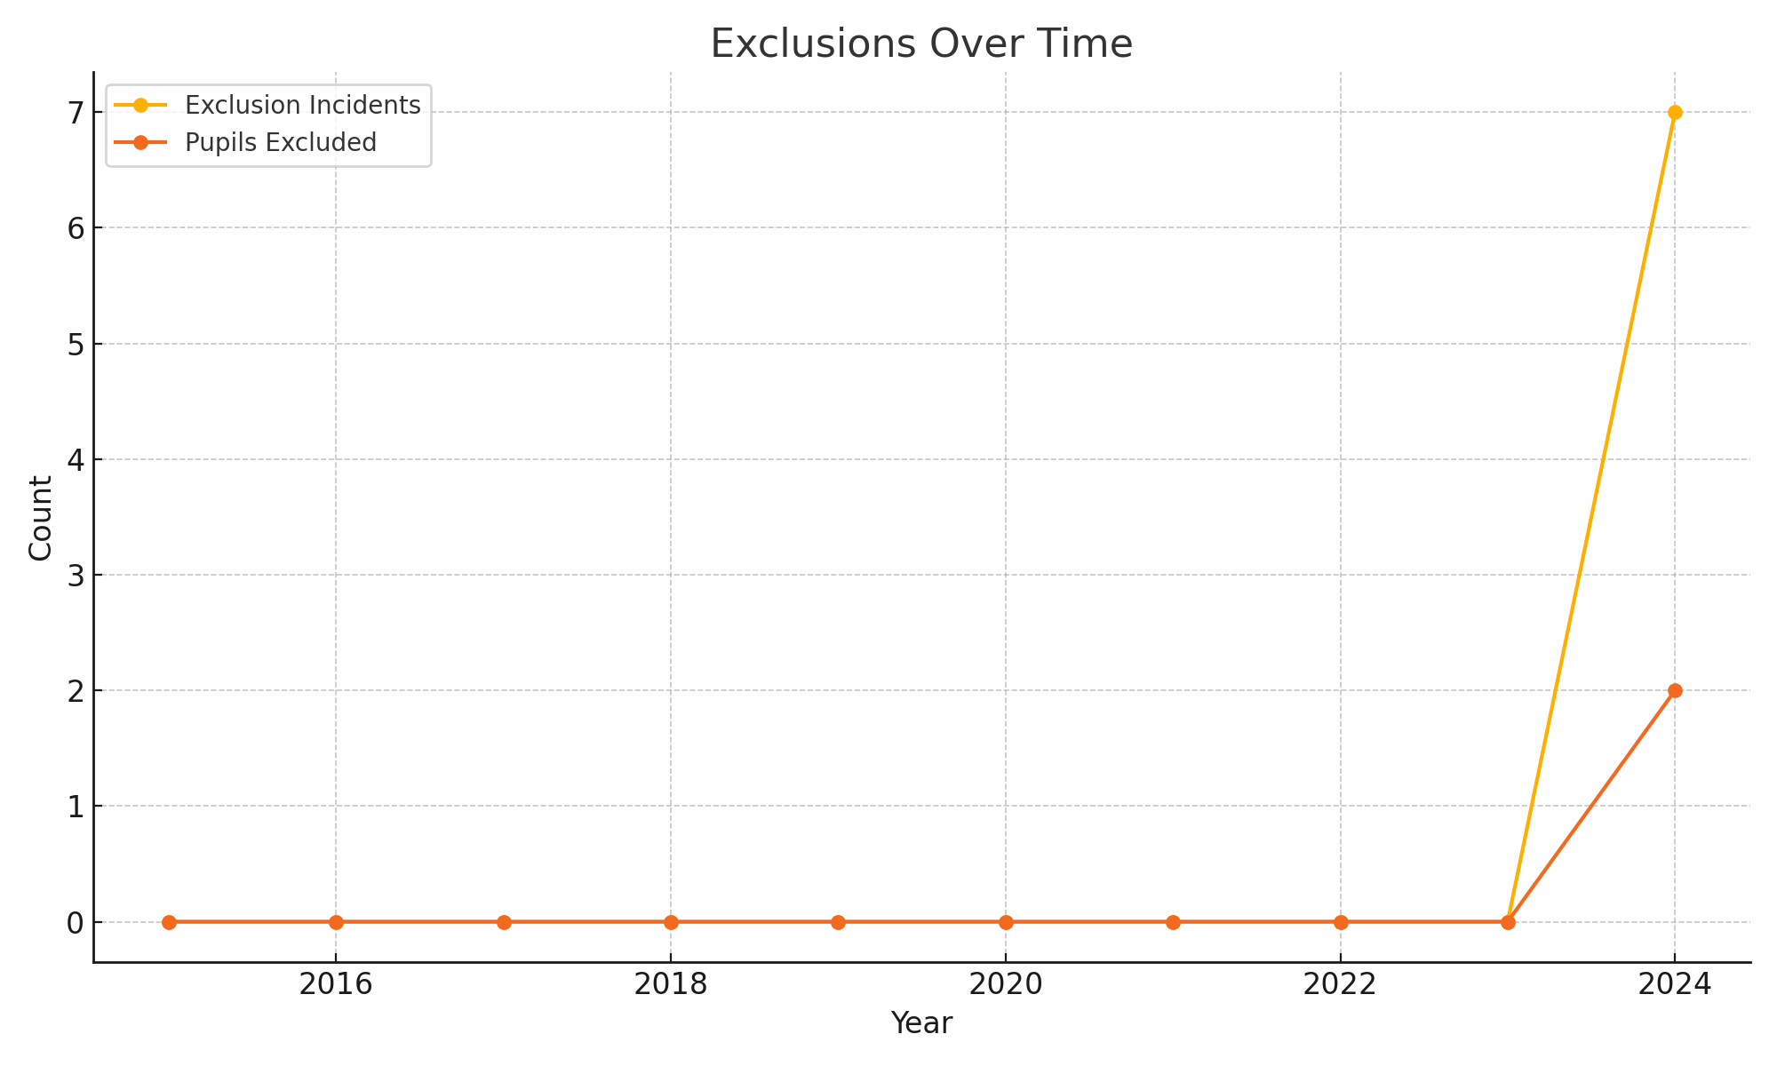
Census FMR (%) | 25 | EAC Census FMR (%) | 24
Census ASN (%) | 43 | EAC Census ASN (%) | 24

ASN and FMR Trends
The percentage of pupils with Additional Support Needs (ASN) has generally increased over the period, rising from 36% in 2015 to a peak of 52% in 2021. It has since stabilised at around 43% in 2023–2024. The percentage of pupils registered for free school meals (FMR) fluctuated more dramatically, from 35% in 2015 to a low of 25% in 2021, rising back to 43% by 2024. This trend may reflect socio-economic pressures in the community and should inform resource planning.

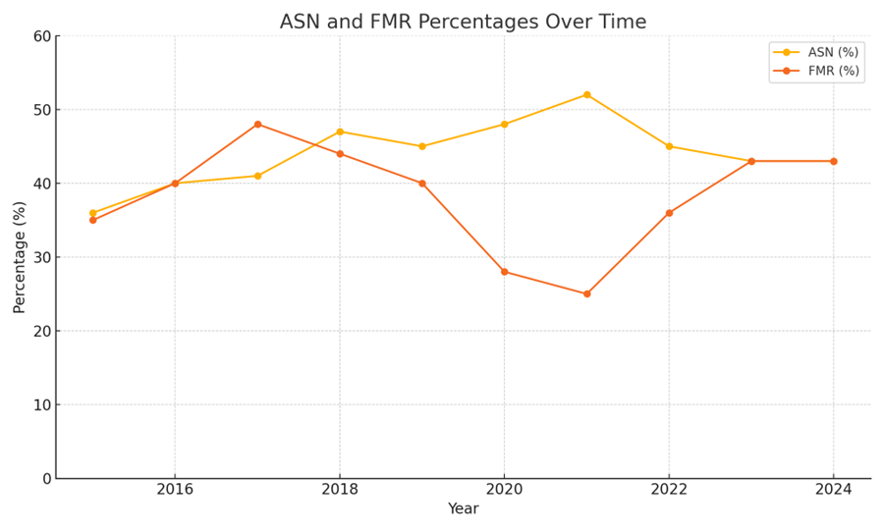

The school’s curriculum has been shaped around the unique needs of its community, with a strong emphasis on outdoor learning, place-based education, and meta-skills development. Interdisciplinary learning is a key feature of planning, making use of the surrounding environment and local heritage. All staff take part in collaborative curriculum design, and pupil voice plays an integral role in shaping learning.

The school has received targeted support from East Ayrshire Council and is part of the Scottish Attainment Challenge (SAC). Both Pupil Equity Fund (PEF) and Care Experienced Children and Young People (CECYP) funding are used to support literacy and numeracy interventions, family engagement, and pastoral care. School improvement has focused this year on ensuring consistency in learning and teaching, embedding quality assurance systems, and securing improved outcomes in wellbeing and attainment.

The school is committed to inclusive practice, building strong partnerships with parents and external agencies. Community events, pupil leadership groups, and a shared values framework help foster a sense of belonging. A recent Education Scotland HMIE inspection published in October 2025 highlighted both strengths and key areas for development, and the SLT have responded with a robust improvement plan and regular engagement with quality improvement officers. HMIe inspectors will return next academic session for a visit to check in on the areas for improvement identified in the school inspection report This has been followed up with an East Ayrshire Council Learning visit in April 2025. Which are:

- Senior leaders and staff should embed policies, guidance and processes to raise attainment and achievement for all children across the school and ECC.

- Senior leaders should support staff to develop further the use of assessments and data to track more clearly how much and how well all children progress overtime. This information should be used to plan learning that challenges children to make the best possible progress.

- Senior leaders should continue to improve the quality of learning and teaching across the school and ECC. This should ensure all children increase their ability to lead their own learning and are clear about their next steps and how they can be successful at school.

Key Priorities for Session 2025–2026

Based on the April 2025 Learning Visit and the June 2024 HMIe Inspection Findings, the following priorities have been identified to support continued improvement at Littlemill Primary School and Early Childhood Centre:

Embed Rigorous Quality Assurance and Monitoring
- Ensure consistent monitoring of planning, learning, teaching, and assessment across all stages and within the ECC.
- Establish clear protocols for feedback and follow-up actions that lead to improved classroom practice.

Improve Tracking and Monitoring for Impact
- Finalise and embed a whole-school tracking and monitoring system that records interventions, staff inputs, assessment data and target-setting.
- Use this system to inform planning, evaluate progress, and evidence impact more clearly.

Enhance Assessment and Moderation Across the Curriculum
- Develop a consistent, school-wide approach to assessment across all curriculum areas.
- Establish regular opportunities for staff to moderate standards of work both internally and with cluster partners.

Review and Finalise Curriculum Rationale
- Engage all stakeholders in reviewing the curriculum rationale to ensure shared understanding and relevance to the multi-composite structure and community context.
- Embed local contexts, meta-skills, and interdisciplinary learning across all stages.

Support Progression and Planning in Multi-Composite Classes
- Continue to adapt planning formats to reflect the structure of multi-composite classes and ensure appropriate progression and pace of learning.
- Provide primary and ECC staff with collaborative planning opportunities and exemplification.

Evidence School Improvement Journey and Impact
- SLT to gather and clearly present evidence of improvement activities, including impact data and stakeholder voice, in preparation for follow-up inspection.
- Use this to inform self-evaluation and communicate progress transparently.

Build External Partnerships for Collaborative Working
- Create opportunities for collaboration with other small and rural schools to share effective practice, support professional learning, and co-develop resources.

Raise Attainment in Literacy and Numeracy
- Continue to target improvements in writing through structured pathways and consistent pedagogy.
- Embed numeracy interventions and use ACEL, standardised assessment, and professional judgement data to measure progress.

Sustain Improvements in Early Years Practice
- Address identified areas from ECC audit and inspection: enhance personal planning, strengthen moderation, and embed deeper learning through responsive planning.
- Continue to build staff capacity in observation, interaction and planning for progression.

These priorities will form the foundation of the 2025–2026 School and ECC Improvement Plan and guide monitoring, evaluation and professional learning activities throughout the year.

Establishment Vision, Values and Aims
Our vision is to “dig deep and build together.” At Littlemill, friendship is the mortar that holds together the building blocks of lifelong learning. We celebrate our history and rural heritage while also preparing our children for a bright, ambitious future. We aim to cultivate a learning environment where all children are supported to thrive academically, socially, and emotionally.
Our values of Friendship, Positivity and Aspiration underpin every aspect of school life.
We promote these through assemblies, curriculum planning, and everyday interactions. Our core aims include:
- working together as a learning community,
- sharing resources and expertise,
- striving for excellence, and
- fostering a culture where every gain, no matter how small, is a victory.

Through a relentless hunger for improvement, we challenge ourselves, and our learners to exceed expectations.

Improvement Priority  (Expressed as outcomes for learners) | To raise attainment in Literacy and numeracy by ensuring high quality learning, teaching and assessment for all learners, specifically those not on track and narrowing the attainment gap  Our curriculum framework is in inclusive, reflects our unique context and enables learners to develop skills for learning, life and work | Education Service Improvement Plan 1: Our Leadership  We actively support, promote and enact leadership at all levels. Our young people are supported to be leaders of their learning in our centres, schools and wider life experiences. All staff have ready access to appropriate CLPL and experiences to promote leadership in every classroom, playroom and centre.
Our Leadership
Progress and Impact | - This year, leadership has been strengthened across the school and ECC despite previous instability. The Senior Leadership Team (SLT) now provides clear strategic direction, maintains a visible and supportive presence, and actively promotes a culture of distributed leadership. This has brought greater cohesion and enabled staff to better respond to the needs of learners.  - Children now participate in a range of meaningful leadership roles, including Digital Leaders, Junior Road Safety Officers (JRSO), Clean Green Award, Rights Respecting School (RRS) Committees, and House Captains. Pupil voice has been amplified through regular assemblies and pupil groups.  - Staff have been empowered to lead areas of school improvement such as numeracy, literacy, and STEM. Collegiate sessions have encouraged professional dialogue and collaboration, and monitoring activities now support continuous professional learning and reflection.  - A culture of active citizenship was promoted through regular pupil assemblies, consultation exercises, and learner-led improvement initiatives.  - Staff leadership was enhanced through targeted CLPL linked directly to school improvement priorities. Opportunities for leadership of learning were embedded, with middle leaders facilitating collegiate sessions on interdisciplinary planning, assessment, and progression pathways.  - Staff reported increased confidence and ownership in leading curriculum developments.  - World of Work Week provided a valuable platform for connecting learning to life beyond school and deepened learners’ understanding of skills for life, learning and work. Pupil voice indicates high levels of engagement and inspiration.  - In the ECC, developments in professional practice around observation, documentation, and planning have enhanced leadership of learning.  - The ECC has also made progress, with practitioners engaging in self-evaluation and digital learning initiatives. Support from the Equity and Excellence Lead (EEL) has enabled capacity-building around planning, child voice, and digital engagement.  - The use of responsive planning and improved quality assurance led to more meaningful learning journals, better capture of progression, and increased staff confidence. Child voice has been more deeply embedded, and planning formats revised to reflect individual and group learning pathways.  - Overall, the establishment has made very good progress in building leadership at all levels. A culture of collaboration, empowerment, and improvement is evident, with positive impact seen in learner engagement and staff practice
Next Steps | - Strengthen strategic use of data in improvement planning.  - Develop and embed leadership tracking tools and wider achievement records and link more explicitly to meta-skills development.  - Increase staff-led professional enquiry and peer collaboration.  - Sustain and expand pupil leadership opportunities, including structured roles within the ECC.  - Strengthen moderation of Learning Journals to ensure consistency and progression.  - Extend leadership of learning through further distributed leadership opportunities for staff.

Improvement Priority  (Expressed as outcomes for learners) | To raise attainment in Literacy and numeracy by ensuring high quality learning teaching and assessment for all learners, specifically those not on track across the stages  Our curriculum framework is in inclusive, reflects our unique context and enables learners to develop skills for learning, life and work | Education Service Improvement Plan Priority 2: Teaching and Learning Together  Our young people should experience a teaching, learning and curriculum offer that meets their needs, and those of our local and national context. All staff should be supported to deliver in new and innovative ways by accessing CLPL relevant to their needs and those of our young people.
Teaching and Learning Together
Progress and Impact | Quality Assurance  - A shared vision for high-quality learning and teaching is now in place, supported by a co-developed “Excellent Lesson” framework that ensures consistency across classes. Staff have implemented individual literacy and numeracy targets, and children are increasingly able to articulate their learning and next steps.  - The reintroduction of the quality assurance calendar has allowed SLT to undertake lesson observations, planning reviews, and jotter sampling. These have helped build consistency and foster reflection. Staff are using moderation within and beyond the cluster to validate teacher judgements.  - The curriculum has been reviewed and adapted to suit the context of a multi-composite school. STEM days, World of Work Week, and real-life interdisciplinary learning contexts have brought relevance and challenge to children’s experiences. In the ECC, the new planning cycle is embedded and shows breadth, with continued focus on depth.  Consistency in Learning and Teaching  - A renewed focus on pedagogy has led to strengthened consistency across the school and ECC. Teachers and practitioners implemented revised planning templates and used shared success criteria to deliver high-quality, structured lessons. Lesson observations and peer reviews confirmed an improved pace, clearer learning intentions, and increased learner engagement across all classes.  - Impact: Children can now articulate their learning goals more confidently. Feedback from pupils during the April 2025 Learning Visit highlighted that they feel more involved in their learning and enjoy varied approaches, including digital tools and outdoor tasks. Inspectors noted that “there are clear, shared expectations regarding the delivery of high-quality learning experiences for all learners.”  Staff Collaboration and Professional Learning  - Collegiate working has improved, supported by regular weekly planning meetings and joint professional development activities. Staff accessed local and national CLPL with a focus on formative assessment, outdoor learning, and numeracy interventions. Shared practice through team-teaching and moderation discussions helped align pedagogy across the multi-composite classes.  - Impact: Staff self-evaluation and feedback highlight growing confidence in applying progressive pedagogy and responding flexibly to pupil needs. Quality Assurance evidence demonstrates an increasing use of success criteria and assessment-for-learning strategies. Staff are more consistent in using formative assessment to shape next steps in learning.  ECC Learning Experiences  - In the ECC, a focus on responsive planning, observation quality, and deeper interactions has led to enriched learning experiences. Practitioners have strengthened their use of formative assessments, particularly in literacy and numeracy, to guide child-led learning opportunities. Observations now reflect clearer progression and inform both daily and weekly plans.  - Improved learning environment that meets children’s needs and enhances opportunities for calm nurturing spaces and for independent learning.  - Impact: The ECC Audit and inspection feedback identified improvements in planning quality and noted that “staff are knowledgeable of their children’s needs and abilities.” Child engagement in play-based learning has increased, with Learning Journals showing more personalised next steps and improved evidence of progression across the early level.  Assessment and Moderation  - This session, assessment practice was refined to align with national standards and local pathways. Staff developed and used holistic assessments and gathered evidence across a range of sources. A moderation calendar was introduced but is not yet fully embedded. The Learning Visit team raised the need for further work on assessment approaches across all curricular areas.  - Impact: Teacher confidence in applying professional judgement has improved, particularly in writing and number processes. However, moderation practices are still developing and require more regular, structured opportunities across all levels. As noted in the Learning Visit: “How are you going to develop approaches to assessment and moderation of learning and teaching across all areas of the curriculum?”  Planning for Multi-Composite Structures  - The introduction of updated planning formats tailored to multi-composite contexts has helped address differentiation and progression. Staff have begun using flexible groupings, stage-overlap planning grids, and progression pathways. However, the Learning Visit highlighted the need to fully embed and evaluate this planning approach.  - Impact: While planning is more consistent and structured, further work is needed to ensure these approaches are used with fidelity and lead to measurable outcomes. Continued development is required to meet the recommendation: “The school must continue to develop a planning format that meets the needs of their multi-composite structure.”  Overall Evaluation (HGIOS4 QI 2.3 – Learning, Teaching and Assessment / HGIOELC QI 2.3)  - The school and ECC have made good progress in improving consistency and quality of learning and teaching.  - There is a shared understanding of high-quality pedagogy and a stronger focus on child-centred, inclusive approaches.  - Assessment and moderation require further embedding to ensure impact is fully realised.  - Progress is evident but more time is needed to secure consistency across planning and assessment in all contexts
Next Steps | - Further develop moderation of literacy and numeracy assessments through implementation of GL Assessments.  - Expand interdisciplinary learning and project-based learning.  - Increase pupil involvement in co-constructing success criteria and self-evaluation.  - Fully embed new planning and assessment formats that reflect multi-composite and early level progression.  - Strengthen moderation processes across the curriculum and cluster to ensure shared expectations of standards.  - Extend high-quality outdoor learning and digital approaches into all curricular areas.  - Continue to support ECC staff in using responsive planning and high-quality observation for individualised next steps.  - Evaluate and adapt Quality Assurance activities to ensure they directly improve pedagogy and outcomes.

Improvement Priority  (Expressed as outcomes for learners) | Attendance  To continue to strengthen positive relationships, pupil participation, and inclusive, nurturing practices to improve outcomes in health and wellbeing, particularly for our most vulnerable learners. | Education Service Improvement Plan Priority 3: Our Wellbeing and Belonging  We want all of our young people to feel supported by people who know them well, and feel included in all of our schools and centres. Our staff need to be supported in their working with our young people, especially in times of adversity. As a key universal service, it is our vision that all young people attend our establishments on a full-time and regular basis to support them in their development at all stages.
Our Wellbeing and Belonging
Progress and Impact | Attendance  - Attendance has fallen from 84% to 83% over the course of the year, this is despite the close monitoring, targeted supports, and increased family engagement. There are few families who are outliers in terms of significant low attendance which is below 50%. This is due to a number of external factors which cannot be reported here. Measures have been put in place to tackle the significant lack of attendance at school. When these outliers are removed, attendance for the school is on average 88.5%.  Positive Relationships and School Culture  - Wellbeing remains central to our ethos and daily practice. Staff across the school and ECC build strong relationships with children and families, creating safe and inclusive learning environments. Interventions such as breakfast provision, free snack provision, and nurture-based strategies are supporting pupils’ readiness to learn.  - The shared values—Friendship, Positivity and Aspiration—were promoted through daily practice, assemblies, and visible reinforcement across the establishment. Restorative practices were embedded through targeted CLPL and integrated into daily interactions.  - All children now have access to wellbeing assessments through the GIRFEC framework and PATHS is beginning to be embedded from P1–P7, supporting emotional literacy and resilience.  - Zen spaces and sensory tools have been introduced to help children regulate their emotions, and the ECC has benefited from targeted interventions and updated child protection procedures following recent audits. Staff have participated in trauma-informed practice training with educational psychology.  - Impact: Learner feedback gathered during the April 2025 Learning Visit confirmed that children feel safe, included, and supported. Inspectors noted: “Relationships across the school are positive, warm and nurturing.” Pupils were observed supporting each other, resolving minor conflicts independently, and confidently discussing their rights and responsibilities.  Nurturing and Inclusive Practice  - The school continued to develop its inclusive approach through robust staged intervention, improved ASN tracking, and regular review of Personalised Support Plans. Staff worked closely with external partners and used data-informed strategies to target support.  - Staff have undertaken CPI (Crisis Prevention Institute) training designed to equip staff with the skills to prevent and manage crisis situations in various settings, including healthcare, education, and social care. It focused on de-escalation techniques, person-centred approaches, and understanding the role of brain science in distress behaviours. The training aimed to create safer and more respectful environments by reducing the need for restrictive interventions and promoting positive behaviour management strategies.  - Impact: The Learning Visit praised the “nurturing ethos across the school” and recognised that support strategies were clearly tailored to individual needs. Staff demonstrated detailed knowledge of learners’ profiles and needs. This has led to measurable improvements in pupil self-regulation, engagement, and attendance among those receiving targeted support.  Family and Community Engagement  - The school provided a range of family engagement opportunities, including open mornings, wellbeing initiatives, and targeted supports. The commitment to building strong family-school partnerships remained a strength.  - Monthly Book Bug session were planned for the summer term by our EAC Family PEEP as part of our ECC to P1 transitions.  - Impact: Positive feedback from parents, noted in both internal evaluations and inspector comments, confirmed a high level of trust and appreciation for the personalised and proactive communication approach. Community-based supports such as PEF-funded check-ins and nurture interventions contributed to improved wellbeing for targeted families.  Wellbeing Curriculum and Pupil Participation  - A structured approach to HWB teaching was supported by East Ayrshire’s progression frameworks. Pupils participated in Promoting Alternative Thinking Strategies initiatives and peer support groups.  - Impact: Pupils demonstrated growing confidence in discussing emotions, relationships, and wellbeing strategies. The April 2025 Learning Visit recognised “clear progression pathways in place for HWB” and noted the effective use of SHANARRI indicators to support children’s wellbeing understanding and planning.  ECC Nurture and Support  - ECC practitioners enhanced routines and environments to provide a calm, responsive and nurturing space for early learners. Use of SHANARRI wheels, keyworker dialogue, and consistent routines supported emotional literacy and regulation.  - Practitioners provided tailored use of the Glasgow MMS sensory processing to support neurodiverse learners in a way that meets individual needs.  - Impact: Children were observed to be settled, secure, and increasingly confident in their interactions. The ECC team demonstrated strong knowledge of individual needs and adapted practice responsively. Inspection and audit feedback praised the warm, relational practice and growing use of child voice in shaping routines and learning experiences.  Overall Evaluation (HGIOS4 QI 3.1 / HGIOELC QI 3.1 – Ensuring Wellbeing, Equality and Inclusion)  - Very Good progress has been made in creating an inclusive, nurturing, and supportive school and ECC culture.  - Relationships are a clear strength, contributing to a sense of safety, belonging, and motivation for learners.  - Staff are skilled in identifying and responding to a wide range of needs, supported by evolving systems and a shared commitment to wellbeing.  - Pupil participation and partnership working are embedded in daily practice and improvement planning.
Next Steps | - Embed trauma-informed approaches across all staff practice with further CLPL across ECC and Primary.  - Reduce exclusion rates through early intervention and regulation strategies.  - Extend the wellbeing web tracking system to more closely link to pupil voice and planning.  - Embed and evaluate the impact of the ASN tracking system and support plans on outcomes.  - Develop further trauma-informed and neurodiverse pedagogy CLPL for all staff.  - Expand SHANARRI-based self-assessment and peer-led wellbeing initiatives across the school and ECC.  - Extend ECC family engagement through personal planning and wellbeing profiles co-constructed with parents to include UNCRC.

Improvement Priority  (Expressed as outcomes for learners) | To raise attainment in Literacy and numeracy by ensuring high quality learning teaching and assessment for all learners, specifically those not on track across the stages | Education Service Improvement Plan Priority 4: Our Attainment, Destinations and Achievements  We want the very best for all of our young people in East Ayrshire. We aim to ensure that all young people secure a positive destination through excellent achievement and attainment at all levels.
Our Attainment, Destinations and Achievements
Progress and Impact | Improved Attainment in Literacy and Numeracy  - Attainment in literacy and numeracy continues to be a focus for improvement. Tracking systems and teacher professional judgement now show early signs of progress in reading and numeracy, though writing remains an area requiring further attention which is being addressed through revised writing planners and involvement in EAC and Education Scotland National Writing Priorities..  - Targeted support funded through Pupil Equity Fund (PEF) has allowed staff to work with identified learners on literacy and numeracy interventions. Assessment data, including diagnostic tools and classroom evidence, is used more effectively to plan next steps. The use of T&M meetings has enhanced staff confidence and improved understanding of learner progress.  - Targeted interventions and refined tracking systems were central to improving attainment. Staff engaged in regular attainment meetings using East Ayrshire progression frameworks and benchmark guidance, supported by robust PEF-funded support. A focus was placed on number processes, writing frameworks, and active literacy interventions.  - Impact: ACEL data indicates improvements in attainment across most stages, with the strongest progress in writing (P4–P7) and numeracy (P1 and P7). Pupil equity funding enabled targeted support for pupils not on track. Inspectors recognised that “staff are confident in identifying learners who require targeted support to ensure they make appropriate progress in their learning.  A detailed analysis of TP3 data highlights varying strengths and areas for development in pupil attainment across Reading, Writing, Listening & Talking, and Numeracy from P1 to P7. This evidence informs our ongoing self-evaluation and strategic planning to close the attainment gap and ensure equity for all learners.  Strengths Identified:  - Early Level Success: Attainment in P1 and P2 is very strong, with both stages demonstrating 83%–100% of pupils on track across all curriculum areas. This reflects the consistent and nurturing pedagogy in our early years and successful transition from ECC to P1.  - Upper Stage Excellence: P7 pupils demonstrate outstanding performance, with 100% on track in Reading, Writing, and Listening & Talking, and 100% in Numeracy. This affirms the effectiveness of targeted support, high-quality learning and teaching, and a well-structured transition programme to secondary school.  - Listening & Talking as a Strength: This area shows the highest average attainment across all stages (78.7%) and is a consistent strength from P1 through to P7. Our whole-school focus on oracy along with new Listening and Talking planners and collaborative learning strategies has positively impacted pupil confidence and communication skills.  Areas for Improvement:  - Middle Stage Vulnerability: Attainment dips notably in P4 and P5, particularly in Writing and Numeracy. Writing in P5 sits at 40%, and Numeracy in P4 is 55%. This reflects a need for a targeted review of pedagogy, differentiation, and assessment in these areas. These stages will form a key focus for tracking, moderation, and responsive interventions in 2025–26.  - Writing Lag Across the School: Writing remains the lowest performing area overall, with an average of 70% on track. Despite gains in Reading and Listening & Talking, Writing has not seen the same rate of improvement. This signals the need for a refreshed writing strategy, including genre-specific approaches, scaffolded support, and shared standards through moderation.  - Numeracy Inconsistency: Although P7 show positive outcomes in Numeracy, the inconsistency across stages (ranging from 20% to 100%) suggests variability in pupil understanding and confidence. This reinforces the importance of continuing our work on concrete–pictorial–abstract models, number sense, and contextualised problem solving.  This section summarises pupil progress toward end-of-session expectations for Reading, Writing, Listening & Talking, and Numeracy during Tracking Period 3 (May 2025). The analysis draws on percentage-based visual charts comparing pupil attainment by stage.
Progress and Impact | 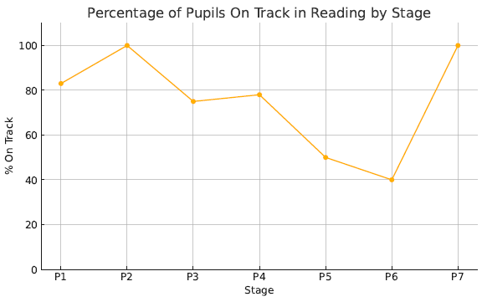 |  | 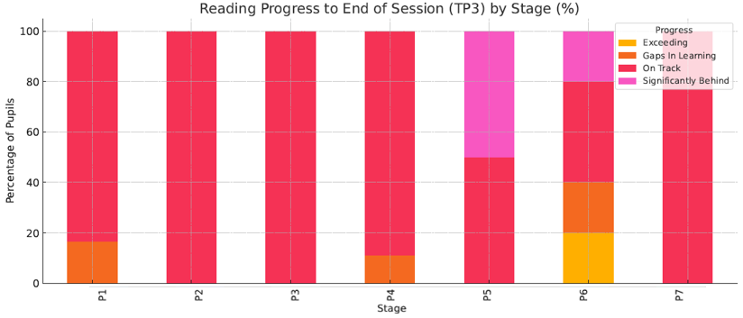
Progress and Impact | Reading attainment across the school is generally strong, with over 60% of pupils on track overall. Stages P1 and P4 show high levels of pupils on track. P5 and P6 show slightly lower attainment, with a small cohort presenting gaps in learning. P7 has a small group of pupils exceeding expectations, reflecting appropriate challenge at the senior stage.
Progress and Impact | 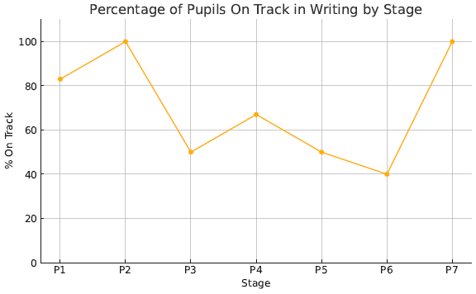 |  |  | 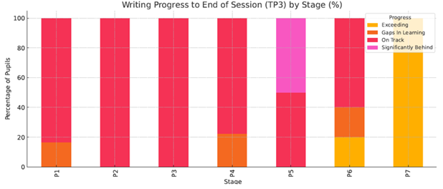
Progress and Impact | Writing presents the most variability across stages. While P2 and P4 display strong attainment, P5 and P6 show increased proportions of pupils with gaps in learning or significantly behind. This suggests the need for improved consistency in teaching, assessment, and moderation of writing.
Progress and Impact | 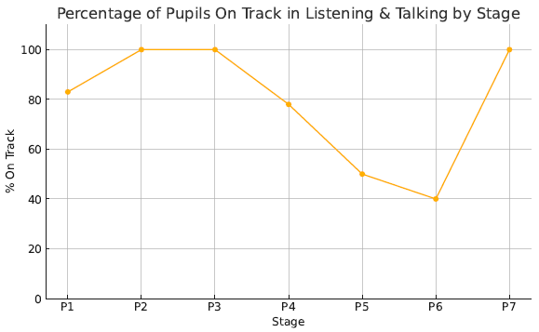 |  |  | 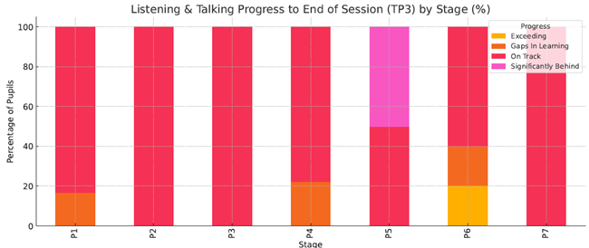
Progress and Impact | Listening & Talking is a relative strength across the school. P1 to P4 show high levels of pupils on track, and the majority of pupils in P6 and P7 remain on track despite some minor gaps. High attainers may benefit from extended opportunities in debating, discussion, and formal presentation.
Progress and Impact | 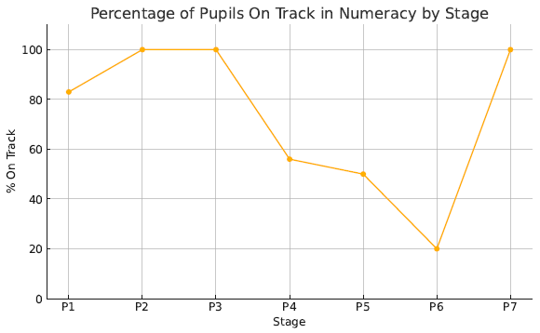 |  |  | 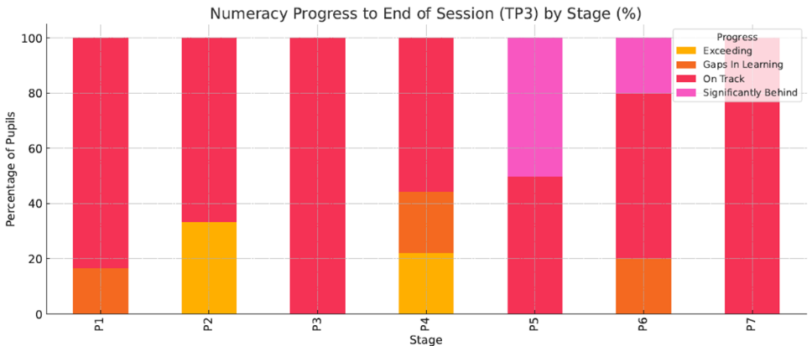
Progress and Impact | Numeracy attainment is more variable, particularly at P5 and P6 where a larger number of pupils are either showing gaps in learning or are significantly behind. P1, P2 and P3 continue to perform well. Middle to upper stages may benefit from conceptual reinforcement, use of manipulatives, and targeted small-group interventions.
Progress and Impact | Overall Recommendations  This analysis informs our next steps in targeted support, challenge for high-attainers, and improvement planning at class, stage and whole-school level.  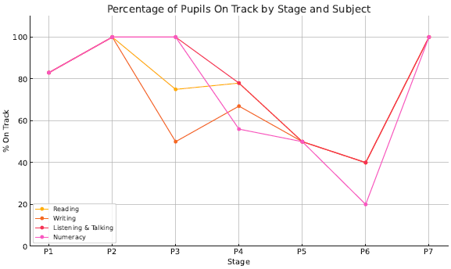  Tracking, Monitoring and Data Literacy  - Tracking was strengthened, through the use of triangulated evidence (standardised assessments, teacher judgement, formative evidence), reviewed termly. A consistent system was used across the school and ECC to plan and review interventions.  - Impact: Staff have greater confidence in identifying progress and next steps. The April 2025 Learning Visit noted that “staff are using data more effectively to support learning and teaching and improve outcomes for all children” and confirmed that interventions were well-targeted and having an impact.  Positive Destinations and Skills for Life, Learning and Work  - The curriculum integrated meta-skills development using the Skills Development Scotland framework. Learners engaged in DYW-themed weeks, pupil leadership, and IDL experiences linked to career pathways. Pupil profiles and Learning Journeys were updated to reflect individual achievements and skills.  - Impact: Pupil discussions during the Learning Visit showed that learners could articulate skills they had developed and how these connected to future learning and careers. The school effectively supported learners to explore aspirations and build personal strengths and confidence.  Celebrating Wider Achievement  - A system for tracking wider achievement needs to be established, with regular updates shared through profiles, assemblies, and displays. ECC and school staff celebrated out-of-school learning and linked achievements to skills development.  - Impact: Wider achievement in school raised learner self-esteem and reinforced the value of participation beyond academic outcomes. Pupils took pride in leadership roles and community involvement. Inspectors noted that this contributed positively to the school’s ethos of inclusion and success.  ECC Transitions and Early Level Progress  - Within the ECC, a revised early level tracking and personal planning process helped practitioners identify needs and adapt provision accordingly. Progress was monitored using formative assessment and responsive planning strategies.  - Impact: Children’s attainment in early literacy and numeracy showed improvement, particularly among those receiving early interventions. The ECC team demonstrated secure knowledge of learner progress and successfully supported smooth transitions into P1.  Overall Evaluation (HGIOS4 QI 3.2 / HGIOELC QI 3.2 – Raising Attainment and Achievement)  - The school and ECC have made good to very good progress in raising attainment and improving learner outcomes.  - Attainment levels have improved across key curricular areas, particularly for pupils receiving targeted interventions.  - Effective use of data, planning, and holistic achievement tracking has contributed to improved equity and learner progress.  - Skills development and learner agency have been embedded through pupil voice, DYW, and leadership opportunities.
  Area | Observation | Action
  Writing | Most variable attainment across stages | Prioritise writing in next SIP cycle – consistency, moderation, progression
  Numeracy | Significant drop-off from P4 onward | Intervene early at P4–P5; build in conceptual scaffolds, visual maths
  Listening & Talking | Strong and stable across stages | Extend challenge, especially for high attainers
  Reading | Positive across the school | Sustain through rich texts and comprehension strategies
Next Steps | - Continue improving writing attainment using structured genre progression.  - Strengthen data triangulation through improved use of assessment evidence.  - Develop and embed wider achievement tracking and link to future pathways through more effective use of Learning Journals.  - Maintain a clear focus on attainment in writing and numeracy, using diagnostic assessments and targeted pedagogy.  - Deepen moderation practice across all levels and curricular areas to ensure reliability of data.  - Continue embedding meta-skills and positive destinations through profiling, IDL planning, and pupil dialogue.  - Evaluate the long-term impact of PEF interventions on sustained learner progress and wellbeing.

Pupil Equity Fund: Evaluation
Approach/Intervention | Impact  Report on how you have improved outcomes for learners impacted by poverty | What evidence do you have of positive impact?  Outline the data that supports your findings.
1. Appointment of a Classroom Assistant (27.5 hours/week) | A dedicated classroom assistant provided support across multiple classes with a focus on:  - Delivering targeted literacy, numeracy, and HWB interventions.  - Supporting pupils identified through staged intervention and assessment data.  - Enhancing access to learning through in-class support and small group delivery.  - Providing nurturing check-ins and supporting transitions across the school day.  - Pupils identified as requiring additional support made measurable gains in confidence, engagement, and early literacy/numeracy skills.  - The assistant played a key role in improving regulation and emotional readiness to learn, particularly for vulnerable pupils. | - Staff feedback and QA evidence confirm improved access to differentiated support and reduced low-level disruption in classrooms.  - The April 2025 Learning Visit noted that “staff interventions are well targeted and making a clear impact on identified learners’ progress.”
2. Deployment of Additional Teaching Staff for Targeted Support in Numeracy and Writing (P4–P7) via Team Teaching | PEF enabled the school to provide increased teaching capacity to:  - Co-plan and deliver targeted lessons in writing and numeracy.  - Support differentiated grouping and one-to-one teaching within the class setting.  - Track and evaluate progress through regular assessment and pupil conversations.  - Build capacity in team teaching and collaborative pedagogy.  - Pupils in P4–P7 receiving targeted support showed notable improvements in core numeracy and writing attainment, reflected in both teacher judgement and assessment data.  - Professional dialogue and joint planning contributed to improved pedagogy and consistent expectations across stages. | - Staff reported increased confidence in identifying gaps, adapting learning, and sharing practice.  - Pupils engaged in targeted groups described their learning as “more focused” and felt “more confident” tackling challenging tasks.  - Children benefitted from smaller teaching groups, greater teacher attention, and responsive, needs-led learning.  These PEF-funded interventions have made a significant contribution to:  - Raising attainment in numeracy and writing for targeted pupils  - Narrowing the attainment gap for those most affected by socio-economic disadvantage  - Improving learner confidence, engagement, and participation  - Supporting inclusion and equity through responsive, needs-led provision.  - The interventions were closely tracked using attainment data, wellbeing indicators, and feedback from learners, staff, and parents.  - Evidence confirms that resources were well-deployed, targeted appropriately, and generated meaningful improvements in outcomes.
Next Steps
- Maintain PEF-funded classroom assistant post to continue supporting learners with additional needs and ensure early intervention.
- Where possible continue the successful team teaching model with further refinements based on learner feedback and data.
- Extend team teaching to support identified learners in early stages (P1–P3) and further embed across the curriculum.
- Evaluate long-term impact on individual learners through deeper analysis of progress over time.

Establishment Self Evaluation: How Good is Our Early Learning and Childcare? Quality Indicators
Quality Indicator 1.3 Leadership of Change | 5
Quality Indicator 2.3 Learning, Teaching and Assessment | 4
Quality Indicator 3.1 Ensuring Wellbeing, Equality and Inclusion | 5
Quality Indicator 3.2 Securing Children’s Progress | 4

Establishment Self Evaluation: How Good is Our School? 4 Quality Indicators
Quality Indicator 1.3 Leadership of Change | 5
Quality Indicator 2.3 Learning, Teaching and Assessment | 4
Quality Indicator 3.1 Ensuring Wellbeing, Equality and Inclusion | 5
Quality Indicator 3.2 Raising Attainment and Achievement | 3

Establishment Capacity for Improvement
Littlemill Primary School and ECC demonstrates a very good capacity for continuous improvement, underpinned by a shared vision, strong leadership, reflective practice, and an increasingly data-informed approach to raising attainment and promoting wellbeing. Across all key areas—leadership, teaching and learning, wellbeing and inclusion, and attainment—there is clear evidence of impact, improvement, and self-awareness.
Strengths Supporting Capacity for Improvement
1.Effective and Empowering Leadership
- The senior leadership team has provided clear direction and stability through a period of change. Staff feel supported, valued, and motivated to contribute to whole-school improvement.
- Leadership at all levels is developing well, with distributed leadership opportunities including working groups, pupil leadership, and increased practitioner agency in the ECC.
- The Learning Visit and HMIe inspection commended the school’s clarity of vision and consistency of approach.

2. Commitment to Inclusion, Equity, and Wellbeing
- Nurturing approaches and strong relationships are central to the ethos and culture of the school and ECC.
- The school is responsive to learners with a wide range of needs, with robust staged intervention processes, multi-agency working, and targeted supports.
- The ECC’s personalised, child-centred planning and responsive routines ensure all children are supported to thrive.

3. Robust Self-Evaluation and Use of Evidence
- The school and ECC demonstrate strong self-awareness, using a range of tools including learner conversations, data analysis, quality assurance, and stakeholder feedback.
- The learning visit highlighted the school’s capacity to use evidence to inform next steps and shape future direction.
- Improvement plans are aligned with local and national priorities and demonstrate coherent, strategic planning.

4. Effective Teaching and Pedagogy
- There is a strong foundation of consistent, high-quality learning and teaching across the school and ECC.
- Staff are committed to developing practice and engage regularly in professional learning and moderation.
- Clear progression frameworks and improved use of assessment have led to more targeted, effective pedagogy.

5. Rising Attainment and Learner Progress
- Attainment data indicates positive trends in literacy and numeracy, with evidence of closing the gap for targeted learners.
- PEF interventions are well-planned and monitored, with strong impact on outcomes.
- Skills development, wider achievement, and transitions into and across the early level are well supported.

Key Next Steps to Sustain and Extend Improvement

1. Further Develop Assessment and Moderation Across All Levels
- Continue embedding holistic assessment and moderation practices across curricular areas.
- Strengthen cluster moderation and ensure all staff develop confidence in standards and expectations.

2. Enhance Planning for Multi-Composite and Early Level Contexts
- Fully implement and evaluate new planning frameworks that support progression in composite classes.
- Ensure early level planning is closely aligned with observation, assessment, and responsive learning pathways.

3. Expand Digital and Outdoor Learning Opportunities
- Build on existing strengths in digital and outdoor learning to enhance engagement, application, and real-world relevance
- Ensure consistent and equitable access to digital learning experiences across stages.

4. Embed Learner Voice and Pupil-Led Self-Evaluation
- Further develop pupil participation in school improvement planning and self-evaluation.
- Use learner voice to support the design of engaging, personalised learning experiences.

5. Consolidate ASN Tracking and Evaluate Impact
- Refine the use of the new ASN tracking and intervention systems to ensure measurable impact on pupil outcomes.
- Use data from these systems to inform strategic improvement planning and partnership engagement.
Summary Statement
Littlemill Primary School and Early Childhood Centre is a nurturing, inclusive, and reflective learning community with a strong and growing culture of continuous improvement. Staff are committed to professional learning, collaboration, and equity. With effective leadership, robust self-evaluation, and increasingly consistent pedagogy, the school and ECC are well-placed to sustain recent gains and further improve outcomes for all learners.
Capacity for Improvement: Very Good

