Littlemill

Primary School & Early Childhood Centre



Welcome Pack

Session 2025 - 2026





ECC Welcome Pack

Welcome to Littlemilll ECC, we hope you and your child will be very happy here.
Starting at the Centre
Starting nursery is a significant milestone in your child's life. We will do all we can to help them feel welcome, safe and secure. We are aware of the tremendous input that you, as parents and carers, have already made in the education of your child and we look forward to developing a partnership with you in these valuable early years.
Preparing Your Child
Starting nursery is a very exciting time for young children and together we can make it a very happy and rewarding time. Before starting our Early Childhood Centre (ECC), talk to your child about coming and about the things they will be doing and the people they will be meeting. It is important to remember that young children vary tremendously in the way in which they react to new experiences, so do allow your child plenty of time to settle in - some children may take longer to settle than others.
Leaving Your Child
When you do leave your child for the first time, it is best to do so for only a short period, building up the time over a few days if necessary. Always make sure that you say ‘goodbye’ to your child and tell them when you will be coming back and what you will be doing whilst you are away. Some children may be upset, and staff will do everything they can to comfort them. Should your child continue to be upset for a prolonged period we will make contact with you and work together to build your child up to being able to stay with us for longer periods each time.
At the beginning
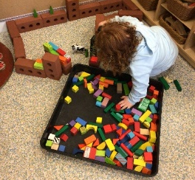
When your child starts our ECC you will find that we introduce them slowly. By admitting the children slowly we find that the children are able to settle quicker and more easily into routines, making the transition from home as smooth as possible for both children and parents.



Let me introduce you to some of our lovely staff within
Littlemill Early Childhood Centre.

- Mr. Simon Leitch – Head Teacher
- Mrs. Heather Sabatini - Deputy Head /ASN (Additional Support Needs) Coordinator

- Mrs. Anna Brown - Early Learning and Childcare Practitioner
- Miss Rachel Montgomery - Early Learning and Childcare Practitioner
- Mrs Sheena Sturgeon – Early Learning and Childcare Support Sssistant

- Linda Kerr – Equity and Excellence Lead (East Ayrshire)

- Mrs. Adele McMillan - Senior Clerical Assistant
)

t•

Opening times
We currently provide the term time structure to meet the 1140 hours of funded places. We open our doors at 8.50am but it is a soft start so children can arrive from this time until 9.05am. We are open all day until 2.50pm. Some children are only in the ECC half days (parental choice or just not quite ready for a full day yet) and for this we try to encourage children to stay and have lunch with the ECC and enjoy the experience we have to offer.
We work with a key worker system so your child will be allocated a group and a key worker.
Daily routine
8.50-9.05am -Soft start and self-register (parental sign in)
9.05 -9.15am -Welcome time and lunch orders
9.15am-1130am – Free play.
11.50am -12.30pm - Mindfulness / lunchtime
12.30pm - 2.30pm - Free play
2.50pm - Home time (parental sign out)
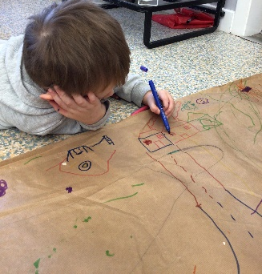
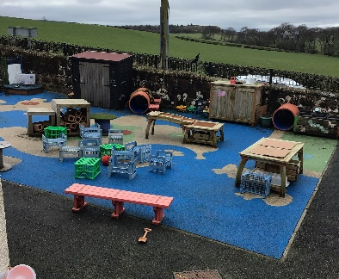
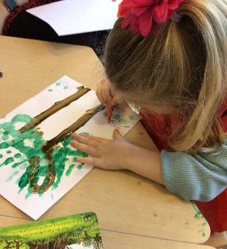

Snack and Lunch Provision
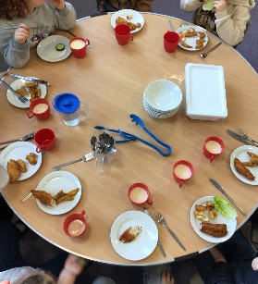
Healthy snack will be provided during the session, milk, and water are available to drink. Snack items are chosen using guidance from NHS Setting the Table and are fruit and vegetables.
Children will be offered a 2-course lunch. ECC Lunches are provided by
Dalrymple School Kitchen


What your child will need when attending the ECC
During free - play the children have open access to outdoors in all weathers so we would ask that you dress your child appropriately for the. Weather.

The children will be encouraged to independently put on their suits and wellies, so in order to make this easier for the children, please consider how difficult it is for them to put on and take off their shoes.
We ask that all items have your child's name on, so they do not get lost.

We ask that children have at least one full change of clothes including socks and pants just in case they require to be changed at any point.
If your child is in nappies, can you please ensure there are wipes and nappies in their bag.

If the weather is very warm, we ask that you put sun cream on your child prior to attending, we can top up the sun cream after lunch with consent.
The children will get messy while in the ECC, so it is probably best not to wear their best clothes.

I'm sorry I got messy today but..
There was flour in the ECC today. I thought it would be fun to make clouds, so I threw it up into the air.

I've been exploring the water and learning about emptying, filling and pouring. Sometimes I might spill a little bit as the muscles in my hands are still developing.

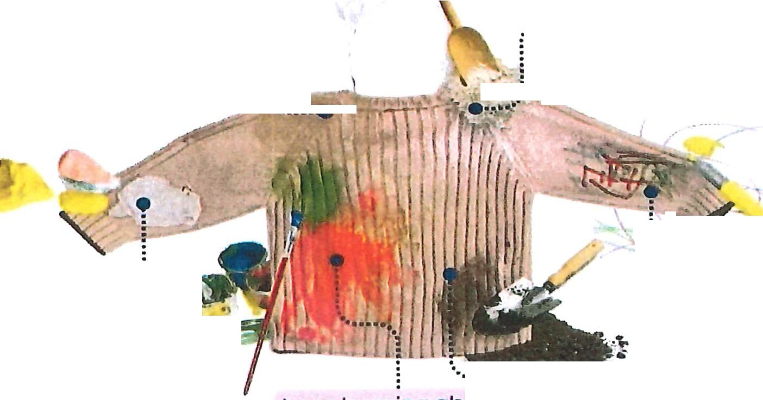

I was learning about what happens if I mix two colours together... Its messy work, but the green point on my jumper comes from the blue and yellow that I mixed!

This mark is from a pen. I'm trying really hard to learn to hold the pen and make marks on the paper.

I loved the texture of the playdough, but I rested my arm on a little bit as I reached across the table. I didn't realise it would stick to my sleeve!

The mud kitchen is very dirty, but it's so much fun! Playing there helps me develop my imagination and explore my understanding of the world. I watched you cook at home, and I wanted to try by myself.

_

Learning Journals
We use the Learning Journals to record your child's learning and achievements, There is a parent’s app where you will be able to access and contribute to your child's Learning Journal.
After you have completed the permission slip, you will be added to the Journals and sent an email to guide you through set up.

Illness and allergies
If your child has any illness or allergies, could you please speak to a member of staff who will get you the relevant paperwork for this. If your child has any medication to be administered at any point the relevant paperwork must be completed. Please do not leave any medication in your child's bag it must be handed to a member of staff.

Toileting
Within our establishment the children are encouraged to go to the toilet independently, the staff will provide assistance if the child indicates that they require help.
If your child is still in nappies they will be changed as and when required.
Staff will assist in the process of toilet training by continuing what you have been practicing at home.

I hope you find this information useful but if you have any further questions feel free to email adele.mcmillan@eastayrshire.org.uk

Linda.kerr@eastayrshire.org.uk
Littlemill Early Childhood Centre
Tel: 01292 590221

