Littlemill

Primary School & Early Childhood Centre



Session 2025 - 2026

A Guide for Parents
Information for when your child starts school

Head Teacher’s Welcome

Dear Parent / Carer,

Within Littlemill Primary School and Early Childhood Centre our aim is simple - to provide the very best educational experience for your child. We believe this will provide them with the foundation for the best possible opportunities in life. This cannot be accomplished by ourselves alone. Never has this been more important as we seek to rebuild our education provision in the light of this year’s pandemic. Strong and effective partnerships are key to the success of the school and the pupils within it. With this in mind we look forward to working with you and your child, in partnership, along this next stage in their journey.

Schools need to be the heartbeat of each community and as such contribute to the strength, safety and vibrancy that we should come to expect from living in East Ayrshire. Like any positive relationship Littlemill PS & ECC and the wider community need each other. We seek to establish a welcoming, proud and confident school which makes the best possible use of the resources, people and places around us. Although practical restrictions will prevent your child from enjoying the Primary 1 school experience we had intended, we are determined to provide an exceptional experience for your child whilst they are at school and learning at home.

We are committed to creating a culture and climate that will centre on meeting the learning needs of all pupils within our care, no matter personal circumstances. We strive to enable our learners to flourish as citizens of the world and as such we lead them in the process of acquiring 6 key competencies: Character, Citizenship, Collaboration, Communication, Creativity and Critical Thinking. When learners are immersed within these, they learn more than content, and this learning contributes to their own futures and to the betterment of their communities and beyond.

‘The greater danger for most of us lies not in setting our aim too high and falling short; but in setting our aim too low, and achieving our mark.’

Michelangelo

Yours sincerely,

Simon Leitch
Head Teacher

‘The First Day and New Weekly Structure’

Primary 1 will begin school on Wednesday 20th August 2025

Parents and carers are asked to bring the children into the school playground and wait in the area nearest the class entrance. Littlemill Primary staff will come out and bring the children into the class at 9.15am and allow you to come in with your child. This will be the starting time for Wednesday 20th, Thursday 21st and Friday 22nd August.

From Monday 25th August onwards, the school day starts at 9am. The school day finishes at 3pm and children will be dismissed from the classroom door. They will not be allowed to depart unless accompanied by a known responsible adult. If the adult is not known to the school, please notify the school office before collecting the child at the end of the day.

Meet the Staff

Leadership Team
Mr Simon Leitch | Head Teacher
Miss Heather Sabatini | Depute Head Teacher/ASN Coordinator
Mr David Stokes | Principal Teacher
Miss Linda Kerr | Equity and Excellence Lead (East Ayrshire)

Teaching Staff
Mrs Lauren Wilson | Class Teacher
Mrs Lyndsay Bradford | Class Teacher
Mrs Gillian Ann Duckworth | EAST Teacher
Early Years Staff
Mrs Anna Brown | Early Learning & Childcare Practitioner
Miss Rachel Montgomery | Early Learning & Childcare Practitioner
Miss Linda Kerr | Equity and Excellence Lead

Support Staff
Mrs Adele McMillan | Senior Clerical Assistant
Miss Gemma Downie | Classroom Assistant
Mrs Trudi Morrison | Classroom Assistant
Mr Elizabeth McQue | Janitor

School Lunch

Legislation changed in January 2020, entitling ALL children in P1 – P5 access to a free school meal. Lunch time is at 12:30pm – 1:15pm and provision is also in place for those who choose to have a packed lunch instead.

Parent Pay

Littlemill Primary School operates a cashless payment system called ParentPay. Pupils have their own online account where payment for school snacks and meals are made without the need of actual cash. Parent/carers are able to access the account to pay in funds electronically, whenever they choose to do so. Payment of school excursions and other events is also made through this system. You will receive communication from the school to set up account activation and guidance on how to use the application.
Attendance at School

It is very important that your child attends school regularly. East Ayrshire Councils
definition of acceptable attendance levels is 90%. This will be calculated as 90% of their planned days for being in school under the current restrictions Regular absence from school can seriously impact on a young person’s ability to thrive socially, emotionally and academically.
That said we do appreciate that from time-to-time your child will have some illness which prevents them from being at school.

Should your child be unable to attend school due to illness it is vital that you inform the school office as a matter of priority. Please be prepared to explain your child’s absence and if possible when you anticipate their return to school.

School Holidays

There are ample school holidays throughout the academic year which I would encourage you to use to facilitate family holidays and visits to relatives etc. Some parents choose to withdraw their child from education during term time to enable them to participate in family holidays. This action is not something that East Ayrshire Council or Littlemill Primary School encourages. A two or three week absence from school can have a significant impact on your child’s learning.

If this is something you are prepared to do then written notification should be submitted to the Head Teacher prior to the holiday occurring. Please note that holiday absences are recorded on your child’s attendance record as unauthorised. Furthermore, request to have school work to take on holiday with them will be declined.

Uniform

At Littlemill we are proud of our pupils and proud of our uniform. It is part of our school ethos, values and aims that everyone should wear our uniform.

Our school uniform consists of a red sweatshirt (with school badge), white polo shirt (with school badge), white shirt with school tie and black/grey skirt, pinafore or trousers and a school tie.

School uniforms are available from schoolwearmadeeasy.com and BE Uniforms in Ayr.

Physical Education

PE is part of the core curriculum and our expectation is that ALL children participate fully in the Physical Education programme. To enable them to do this please provide the following:
- Pair of shorts (clearly marked with your child’s name)
- Gym shoes/training shoes (clearly marked with your child’s name)

You will be notified in the new term the days your child has PE.
ALL jewellery, including earrings and body piercings must be completely removed prior to participation in PE. This should be done at home or by the child themselves.
Or there is an alternative that a child may cover them with tape.
Tape will not be provided.
Please note, staff are not permitted to remove earrings.

Health & Wellbeing

International research suggests that plain water is excellent at keeping our brains hydrated and enables us to focus and concentrate for greater periods of time as a result. Our pupils are encouraged to drink plain water during class to aid this hydration. If this is something you wish your child to participate in then please provide this for them – again clearly labelled with their name. No juices or flavoured waters should be provided for during class time.

Please put water in a bottle with a sports cap top to avoid spillages, Stanley cups (or similar brands) are currently not permitted in the school or any trips.

As we are a health promoting school we actively encourage healthy play-time snacks. No food is to be consumed in the classrooms. The school kitchen provide free fruit for children at morning break.

Allergies
Clearly certain foodstuffs are not permitted within the school due to pupils having specific food allergies. Further information will be provided regarding this after the summer.

IT IS IMPORTANT THAT YOU PUT YOUR CHILD’S NAME ON EVERYTHING THAT THEY BRING TO SCHOOL ESPECIALLY THEIR JACKETS AND JUMPERS!

The Curriculum
Curriculum for Excellence is the education system in Scotland. It includes nurseries, schools, colleges and community learning from 3 to 18 and beyond.
In Littlemill Primary School we follow the values and principles for the curriculum as set out in ‘A Curriculum for Excellence’. We encourage our pupils to develop skills for learning, life and work, including literacy, numeracy and health and wellbeing in and out of the classroom.
We have previously worked alongside Strathclyde University to implement a play based learning approach in P1-3. Children are naturally motivated to play. A pay-based program builds on this motivation, using play as a context for learning. In this context, children can explore, experiment, discover and solve problems in imaginative and playful ways. A play-based approach involves both child-initiated and teacher-supported learning.
Developing the use of a play based curriculum in Primary 1-3, where each child reaches their potential in a positive and appropriate context, has supported the consolidation and holistic development of children’s early learning experiences from an Early Learning Centre setting as part of the transition into Primary 1. This naturally becomes more structured throughout the year and as the pupils go into P2 and P3.

It affirms that curriculum for Excellence is for all young people in all educational settings and that it should support them in a range of ways which helps them to maximize their potential. At the heart lies the aspiration that all children and young people should be successful learners, confident individuals, responsible citizens and effective contributors (the 4 capacities as outlined in CFE).
It defines the scope of the new curriculum as extending beyond subjects to include:

- The ethos and life of the school
- Curriculum areas and subjects
- Interdisciplinary projects and studies
- Opportunities for wider achievement

Children and young people enjoy making progress and find satisfaction in meeting the challenges posed by a curriculum that engages, stimulates and motivates them.
In Littlemill Primary School we recognise that children and young people progress at different rates and we have a great focus of teaching the skills of literacy and numeracy to ensure they are prepared for their future lives.

The Curriculum is organised under the following headings:

- Literacy and English
- Numeracy and Mathematics
- Health and Wellbeing
- Expressive Arts
- Religious and Moral Education
- Science
- Social Studies
- Technologies

Teachers plan exciting and challenging inter-disciplinary studies where each of the curriculum areas makes its own unique contribution to developing the four capacities of children and young people. Teachers have much more freedom to teach in innovative and creative ways, with the emphasis on the competencies outlined at the outset of this booklet: Character, Citizenship, Collaboration, Communication, Creativity and Critical Thinking.

Communication

Our School Website and School App contain information of a general nature about what is happening in school.

School website:
https://blogs.glowscotland.org.uk/ea/Littlemillpsandecc2017/

Safer Schools Scotland App
A leaflet explaining how to download the app and access it is available from the school office but can also be found on our school website.

We are currently reviewing our procedures for communicating with parents and the wider community and are hoping to reduce the amount of paper communications to rely solely on digital provision.

If your child is involved in a school excursion, it is important therefore, that you ensure you have notifications switched on for your device and regularly check them.

The exception to this will be the initial annual paperwork issued at the beginning of the school year to ensure pupil information is correct and up to date.

Parents may make contact with the school at any time. Should you wish to discuss any matter/concern with a member of the senior leadership team it is advisable to do so via appointment, this can be arranged by speaking with a member of the administration team.

Emergency Contacts

When you registered your child, you were asked to give information about addresses and telephone numbers, etc. we also ask for a person who can be used as an emergency contact.

PLEASE NOTIFY THE SCHOOL IF THERE ARE ANY CHANGES TO THIS INFORMATION.

The emergency contact is called upon when the school is unable to make contact with a child’s parent or carer and circumstances have arisen whereby the child needs to be sent home or taken to hospital etc.

We have first-aid trained staff in school. If your child is injured, this person will be contacted and will offer first aid. If the injury is more serious, parents (or emergency contacts) will be contacted and asked to take the child for further investigation. In order that you are kept informed, a letter is given to children who have fallen and received first aid in school.

It is school policy that contact will be made with a parent/carer in the event of a head injury, regardless of the severity of the injury.

If your child requires to take medicine during school hours, you are required to complete a form stating the dosage, frequency and authorisation of school personnel to administer the medication. In doing so parents /carers understand that the medication will be administered by a non-medically trained staff member.

Only medication prescribed by a GP for your child can be administered by school personnel.

School personnel cannot administer ‘over the counter’ medication.

Supporting your child’s Learning

All of these activities provide lots of opportunities for developing communication and life skills and are things you can do at home (especially during the summer holiday and in preparation for coming to P1).

We have been placing a specific importance on listening skills and also resilience in Littlemill. Please consider these and support us in helping our youngsters become more effective listeners, able to follow instructions and encourage the ability to develop resilience from an early age.

Try and complete the following:
- Helping you around the house e.g. setting the table, washing up, tidying their room and putting the shopping away.
- Sitting together looking at a book and listening to stories.
- Visiting places together like the park, supermarket, station, bank, library, post office.
- Singing rhymes and songs together.
- Collecting things like buttons, shells, postcards or pebbles.
- Simple games for all the family to play:
  - Snakes and ladders
  - Large jigsaw puzzles
  - Snap
  - I spy…
  - Picture lotto
  - Skipping games

- Talk about
  - What happened today
  - What you did today
  - A television programme
  - Things you like/dislike
  - The games your child plays with other children
  - The I can activities/statements on the resilience flower (and try these activities throughout the summer and into P1)

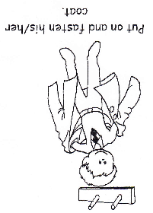
Before your child starts school, it would be helpful if he/she could have some of these life skills.
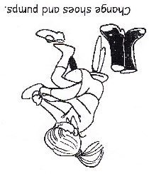

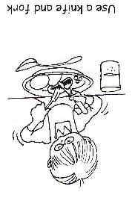

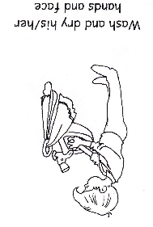
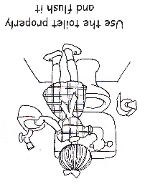

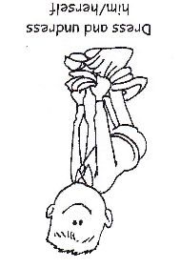

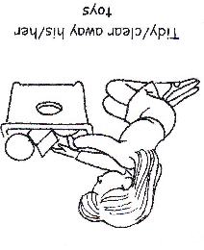
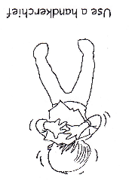

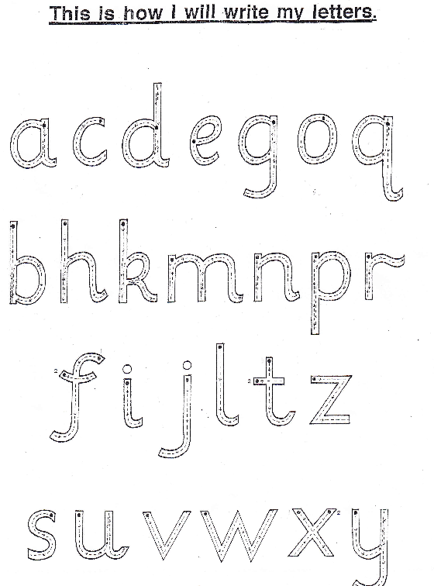

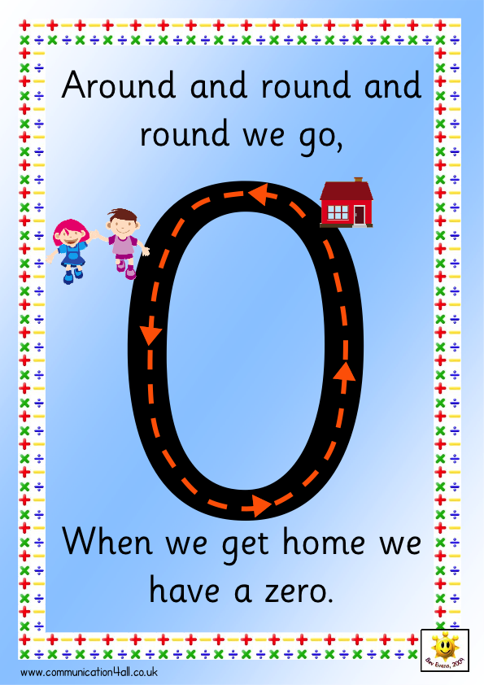
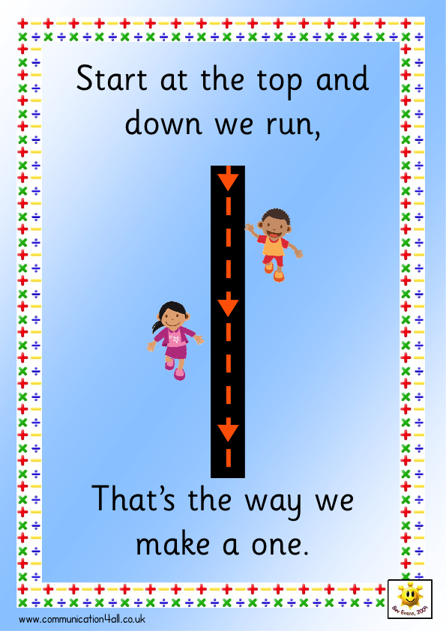
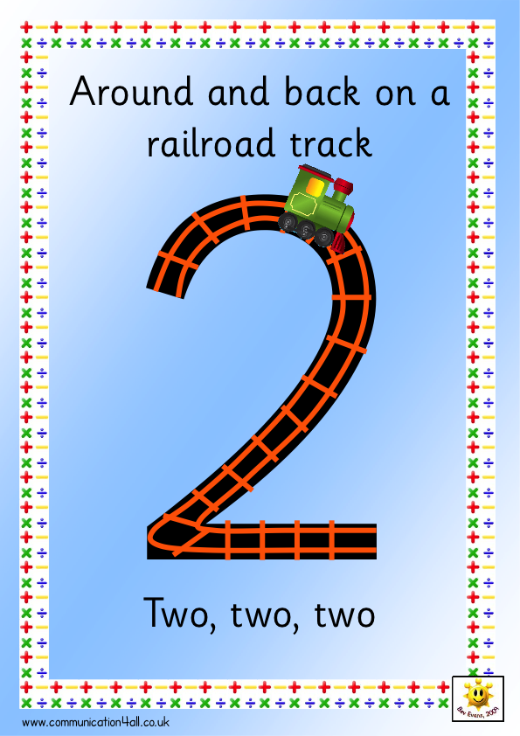
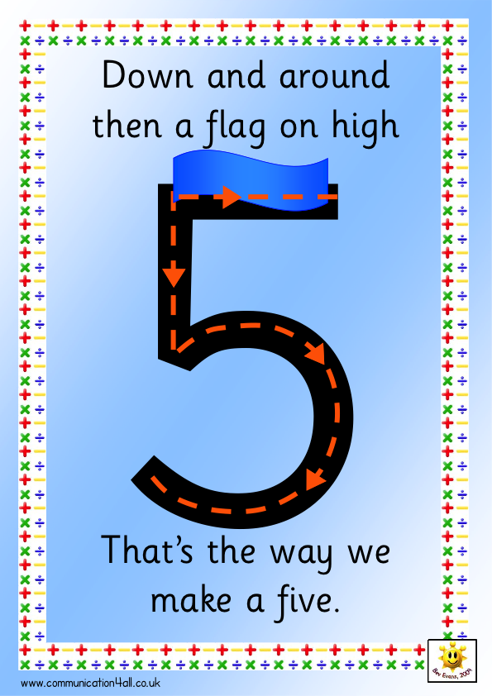
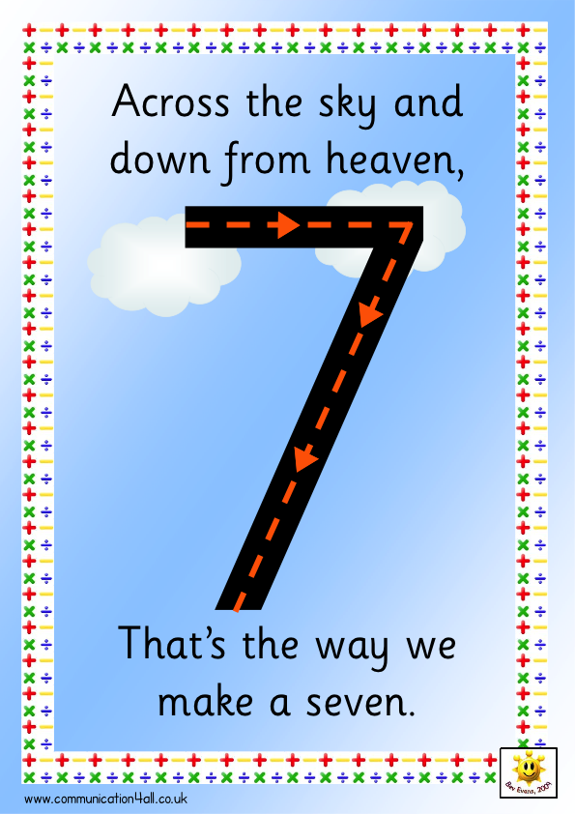
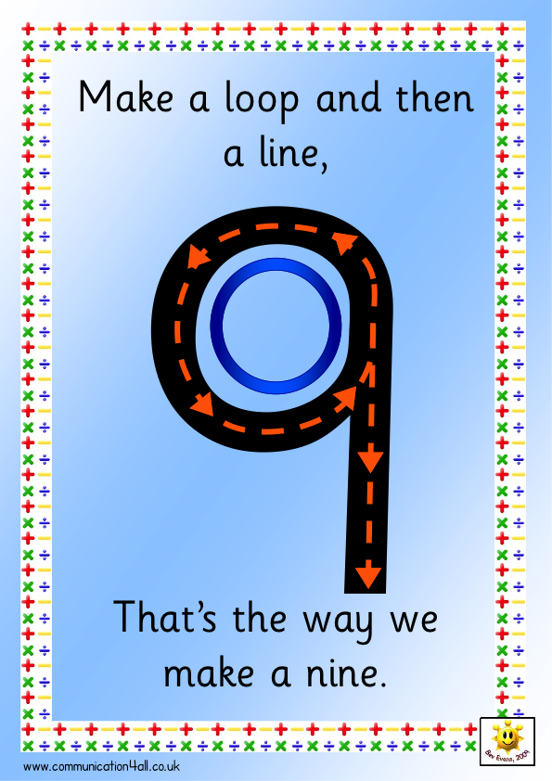

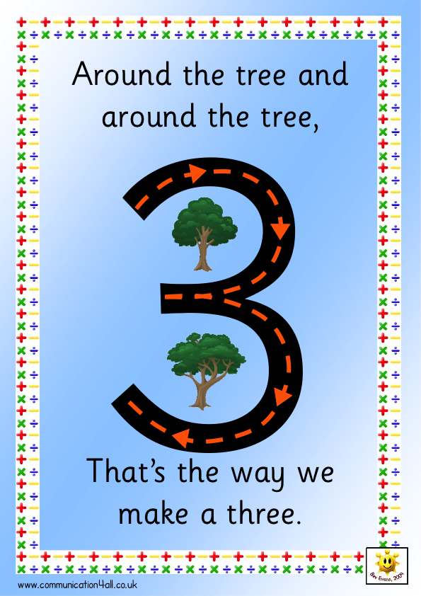
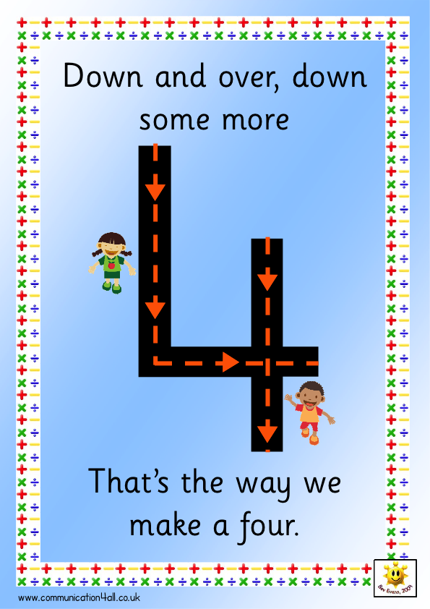

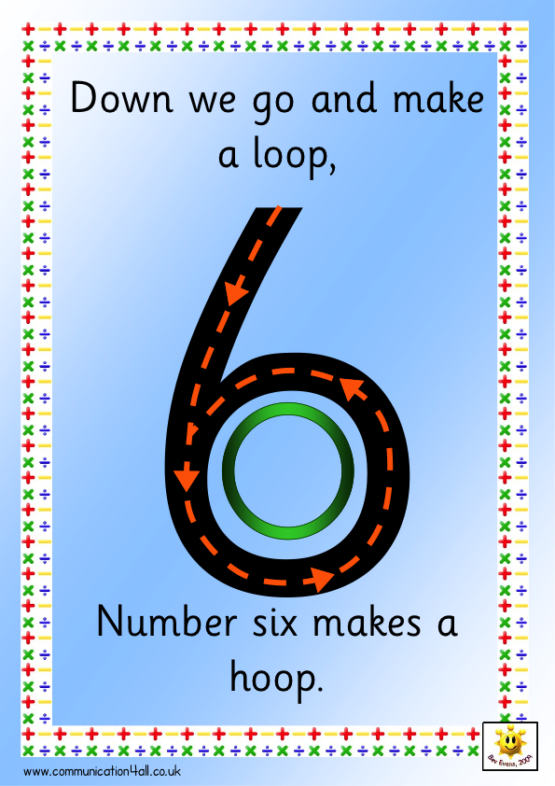

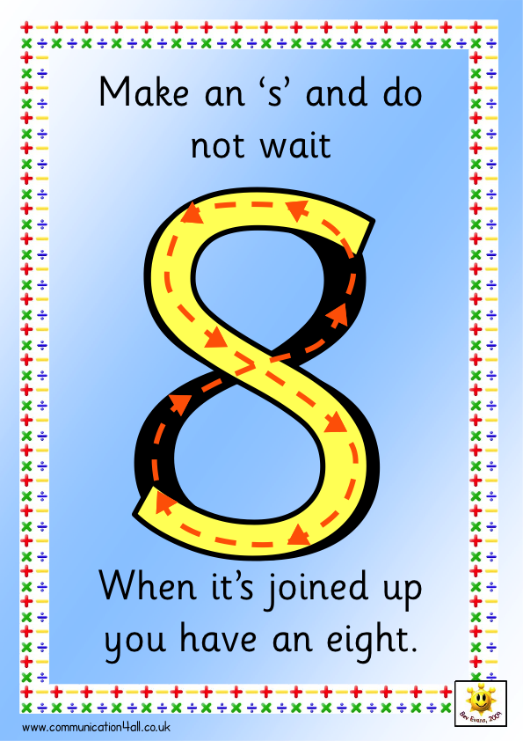

Contacting Us

Littlemill Primary School & Early Childhood Centre
LITTLEMILL
RANKINSTON
AYR
KA6 7HJ
Phone: 01292 590221

E-mail: Littlemill.Primary@east-ayrshire.gov.uk

We look forward to seeing you and your child in August 2025

