Addition and Subtraction  I use practical materials and can ‘count on and back’ to help me to understand addition and subtraction, recording my ideas and solutions in different ways. MNU 0-03a  How many altogether?  Use loose parts items to investigate addition and subtraction calculations. Adult focus group where adult poses problems relating to the story and children use loose parts to calculate answers. Children make up own problems. | Pattern  I have spotted and explored patterns in my own and the wider environment and can copy and continue these and create my own patterns. MNU 0-13a Goldilocks decided to make the bears scarves to say sorry for going into their house. She wants to put patterns on them. What can we use to make patterns? What kind of patterns can she make? Using objects found in the environment, shapes and numbers to make patterns. Design and make a pattern for the bears. Have a pattern race with your friends, who can complete their pattern first? Look for patterns in the wider environment as inspiration. |  | Position and Movement  In movement, games, and using technology I can use simple directions and describe positions. MNU 0-17a. I can use the signs and charts around me for information, helping me plan and make choices and decisions in my daily life. MNU 0-20C  Can we create a lovely route for the 3 Bears to take their friend Goldilocks on? What could they show her? Children create a route/path using loose parts. Could make large scale route in the playground on smaller scale in tuff tray. Encourage use of positional language. Use pallets, tyres, crates etc. so they have to go over, under, around to promote use of positional language.  Children to create a map of their route and make signs to direct the characters.  Take the children on a maths trail around the playground. Ask questions that will encourage them to think mathematically. Encourage children to come up with own mathematical questions.
Measure  I have experimented with everyday items as units of measure to investigate and compare sizes and amounts in my environment, sharing my findings with others. MNU 0-11a  Baby bear was the smallest bear, Daddy bear was the tallest. Who is the tallest in your group? How do you know? Order the group smallest to tallest, how can you measure how tall? Encourage children to draw round each other and measure with a nonstandard unit.  How much porridge did each bowl contain? How do you know? Use non-standard units to measure capacity. Estimate then measures the capacity of a variety of 3 bowls then develop to other familiar objects. In an outside space use soil for porridge or a bucket of dry porridge oats. | Numeracy and Mathematics  In the Outdoors  Early Level  Goldilocks and the 3 Bears  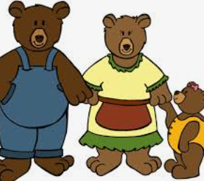  Teacher Planner
Data Handling
I can collect objects and ask questions to gather information, organising and displaying my findings in different ways.
MNU 0-20a Look at the bears treasures from the forest. What questions can we ask to sort them? How can we organise this information.
Depending on what has been collected display on a pictogram, Carroll diagram or Venn diagram.
Shape  I enjoy investigating objects and shapes and can sort, describe and be creative with them. MNU 0-16a. I have had fun creating a range of symmetrical pictures and patterns using a range of media. MNU 0-19a  Can you make the other half of the bear? Adult to draw a large outline of half a bear, children make other half using loose parts. How will you make the shapes? | “Learning outdoors can be enjoyable, creative, challenging and adventurous and helps children and young people learn by experience and grow as confident and responsible citizens who value and appreciate the spectacular landscapes, natural heritage and culture of Scotland.”  (Curriculum for Excellence through Outdoor Learning) |  | Sharing  I can share out a group of items by making smaller groups and can split a whole object into smaller parts. MNU 0-07a  When the bears went for a walk in the woods they collected lots of treasures. How can we share them so they get the same amount each? Are the groups equal/unequal, how do we know, how many do they get? Experience of sharing items such as stones, shells, pinecones, leaves etc. How many in each group, how many groups, how many altogether?
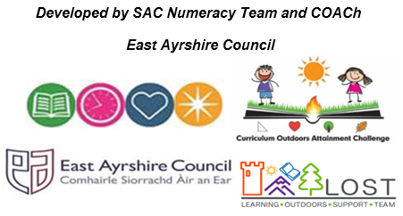 | Sorting  I can match objects, and sort using my own and others’ criteria, sharing my ideas with others. MNU 0-20B  Can you organise a picnic for the three bears?  Role play setting up of a picnic for the 3 bears. Sort the items needed for each bear, e.g. big, middle sized and small of each item. Then sort using own criteria. | Counting  I have explored numbers, understanding that they represent quantities, and I can use them to count, create sequences and describe order. MNU 0-02a  How many can you count?  Using bears counting, ordering and sequencing bears and arranging in regular/non regular patterns to assist counting. Order numbers to 20 and 30 making a giant outside number line.

