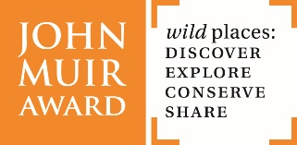

Using Film as a media with your John Muir Award
Watch ‘The Life of John Muir’ [link] by Galston Primary 7 – a three-minute animation film.
East Ayrshire’s Galston Primary 7 class have been learning about film making and climate action as part of their John Muir Award. Pupils chose to make a film about John Muir after discussion on what he may have campaigned about had he been alive today. They chose to recreate parts of John Muir’s life through art and use the Stop Motion App* to make their film.
Pupils planned, scripted, drew and filmed themselves. Their class teacher commended the pupil’s efforts and teamwork in this pupil led project. “Pupils have enjoyed and engaged fully in working towards their John Muir Award, they are presently working on a film about how they are improving their wild places through tree planting.” Class Teacher
Pupils voices “We have recently made an animation about John Muir's life. It took a lot of work and time, but it was worth it. I loved making the movie, it was good so we could inspire other people to love nature. I liked the Award because we got to have more time outside and helping the environment by planting trees, making habitats, and making movies. I want the courses to continue. I think the John Muir Award is a great chance for children and adults to enjoy nature.”
“For our John Muir Award we have done several things; made a movie and have done tree and hedge planting and lots more. We are doing this to save our planet from climate change. My favourite was planting trees. It was really fun as it brought everyone working closely together as we are in very tough times right now due to Covid.”
Thanks to pupils and staff for sharing their work and to Keep Scotland Beautiful for supporting with film making.
*Stop Motion is available for iPhone, iPad, and macOS as well as Android and Windows.

