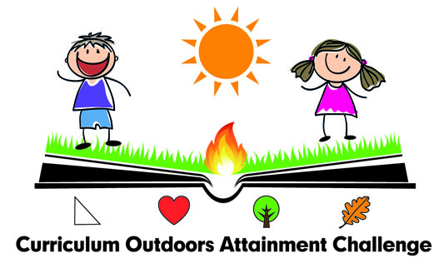
Class: Second Lesson: B1c

Reference to Curriculum: Numeracy and Mathematics

Learning Outcomes  Pupils will: | Learning Activities  Pupils will: | Teaching & Learning Approaches, Organisation/Timing | Resources | Assessment
Calculate the perimeter of simple 2Dshapes in millimetres, centimetres and meters and explain their choice of method.  I can explain how different methods can be used to find the perimeter and area of a simple 2D shape or volume of a simple 3D object.  MNU 2-11c  Perimeter is the length of the boundary around the edge of a 2D shape.  Area is a measure of the amount of 2D space inside a boundary. | Introduction:  Each child is to go and find two item. These can be natural or manmade. Demonstrate how to use a ruler, tape measure and trundle wheel.  Ask them what would be the most appropriate piece of equipment to use to measure the items they have collected. Ensure the appropriate vocabulary is used when measuring length and width. These are the terms used for 2D shapes. Explain that the third dimension is depth.  Development:  Ensure children have a clear understanding of length, width and depth and then give them all sheet A in groups of 4. They need to measure at least 2 objects and add the measurements to the sheet. These are for both 2D and 3D shapes.  Using Sheet B as a class or group, depending on the children, measure something in the playground and calculate the perimeter and area.  Conclusion:  Recap of all of the terms used. Ensure that children are given the opportunity to demonstrate their understanding. | 5/10 minutes  Whole class  Active learning, collaboration  10mins Class discussion  10 mins in groups, collaboration  15 minutes  Whole group  Active learning, peer support, | Rulers  Tape measures  Trundle wheels  Worksheets A and B | Focus  Calculate the perimeter of a shape.  Method/s  Worksheet B  Assessor/s  Class teacher  Pupils  1 group

