Emergency Procedures

Emergency situations can occur despite the best precautions and therefore contingency planning and consideration of emergency procedures are necessary. Such planning ensures that the consequences of an incident are handled efficiently and sensitively and do not progress arbitrarily.

The principles outlined provide a format for response and communication for East Ayrshire LOST/OEC groups encountering misfortune whilst undertaking outdoor activities.

The effectiveness of such plans depends on staff being familiar with their specific duties and responsibilities. The role of each individual must be understood by all concerned. Lines of communication must be confirmed or established for each planned excursion.

Detailed arrangements will reflect the nature and size of the visit and activities planned or anticipated. In complex visits, e.g. yachting expedition this will be included in the risk assessment and recorded in Evolve.

As all risk cannot be eliminated in dynamic outdoor settings, appropriate training, competence and experience of LOST staff is vital in the avoidance of and management through an emergency. As leader, first responder and first aider, staff judgement and dynamic decision making will significantly determine the outcome of an emergency situation. All staff are competent for the task deployed and trained first aiders.

Generally after participants are secured, triaged, and first aid administered as trained then a call for external support may be required. Depending on the scale and severity this may progress simultaneously.

When teaching/instructing outdoors either in an EAC school grounds or in local greenspaces during the school day the at home emergency contact will always be the school office, who have parents contacts, and can access senior managers and corporate support staff.

It must be recognised that many LOST/OEC events take place out of normal office or school hours and/or very remotely from school. Planned emergency contact arrangements must take account of this and will be named for each off site visit on the Evolve system. Frequently the emergency contact will be another member of LOST staff (with parents contacts, and can access senior managers) or, in some cases a spouse. Where the emergency contact role is undertaken by a person who is not a member of staff the function will be limited to the recycling of information in a predetermined manner.

On occasion rather than lead, LOST staff will accompany a school managed activity, either to assess or observe. In this circumstance the school have planned and retain responsibility for safety management and any emergency response. LOST staff are in effect lone working but should obviously assist in emergency as competent to do so.

Misfortunes and incidents often develop dynamically and do not fit naturally and automatically into categories. However the appropriate level of response, both to deal with the event at the time and in subsequent investigation would be:

Level 1 Miss fortunes. Slightly delayed return to home, minor accidents requiring some attention from the Activity Leader. No medical attention required.

Level 2 Minor events. Significantly delayed return. Injuries minor but requiring medical attention on return. Party still able to extract itself and return home without outside help. Alert emergency contact, parents, Head of centre.

Level 3 Serious events. Injuries significant but not life-threating. Part or all of the party requires to be rescued. Head of centre advices Head of Education.

Level 4 Fatal or near-fatal events. Head of Education advises CEO.

It is imperative that communication is made with the appropriate authority at each stage. Therefore, individual staff must be clear who they will need to contact and how. If that person is not available then an alternative contact on the same or next tier of administration should be advised, using EAC 24h emergency number if no one can be raised.

The Action Cards issued provide basic outline in a crisis:

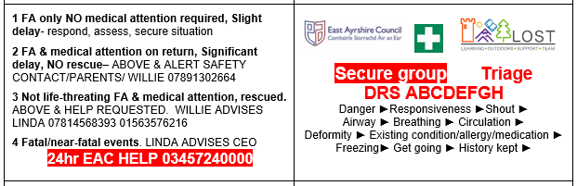

Near misses. An event where no injury or other misfortune has actually befallen the party - but may well have, this may or may not require specific response at the time, but should subsequently be investigated in order that lessons may be learned and appropriately shared.

