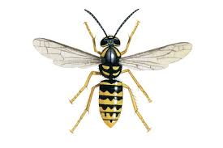
Wasps
Wasps in School Grounds
Late summer is the time when we are mostly likely to come across disoriented wasps. Wasp colonies are breaking down and wasps are searching for sugar.
Some suggestions for how to deal with wasps in the playground
If you know there is an area where wasps congregate, simply keep away.
If a wasp flies near you, do not flap or wave your arms around (the wasp will send out a signal to all its friends to say it is under attack and please come and help!).
If a wasp lands on you, stay still and wait for it to fly off.

What Do Wasps Do for Us?
Most of us view wasps as pests and we overlook the fact that they do important work to keep down the number of pests.
To find out a bit more about wasps and what they do for us visit the Natural History Museum website https://www.nhm.ac.uk/discover/what-do-wasps-do.html and the RSPB https://www.rspb.org.uk/birds-and-wildlife/wildlife-guides/other-garden-wildlife/insects-and-other-invertebrates/bees-wasps-ants/wasp/
According to the BBC news website Dr Seirian Sumner of University College London said wasps are nature's pest controllers and a world without wasps would mean that we would have to use a lot more pesticides to control the other insects that we dislike and find annoying.
"They're the maligned insect of the insect world - they're viewed as the gangsters, " she told the BBC. "Whereas actually we should be viewing them as a beneficial insect - they're doing us a favour, and we're just completely overlooking that favour."

