Tubular Bells Lengths and Guide

The length of the tube is what determines the pitch of the sound you get when you hit the bell. I have listed 2 sets of lengths depending on the size you want your bells to be and how much material you have available. The longer the bells the lower the pitch.

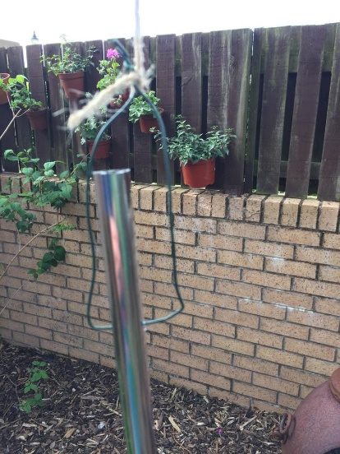
The Hang Point is the distance from the top of the tube to where you need to drill a hole to fix the tube to get the best resonance. It is important that when you fix the tubes the fixings don’t touch the bell as this will dampen the sound. I used quite stiff garden wire that I could form so that it stayed away from the tube.

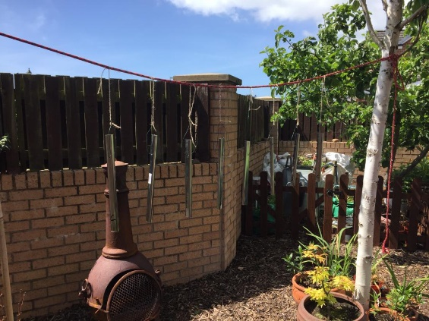
I hung mine from a rope stretched between two trees, but you could just hang them from tree branches or the back of a seat.

Lengths and Hang Points
Note | Frequency | Length mm | Hang Point mm
C6 | 1,047 | 518 | 116
D | 1,175 | 489 | 110
E | 1,319 | 462 | 104
F | 1,397 | 448 | 100
G | 1,568 | 422 | 95
A | 1,760 | 398 | 89
B | 1,976 | 376 | 84
C7 | 2,093 | 367 | 82
Total length of tube required |  | 3,480

Note | Frequency | Length mm | Hang Point mm
C7 | 2,093 | 367 | 82
D | 2,349 | 346 | 78
E | 2,637 | 325 | 73
F | 2,794 | 318 | 71
G | 3,136 | 298 | 67
A | 3,520 | 283 | 63
B | 3,951 | 267 | 60
C8 | 4,186 | 259 | 58
Total length of tube required |  | 2,462

