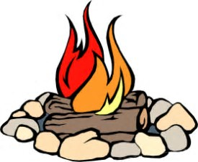

Lighting a Fire

This document is intended to be used as a guide for adults/practitioners using fires/Ghillie kettles with children.
- Everyone present, children and adults, will be given guidance on fire safety; a fire blanket and fire gloves should be close at hand.
- A rope or clearly marked area around the fires/Ghillie kettles will highlight the fire zone to everybody. (This should mean that the distance between the edge of the fire and members of the group is equivalent to the height of the tallest person in the group.)
- Only the person lighting the fire/Ghillie Kettle should be within the fire zone.
- Seated or on knees is the best position for the person lighting the fire/Ghillie Kettle.
- No one should enter the fire zone unless invited to do so by an adult.
- There should be no running around near the fire zone.
- A lit fire will not be left unattended at any point.

