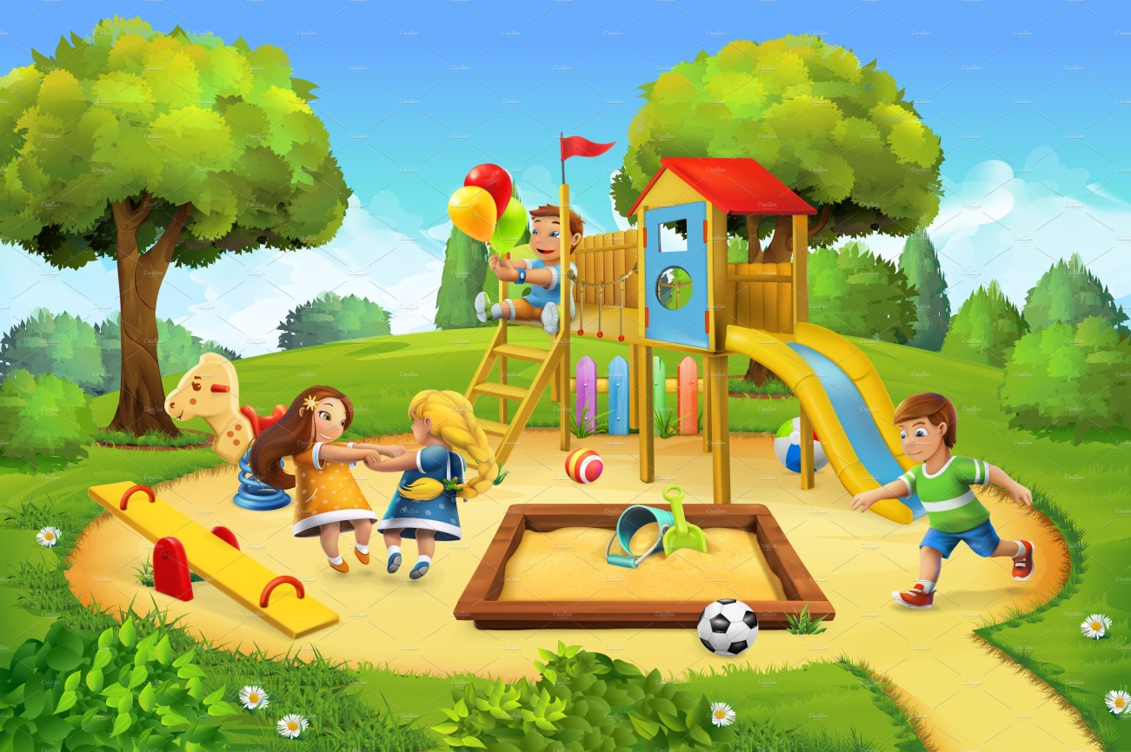**Curriculum for Excellence Class P1M and P1F**



**What are we learning this term? Term 2 2020-2021**

We hope that everyone enjoyed their October break and are ready for the new term ahead. This newsletter will give you more information about what we will be learning across the curriculum in Term 2. We thank you for your continued support.

|  |  |
| --- | --- |
| **C:\CACHE\Temporary Internet Files\Content.IE5\HUC6PVTZ\MCj04300490000[1].wmfLanguage & Literacy**  We will continue to learn new sounds as part of our Active Literacy programme. We will use our magnetic boards to blend and segment words to help us learn to read and write. The school purchased a new reading scheme last year called Big Cats. We will be reading these books in class to help us develop our skills. In writing we will write for a variety of purposes, encouraging the children to ‘have a go’ and write independently. Our writing area will provide opportunities for children to write for enjoyment. | **C:\CACHE\Temporary Internet Files\Content.IE5\A6XQHQUC\MCj04361290000[1].wmfNumeracy & Mathematics**   * We will develop our addition and subtraction skills using our own strategies and learning new ones to help us solve different calculations. * We will explore data handling and look at different ways to collect and gather information * We will continue with our Number Talks, using ten frames and dot patterns. |
| **Health & Wellbeing**  See the source image**P.E**- We hope to now be able to access the gym hall and will be  allocated two weekly slots in the hall.  **Health** – We hope the children have enjoyed being  ‘Pupil of the Day’ and bringing home their compliment slips. Everyone will now get a chance to have another go and receive a second set of compliments. We will continue our ‘PATHS’ lessons. This term we will also focus on ’Friendship’ and discuss ways to show kindness towards others. | **Contexts for Learning**  [Image result for gruffalo](https://www.bing.com/images/search?view=detailV2&ccid=%2bMrWcNcP&id=410894D950458A8873A8079E1FD3E0B607C7235B&thid=OIP.-MrWcNcPLwPZVM21ZL1uZgHaFu&mediaurl=https://i.ebayimg.com/images/i/261498007438-0-1/s-l1000.jpg&exph=773&expw=1000&q=gruffalo&simid=608011917305447798&ck=EC79FD3913890906434DF8E49933CEE6&selectedIndex=3&FORM=IRPRST)We are continuing to read and complete activities linked to Julia Donaldson stories. This term we will read, The Gruffalo, The Gruffalo in Scots, The Gruffalo’s Child and Stick Man. In December we will be taking part in lots of activities related  to Christmas. |
| **Homework**  We hope you have managed to access the blog and the home learning grid. Sound flashcards and common words will continue to be sent home. The home learning grid will change every four weeks.  P1F blog - <https://blogs.glowscotland.org.uk/ea/lainshawprimaryp1f/> P1M blog - <https://blogs.glowscotland.org.uk/ea/lainshawp1m/> |

**Additional Information**

Please can children bring in their gym shorts and shoes in a bag please. It would be helpful if the children wore a school polo shirt on those days to save changing. P1M will go to gym on a Tuesday and Friday. P1F will go on a Monday and a Friday.