

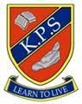

Kilmaurs Primary School

P1 and P6/P7 Buddies

**Welcome to Kilmaurs!**

2024/25



Dear Parents/Carers,

Moving from preschool to primary school is a very exciting time, but it can also be a daunting experience for many children as they can worry about change. At Kilmaurs Primary, we aim to make it as smooth a transition as possible and this begins in the preschool year.

In Kilmaurs Primary we have a P6/P7 Buddy System that is designed to help your child settle into their year as pre-schooler and beyond into primary school life, and it is our aim to do this as quickly and as happily as possible.

Every preschool child is assigned a buddy and these buddies will support your child as they move forward and into P1.

Your child’s buddy will:

* Be a good role model
* Be a welcoming and friendly face
* Help your child learn the school routines and become familiar with layout of the building and playground
* Always make sure your child has someone to play with

Our Buddies will also encourage our new P1 entrants to follow the Kilmaurs Values of: Kind, Proud and Successful; and our Buddies will support your child and help them settle into school life.

Our Buddies are very keen to support all of our new Primary 1 pupils and they will be on hand to offer ongoing help and support should your child need this.

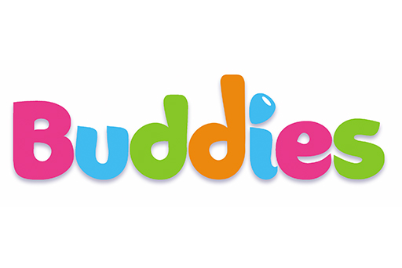

We look forward to seeing lots of super new buddying friendships develop.

With kind regards,

Miss G Crawford