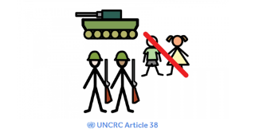  Article 38 - Poetry  There are lots of famous poems written about war and peace. Can you create your own acrostic poem using the word PEACE? | Article 14 -Religious Symbols  How many religions do pupils know? Can they brainstorm them and draw pictures of the symbols associated with various religions. | 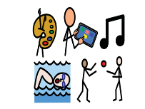  Article 31 – Play a Game/Read a Story  Play a board game with your family or read with an adult – time to relax and play.
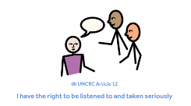  Article 12 - Popular and Unpopular Opinions  Share your popular and unpopular opinions, such as your opinions on foods and behaviours… what gives you the ick?! Talk to an adult to fins out their opinions too. Write down some of these opinions and be ready to share. | National Children’s Day and UNCRC  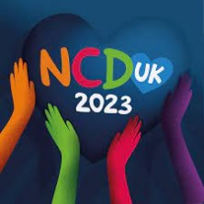 | 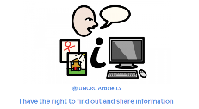  Article 13 - Keeping Safe Online  Watch this video from CBBC with top tips for staying safe online. Create a poster to share your top tips for online safety.  https://www.youtube.com/watch?v=-sbzPt-KACI
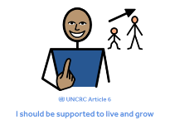  Article 6 - My Timeline  Thinking about all the skills you have learned since you were a baby, talk to your adult at home and create a personal timeline showing your key development of skills eg. crawling, walking, talking etc. | 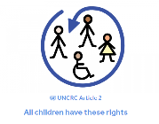  Article 2 - What is Discrimination?  Watch this video from Pop’n’Olly describing what discrimination is. Make a list identifying ways people discriminate against others.  https://www.youtube.com/watch?v=6uXgJA-VfjI | 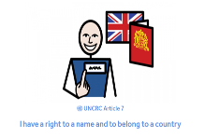  Article 7 - Research What Your Name Means  Do you know what your name means? Use the website below to find out the meaning and origin of your name. Is there a reason you were given your name? Talk to your adult at home to find out.  http://www.meaning-of-names.com/

Homework – Week Beginning 20th November
As part of our work as a RRS and in conjunction with National Children’s Day, this week’s homework will be exploring a variety of articles from UNCRC. This will provide learners with the opportunity to share their learning and for adults to work in partnership with their learner. Pupils should choose at least 3 activities to complete over the week. All homework should be returned by Friday 25th November.

