The uniform for James Hamilton Primary and Sgoil na Coille Nuaidh is the same. Each school has their own unique badge that can be worn on the uniform.

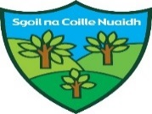
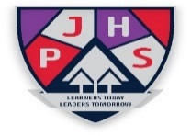

Clothing items such as sweatshirts, cardigans & polo shirts can be bought with both logos embroidered on them from local suppliers in Kilmarnock.

The school uniform is:
- white shirt or white polo shirt
- navy jumper or cardigan
- school tie
- grey trousers
- grey skirt

It is expected that all children attending our school will adhere to this dress code.

PE Kit

The P.E kit is:
- white polo shirt
- navy jumper or cardigan
- black/ navy joggers, leggings or shorts
- gym shoes

Children should come dressed in their gym clothes on gym days at this time.

It is important that pupils come prepared to learn and for PE this requires appropriate clothing. All jewellery should be removed. Pupils who are not participating in PE must have a note or a medical certificate. Pupils who are unable to participate in practical PE should still bring their kit to allow them to assist in the lesson by refereeing, keeping scores or assisting with the distribution of equipment. This ensures that they are still able to take part in some way in the work of the class and do not miss out on the knowledge and understanding of the course.

There are forms of dress that are unacceptable in school, such as items of clothing which:

- Potentially encourage factions (such as football colours)
- Could cause offence (such as anti-religious symbolism or political slogans)
- Could cause health and safety difficulties (such as loose fitting clothing, jewellery)
- Could cause damage to flooring
- Carry advertising particularly for alcohol or tobacco
- Could be used to inflict damage on other pupils

