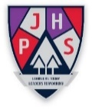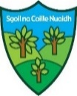

**James Hamilton Primary School and Sgoil na Coille Nuaidh**

Telephone: 01563 558508

*Head Teacher: Lorraine Dougan*

Term 3 Newsletter: January 2022

*Dear Parents and Carers,*

*Here we are at the start of Term 3. It continues to be a very busy and exciting term ahead with many learning experiences and opportunities planned. The children have settled well and I have enjoyed their warmth of welcome to the school.*

*Please ensure you look closely at this newsletter to identify key events and dates that may affect your child, as well as checking the school app and blog regularly.*

*If you have any issues you wish to discuss with your child’s Class Teacher or the Senior Leadership Team please contact the school office.*

*Thank you for your on-going support.*

*Lorraine Dougan*

*(Head Teacher)*

Follow us on twitter: @JHP_SnCN_SanCN

https://blogs.glowscotland.org.uk/ea/jameshamiltonprimaryschool/

**Reporting your child’s absence**

***You have a legal requirement to ensure your child is attending school on a regular basis. Attendance under 90% disrupts children’s learning. If your child is absent you have a parental responsibility to inform the school by 9.15am via the***

***School Phone Line on 01563 558508***

*If your child is going to be absent please call the school. If you have not made contact, the school will try to contact you via telephone/text.*

*If a child is persistently absent or late this matter will be investigated and appropriate action taken to support your child to attend school every day*

**Remember school begins at 8.50am/9.00am**

**Support your child to be on time. Late-coming disrupts learning.**

**Appointments**

If your child is required to attend an appointment during school time please provide the school office with a proof of appointment such as a letter, appointment card or hospital letter.

**School Communication**

If you need to contact the school these are the following methods available:

School phone line (answering service for absence and messages available) - 01563 558505

Ms Dougan (Head Teacher)– [***lorraine.dougan@eastayrshire.org.uk***](mailto:lorraine.dougan@eastayrshire.org.uk)

Mrs Abercrombie (Depute Head Teacher) -[***lynsey.abercrombie@eastayrshire.org.uk***](mailto:lynsey.abercrombie@eastayrshire.org.uk)

Mrs Stewart (Depute Head Teacher) -[***lesley.stewart@eastayrshire.org.uk***](mailto:lesley.stewart@eastayrshire.org.uk)

You will find lots of information about what is happening in the life of our school on the James Hamilton Primary School & Sgoil na Coille Nuaidh GLOW blog, the web address is:

*https://blogs.glowscotland.org.uk/ea/jameshamiltonprimaryschool/*

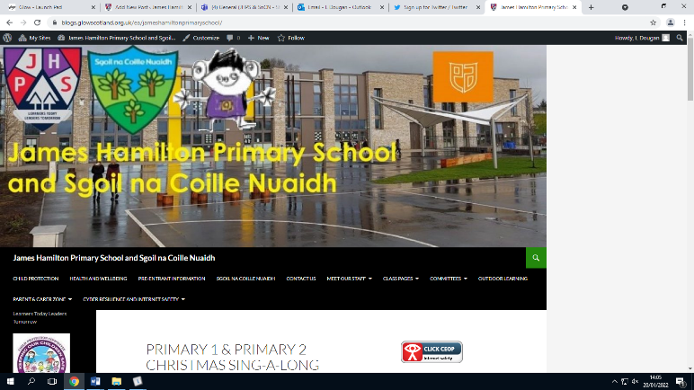

Each class has their own section on the blog under the ‘Class Pages’ menu. For each class, you will find a ‘News and Updates’ page, a ‘Celebrating Success’ page with information about the Pupil of the Week, Termly Outlines to give an overview of what the class will be learning about and Photo Galleries showing some of the learning taking place in the classroom.

Our blog also has a ‘Parent and Carer Zone’. From this menu, you can:

· visit the Parent Council section

· read the School Improvement Plan

· read school newsletters

· check the dates of school holidays

· visit the ‘Homework’ section

You can also find the contact information for the school on the blog as well as a staff list and some information about the committees we have within the school including Dyslexia Friendly Schools and Rights Respecting Schools. We hope you find the blog informative and useful.

**Covid Update**

We are continuing to follow the most up-to-date guidance from public health.

***NHS Ayrshire and Arran Public Health advises:***

***If your child has a fever, cough or loss of taste or smell, or are showing milder symptoms such as a sore throat, headache, upset stomach or cold like symptoms, they should please stay off school/ECC and book a PCR test.***

***If your child has any possible symptoms of Coronavirus, they should not use LFD testing and instead you should book a PCR. Anyone with symptoms, however mild, should not rely on a negative LFT result.***

As you will be aware, if your child now has a positive LFT result they no longer need a PCR to confirm this and the LFT result must be uploaded to the website as soon as possible to register the case with health. We will ask you to confirm that this has been done. You will receive a text/email from Test and Protect asking you to complete an online form. It is really important that this is completed to identify close contacts and to determine dates for the isolation period. You should then follow the advice from health on self-isolation and testing for your child and for any household members. If you need to apply for the Self-Isolation Support Grant then you will need a positive PCR result, even if you already have a positive LFT result.

**Healthy Snacks and Lunch**

Please ensure your child has a healthy snack and lunch. Encourage your child to make healthy choices for snacks. Remember **no fizzy** drinks please!

Children are also encouraged to drink water (plain) in the classroom to keep hydrated and refreshed. Juice is not allowed in the classroom.

Nuts are not permitted in school as we have some children who have severe allergies to nuts. Your support and understanding in this matter is greatly appreciated.

**Car Parking**

At pick up and drop off times please make sure you park safely in a designated parking space that you are entitled to use. These times can be very busy around the campus so we ask for your cooperation to keep everyone safe. This will be monitored at times by our Campus Police Officer.

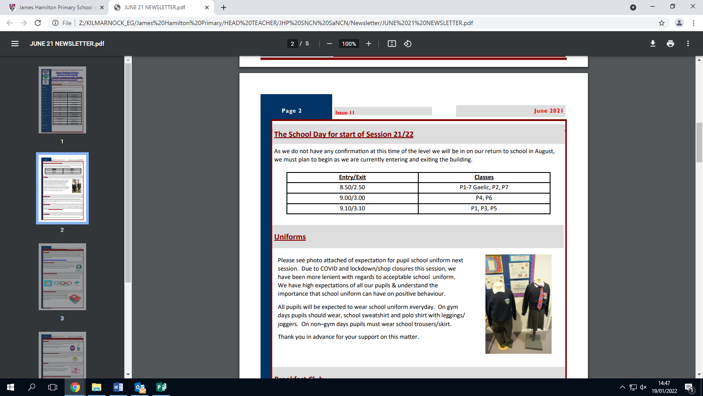 **School Uniform**

Please see photo attached of our school uniform. We have high expectations of all our children and young people and understand the importance that school uniform can have on positive behaviour. All pupils will be expected to wear school uniform every day. On gym days pupils should wear, school sweatshirt and polo shirt with leggings/ joggers. On non–gym days pupils must wear school trousers/skirt. Thank you in advance for your support on this matter.

**P.E Kit and Jewellery**

**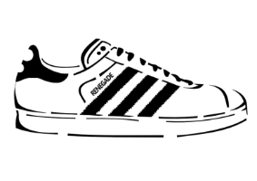***Your child should come to school dressed for P.E on P.E. days.* ***No jewellery is allowed*** *to be worn in P.E for the health and safety of all children. Please ensure it is removed on gym days. Children will be unable to participate in P.E if wearing jewellery*.

**Forgotten P.E. Kit**

Where a child has forgotten their kit they will be provided with school shorts. Parents/carers will be alerted by text that their child has forgotten their kit.

**Lost Property**

We regularly have children losing many items of their clothing. Please ensure all clothing has your child’s name clearly marked on it. You can contact the office if you need to locate a lost item.

**Personal/ Expensive Items**

Valuable items and toys should not be brought to school. Children who bring a bike/ scooter to school should bring a bike lock. Personal items are not covered by our insurance and we are not responsible if anything happens to them.

**Advice on Head Lice**

In the past schools used to send out advice and information to parents about the detection and treatment of head lice. Alert letters are no longer sent out.

A very useful leaflet is available on line at: <http://www.healthscotland.com/documents/25.aspx>

Further advice can be given by staff in your local chemist

We would like to remind all parents and carers that Head Lice cannot be prevented but that regular checking ensures early detection and treatment. If you need further support or advice please contact the school who can refer you to the school nurse for extra advice.

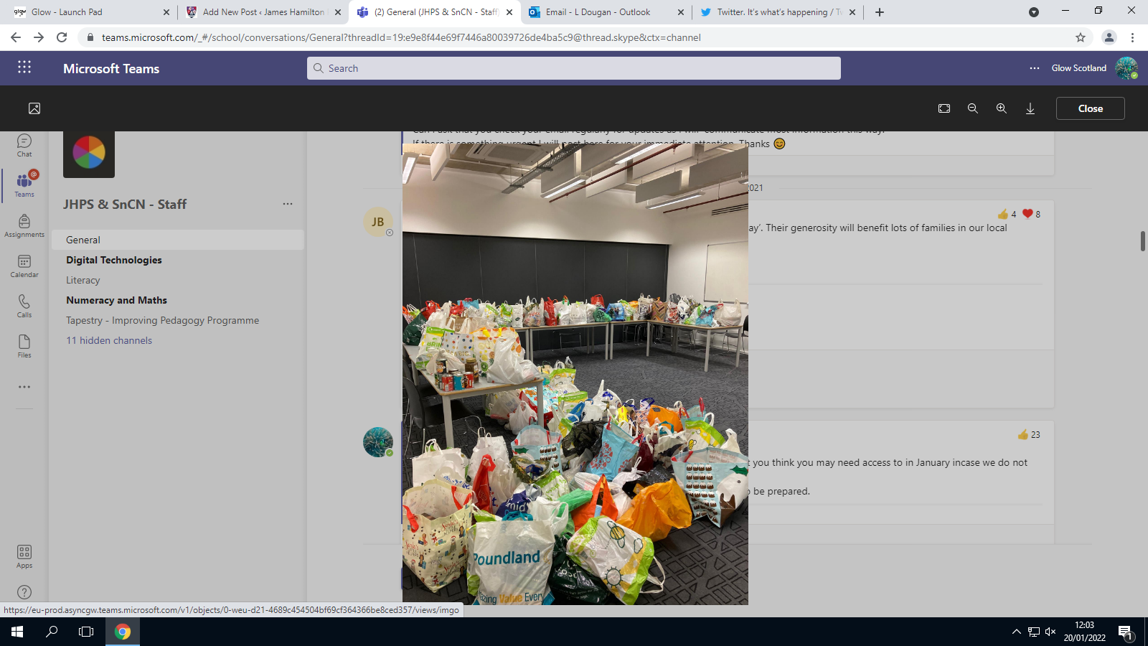**Good News Story and ‘Thanks’**

A huge thanks to all our families who donated to our ‘Festive Friday’ foodbank collection. This photograph captures how generous your donations were.

It was greatly received by the foodbank team based in St Matthews who ensure it went to those who needed it most in our local community.

**PUT ME SOMEWHERE ‘HANDY’ to keep an eye on up-coming events. *Please note additional dates and activities will be added throughout the term for individual classes. You will receive regular updates via the school app and school blog***

***PLEASE CHECK THE SCHOOL APP and BLOG REGULARLY***

**Feb**

Friday 11th February

* *School closed- HOLIDAY*

Monday 14th February

* *School closed- HOLIDAY*

Tuesday 15th February

* *Staff In-service Day- HOLIDAY for children only*

**April**

* Friday 1st April- School closes 2.50pm/ 3.00pm today for Spring Break

**SCHOOL CLOSED Monday 4th April- Monday 18th April inclusive**

**School re-opens on Tuesday 19th April**