Child Protection Coordinator


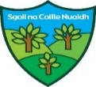


FOR ALL STAFF, PARENTS & CARERS in our School Community

If you have concerns about a child or young person’s welfare or direct evidence or suspicion of a child being at risk then the only way you can protect the child or young person is to report the matter. Whether you are a permanent member of staff, a supply teacher, a visiting specialist, visitor, parent, carer or member of our community you should intimate your concerns to the Head of Establishment or, in their absence, the most senior member of staff.

Parents/Carers and members of the community can also contact Social Work Children and Families directly on 01563 554200

If you have any concerns about child protection
please report them to:

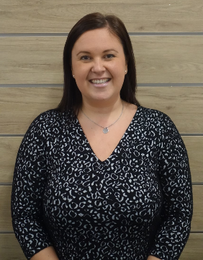
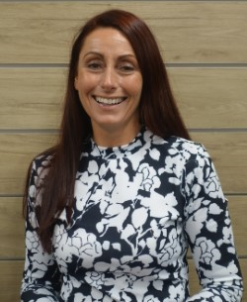
Ms Lorraine Dougan
Head Teacher

Mrs Lynsey Abercrombie
Depute Head Teacher

