Oxford Owl Access Information
JHPS and Sgoil Na Coille Nuaidh
- Visit the site at www.oxfordowl.co.uk
- Click ‘my class login’ from the toolbar
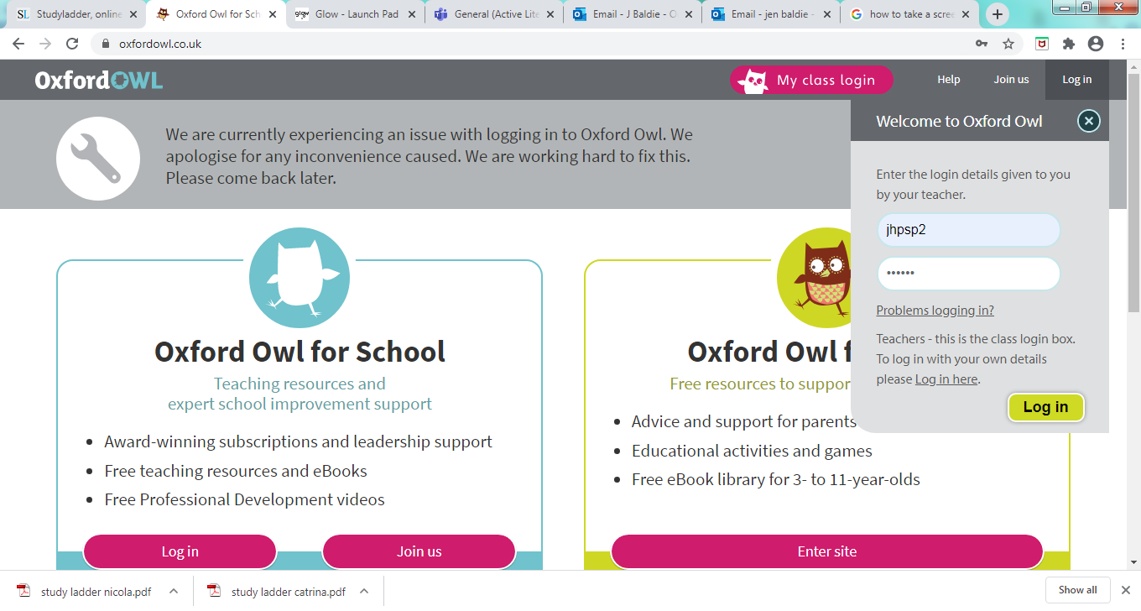
Class | username | password
Primary 1 | jhpsp1 | jamham
Primary 2 | jhpsp2 | jamham
Primary 3 | jhpsp3 | jamham
Primary 4 | jhpsp4 | jamham
Primary 5 | jhpsp5 | jamham

- To view the books, click on my bookshelf
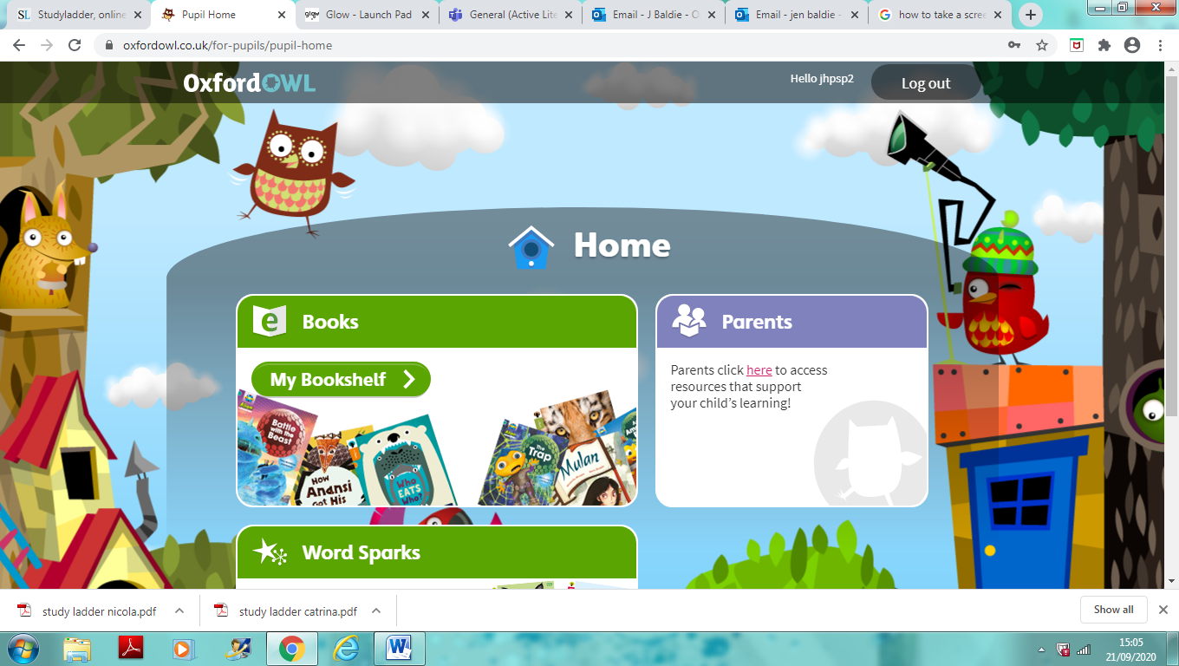

- The children can then search for the correct title in the search box
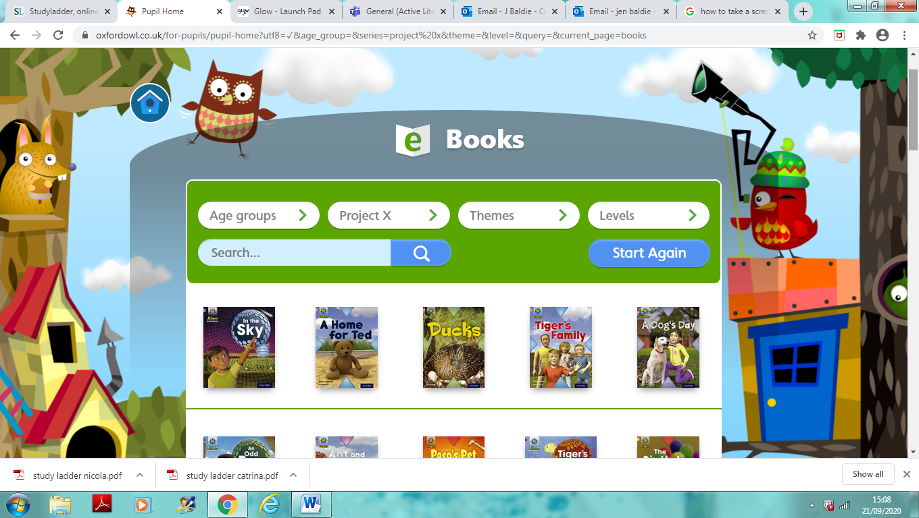

- When the children open up a specific book there are often short activities to complete. Children can use the audio function if they wish to listen to the book being read through before reading it on their own or with an adult.
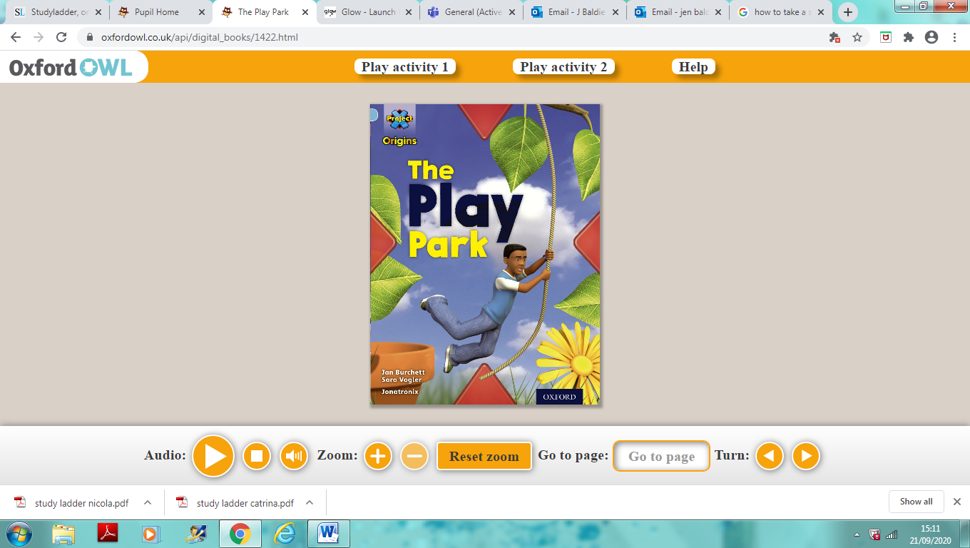

We hope you find this a useful resource to use at home until such time as we are able to send reading books home with our children. All the children have been shown how to use this in school so hopefully it will be straightforward to access. Please let the school office know if you are experiencing any issues.

Many thanks for your continued support.

