
James Hamilton Early Childhood Centre
William McIlvanney Campus
Sutherland Drive
Kilmarnock
KA3 7DF
Telephone No: | 01563 558508
Email: | julie.clelland@eastayrshire.org.uk
Centre Blog: | https://blogs.glowscotland.org.uk/ea/jameshamiltoneccmain2019/
Twitter: | @JamesHamiltECC
Centre App: | James Hamilton ECC
Denominational Status (if any): | Non-Denominational
Centre Roll: | Current Role: 108
Further Information: | www.east-ayrshire.gov.uk/schoolhandbooks

Dear Parents/Carers,
Welcome to James Hamilton Early Childhood Centre where staff look forward to working with you in collaboration with East Ayrshire Council. Our staff team consist of highly skilled and motivated individuals who strive to provide high quality care and education for children aged 2 to 5 years across the centre. Staff use a nurturing and caring approach when working with children and families. We value each child as an individual and support them in developing their confidence as well as building on their strengths.

Partnership working is highly important to us. We work effectively to communicate and build trusting and respectful relationships with all service users. We aim to provide an excellent service and welcome feedback to support us in achieving this.

If you require further information regarding the details enclosed or have any concerns please to do not hesitate to contact me. I will be happy to assist you.

Yours sincerely,

Julie Clelland
Head of Centre
Vision and Values

Vision

At James Hamilton Early Childhood Centre we are passionate in providing a safe, nurturing and inclusive environment. We strive to deliver high quality provision which supports the wellbeing and independence of all.

Values

Cares
Approachable
Respectful
Enthusiastic
Supportive

AIM

We aim to provide an inclusive, nurturing and engaging environment which allows everyone to reach their full potential. We also aim to build positive and trusting relationships which will enable us to work collaboratively with all stakeholders and provide the best possible outcomes for children and families within our care.

Name | Role
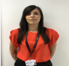  Julie Clelland | Head of Centre
  Alison McMahon | Depute Manager
Lynn Kerr   | Equity and Excellence Lead
Louise Clark   | Senior ELCP
  Natalie Dinning | Senior ELCP
Lisa Paxton   | Acting Senior ELCP
Leonna King   | Acting Senior ELCP
Taylor Miller   | Acting Senior ELCP
  Tracy Murray | ELCP
Lauren Russell   | ELCP
  Louise Murphy  # | ELCP
Amy Whitelaw   | ELCP
Ashley Smith   | ELCP
Gail Reid   | ELCP
  Lindsey Riggins | ELCP
  Christine McPherson | ELCP
  Gemma Rennie | ELCP
Lauren Heggarty   | ELCP
Nichola Ford   | ELCP
Heather Innes   | Support Assistant

Centre Overview

James Hamilton Early Childhood Centre opened in April 2018. The current roll of the centre is 108. We have excellent facilities which enables us to provide care and education for children aged 2 to 5 years. To accommodate the different age groups we have two playrooms.
Caterpillar Room: 2-3 years
Rainbow Room: 3-5 years
Please see below for session times.
Caterpillar Room (2-3’s)
AM PM
8.00am – 12.45pm 1.15pm – 6.00pm
Rainbow Room (3-5’s)
8.00am – 6.00pm
8.00am – 12.45pm
9.00am – 3.00pm
1.15pm – 6.00pm

Within our 3-5 playroom we offer 1140 hours of Early Learning and Childcare. Parents/carers are able to choose from the following models.
Model 1: 1140 hours across 38 weeks (term time – for example 9.00am to 3.00pm)
Model 2: 1140 hours – the block model: a block is 4 hours 45 minutes
Model 3: 1140 hours the blended model or split placement (combination of ECC or funded provider with a participating childminder)

Attendance/Reporting an Absence
Please inform the establishment on 01563 558508 if your child is not attending for any reason. A member of staff will call if we do not know the reason for the absence. This process ensures the safety of all children while keeping a record of their attendance.
It is important that you make a member of staff aware if someone different is collecting your child either by telling them when dropping your child off or by calling the centre. If we have not been informed of this then a member of staff will call you to gain permission.
The school SEEMIS messaging system holds one main contact and will send attendance notifications to the main contact only. It is not possible to generate the automated message necessary to inform all parents/carers. However, should a parent/carer have a significant concern that the main contact is not sharing key information regarding attendance, they should contact the centre to discuss possible alternative solutions.

Concerns/Complaints
Should you wish to raise a concern or make a complaint about any aspect of provision you should contact the Head of Centre in the first instance. Our aim is to resolve as many complaints as possible at the first point of contact. You have the right to contact the Care Inspectorate with any complaint which you may have.

Dress Code
You are able to purchase James Hamilton Early Childhood Centre polo shirts and jumpers from the following establishments:
Ayrshire Schoolwear Walker and Templeton
7-9 Princes Street 14 Strand Street
Kilmarnock Kilmarnock
KA1 3DD (01563 550200) KA1 1HU (01563 521345)

Transitions
You and your child will be invited along to the centre for an induction visit where a member of the Senior Leadership Team will assist you in completing relevant paperwork, explain procedures and answer any queries which you may have. Your child will be provided the opportunity to explore the playroom and meet their key worker during this visit. We will support your child in feeling confident and secure within the centre and adapt transitions to suit their individual needs.

Your child’s key worker will contact you within 28 days of their start date to complete their Personal Plan. This will enable us to ensure your child’s individual needs are being met and the appropriate supports are in place.

We work in partnership with James Hamilton Primary School to provide an enhanced transition to children who will be attending there. We also work closely with all other feeder schools and ensure all relevant information is shared.

Effective Partnerships
Parents and carers are given the opportunity to be involved in the life of the centre through attending stay and play sessions, personal plan meetings, progress meetings, PEEP sessions and special events such as fundraisers and concerts.

Parents/carers are also encouraged to take an active role in their child’s learning through contributing to their learning journals as well as home link activities. Parents/carers are also encouraged to share views and opinions through completing questionnaires and posting comments in our suggestion box, which is located within the main corridor of the centre. Effective communication between parents/carers allow information to be shared successfully and ensures the needs of the children are being met. Staff are available to offer advice and support at any time and are happy to discuss your child’s progress or any concerns, which you may have.

Staff will seek advice from other professionals if required and provide you with additional information to ensure the appropriate support is in place and the best possible outcomes are being achieved.

The centre has established a ‘Friends of James Hamilton Early Childhood Centre Parents Group’, the purpose of this group is for parents/carers to arrange fundraising events to raise vital funds for the centre. Meetings are held on termly and there are staff representatives from the Caterpillar and Rainbow Room
Additional Support Needs
James Hamilton Early Childhood Centre provides an inclusive learning environment, which ensures every child is included and supported. The Additional Support Needs Coordinators for the establishment are Julie Clelland (Head of Centre) and Lynn Kerr (Equity and Excellence Lead).
We value and respect the views and opinions of parents and carers and promote partnership working to ensure each child’s individual needs are supported and met. Through consultation, we ensure parents and carers are included in creating personal and individual learning plans which support the children’s development and learning.

“To access support we need to ensure that we work with parents from the very start, and make every effort to try to understand their hopes, and concerns.”
Realising the Ambition (2020)

We work in collaboration with other professionals such as Health Visitor, Educational Psychologist, Speech and Language Therapist, Occupational Health Therapist, Dietician, Visual Impairment Team, Teacher of the Deaf and Home Visiting Teacher to enable us to seek advice and fully support the children within our care. Parental consent is always requested.

Team with the Family meetings may be held for children who require additional support. Such meetings allow all professionals involved with the child to discuss their progress and ensure the appropriate measures and supports are in place to enable them to meet their potential. Action Plans and Individual Learning Plans are then created and implemented to support the child’s development. Review meetings take place every 3 months. Parents and carers are fully involved and supported within this process.

Playrooms
Both our playrooms provide a welcoming and nurturing learning environment. The Caterpillar Room provides provision for up to 10 children and our Rainbow Room can accommodate up to 72 children. Each playroom provides the children with the opportunity to explore a range of learning experiences which takes into account their individual needs and interests.
Please see below for further details of each playroom.
Caterpillar Room (2-3’s)
The children within the caterpillar room are provided a range of stimulating learning experiences each day which enables them to explore, investigate, problem solve as well as develop their independence skills.

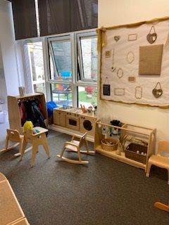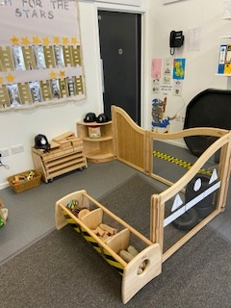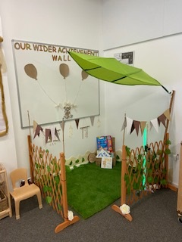
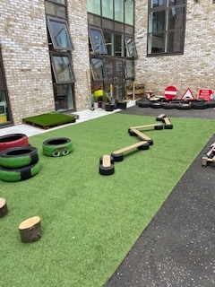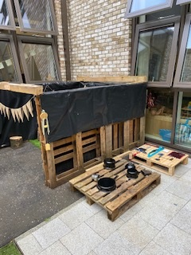

Rainbow Room (3-5’s)
The rainbow room consists of the following areas Literacy, Numeracy, Art and Science, Imaginative, Construction, Cosy Corners and Outdoors. The children will be provided with a range of learning experiences which supports their development as well as taking into account their interests. The children are also encouraged to lead their own learning which is documented within floor books.
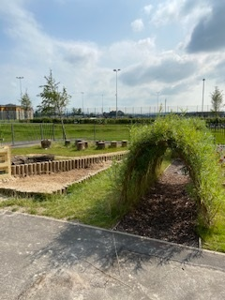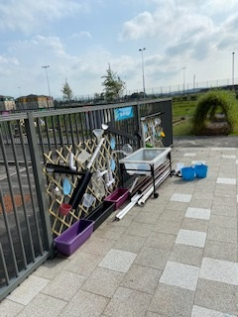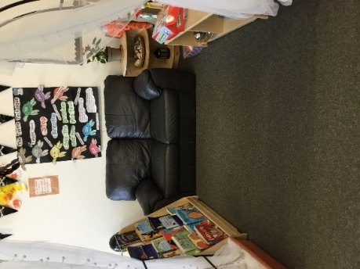
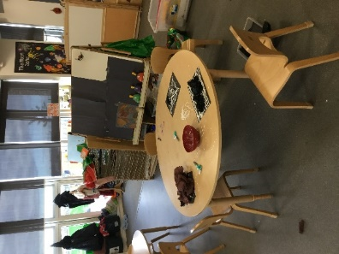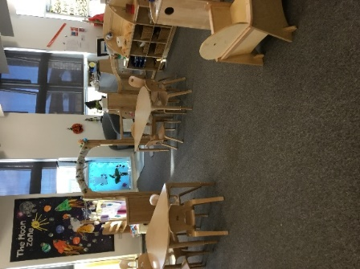

Curriculum

Playroom Planning
The implementation of EAC Being Me (2-3’s), Realising the Ambition (2-3’s/3-5’s) and a Curriculum for Excellence (3-5’s) within the playrooms assist staff in providing a range of learning opportunities which supports their stage of development. Staff encourage the children to lead their own learning and plan learning experiences which reflects their interests. Learning within each playroom is documented in floor books. The children are encouraged and supported to contribute to the floor books through mark making and scribing. The children’s learning is also documented via learning journals. The children within the caterpillar room receive weekly stories as well as a monthly narrative. The children within the rainbow room receive weekly observations. All learning journals are published on a Monday by a member of the Senior Leadership Team.

Tracking Learning
Through observations key workers track the children’s development and put in place strategies to further support and enhance their learning. Each child has their own learning journal and special book which consists of photographs, observations and pieces of work. Such documentation highlights the children’s individual learning targets and shows progression. The children are also provided with the opportunity to express their views and opinions of their learning using visual aids.
Within the Caterpillar Room key workers use EAC Being Me to track the children’s development. Key workers within the Rainbow Room use EAC Early Level Monitoring and Tracking tool. Staff use the evidence gathered from tracking documents to plan next steps which reflect the children’s stage of development.

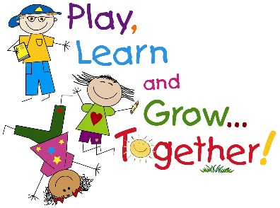
Communication
To support us in communicating effectively with others we use a range of digital platforms. This enables us to share important information as well as keep you updated on learning which is happening within the centre.
Please see below for further details.

Safer School Scotland App
This allows us to send out messages and links to information important to our centre. Download the app via the Apple / Android store then add James Hamilton ECC. Please ask a member of staff for the pin required to access information.


Twitter
This allows us to share our successes and achievements.
Follow us @JamesHamiltECC


GLOW
We also use our GLOW site which allows us to share newsletters, photos and achievements by posting links to GLOW on our Twitter and School app.
GLOW link to information - https://glowconnect.org.uk/about-glow/glow-for-parents/

Learning Journals
We also communicate important information via your child’s individual learning journals.

Achievements 2024/2025
- Staff and children developed their awareness of The UN Convention on the Rights of the Child and how these support individuals to reach their full potential
- Rights Respecting Leadership Group created.
- Introducing Children’s Rights training delivered to all staff.
- Staff and children have developed their confidence when using digital technologies and have used skills gained to further support their learning and teaching.
- Digital leaders within the centre provided training and How to Guides throughout the year which took into consideration staff development needs as well as how to further develop their knowledge and skill when using digital technologies.
- Monitoring of learning journals, tracking, transition reports and floor books demonstrated almost all staff have used skills gained to document the children’s learning to a high standard as it was completed to a high standard with minimum areas for development required.
- Each month a digital technology focus was included within planning. This ensured the children were provided with a range of learning experiences which supported them in exploring digital technologies as well as develop their confidence.
- Evidence documented within monthly evaluations, tracking, floor books and individual learning journals demonstrated that some children were making progress in meeting developmental milestones which related to digital technologies.
- Children and staff were supported to develop an awareness of their emotional wellbeing and strategies which they could use to help regulate their emotions.
- All staff were provided training by Claire Ferguson (Education Psychologist), Lynn Kerr (Equity & Excellence Lead) and Lynnette Milligan (Community Practitioner) which focused on managing children’s behaviour and de-escalation strategies.
- The Leuven Scale of Wellbeing and Involvement was used as a measure during playroom observations with data gathered highlighting almost all children’s wellbeing and involvement score to be 4 or above.
- Staff worked in collaboration with Christine Barr (SALT), Louise Phillips (Teacher of the Deaf) and Eliza McDowall (Advanced SALT) to further develop their knowledge and understanding of communication and language difficulties which affect some children within the centre.
- Children’s progress was evident as almost all children achieved targets set when reviewed within a 12-week period.

James Hamilton Early Childhood Centre
Improvement Plan

Please see below for our 4 main improvement priorities for academic year 2025/2026.
Priority 2
Staff and children to develop their confidence when using digital technologies and use new skills gained to further support learning and teaching.

- Digital leaders to support staff in developing IT skills.
- Staff to participate in training to further enhance IT skills.
- New resources relating to technology to be purchased.
- Staff to use knowledge and skills gained to complete relevant documentation for children.
- Children to be provided the opportunity to develop their IT skills by participating in a range of learning experiences relating to digital technology.
- Children’s learning to be documented via learning journals, floor books and tracking.

Priority 1
Staff, children and parents to develop their awareness of The UN Convention on the Rights of the Child.

- Group of 6 children to create Rights Respecting Champion Group where they will take on an active role.
- Questionnaire relating to The UN Convention on the Rights of the Child to be created and completed by parents/carers.
- Parents/carers to have access to an information station during stay and play sessions which relates to The UN Convention on the Rights of the Child.
- Monthly article relating to The UN Convention on the Rights of the Child to be published and children to participate in learning experiences.
- Home link relating to The UN Convention on the Rights of the Child to be issued each month.
- Staff, children, parents and carers to participate in an end of year quiz relating to The UN Convention on the Rights of the Child.

Priority 4
Data from learning journals to be used to inform planning as well as to create targeted groups which further support and challenge the children’s learning.
- Children’s development to be tracked via observations and monthly narratives as well as key worker knowledge.
- Children to participate in weekly targeted group work which supports or extends their learning.
- All children with additional support needs to be provided daily targeted support.
- Key workers and management to review data and agree next steps to ensure children are being supported to achieve targets.
- Children’s individual next steps to be included within monthly planning for both playrooms.
Priority 3
To embed strategies used to support children’s emotional wellbeing ensuring a safe and nurturing environment for all.
- Consistent approach to managing children’s behaviour to be implemented.
- Zones of Regulation to be implemented and children to be encouraged to choose a strategy to support them in regulating their emotions.
- Termly staff wellbeing check in’s to be carried out.
- Staff and children’s wellbeing to be measured.
- PEEP sessions relating to supporting children’s emotional wellbeing to be provided to parents/carers.
- Staff to participate in training which further develops their knowledge of how to manage children’s behaviour and support their emotional wellbeing.
- Monthly audit of accidents and incidents.

