Beach Party Theme Day

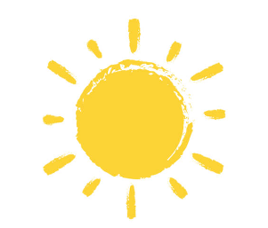   

   

   

   

   

   

   

   

   

   

16th June 2023



**Pirates pizza**

**Sausage submarine**

**Shark bites**

**Treasure chest chips**

**Sea shore salad**

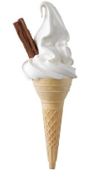**Barnacle biscuits / ice lollies**

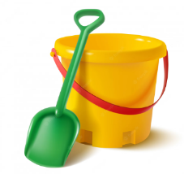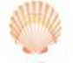

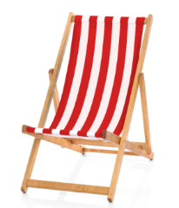

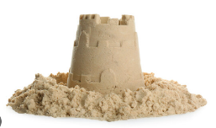

   

   

   

   

   

   

   

*Pirates pizza = peperoni pizza Sausage submarine = hot dog*

*Shark bites = fish goujons*

*Treasure chest chips = chips Sea shore salad = mixed salad*

*Barnacle biscuits = Cookies Ice lollies = fruit ice lollies*

**Fun facts – In Scotland you can find over 800 islands and some of the UKs most beautiful beaches where you can often spot seals and dolphins.**