

**James Hamilton Early Childhood Centre**

**William McIlvanney Campus**

**Sutherland Drive**

**Kilmarnock**

**KA3 7DF**

|  |  |
| --- | --- |
| **Telephone No:** | 01563 558508 |
| **Email:** | [julie.clelland@east-ayrshire.gov.uk](mailto:julie.clelland@east-ayrshire.gov.uk) |
| **Centre Blog:** |  |
| **Twitter:** | @JamesHamiltECC |
| **Centre App:** | James Hamilton ECC |
| **Denominational Status (if any):** | Non-Denominational |
| **Centre Roll:** | Current Role 116 |
| **Further Information:** | [www.east-ayrshire.gov.uk/schoolhandbooks](http://www.east-ayrshire.gov.uk/schoolhandbooks) |

Dear Parents/Carers,

Welcome to James Hamilton Early Childhood Centre where staff look forward to working with you in collaboration with East Ayrshire Council. Our staff team consist of highly skilled and motivated individuals who strive to provide high quality care and education across the centre. Staff use a nurturing and caring approach when working with children and families. We value each child as an individual and support them in developing their confidence as well as building on their strengths.

Partnership working is highly important to us. We work effectively to communicate and build trusting and respectful relationships with all service users. We aim to provide an excellent service and welcome feedback to support us in achieving this.

If you require further information regarding the details enclosed or have any concerns please to do not hesitate to contact me. I will be happy to assist you.

Yours sincerely,

Julie Clelland

Head of Centre

Vision and Values

In collaboration with stakeholders the following vision and values were created during academic year 2019/2020.

**Vision**

At James Hamilton Early Childhood Centre we are committed to providing a quality service which is flexible and inclusive to all. We strive to provide a nurturing environment which enables individuals to achieve and reach their full potential.

**Values**

**S** Supportive

**T** Trustworthy

**A** Achieving

**R** Respected

**S** Stimulating

|  |  |
| --- | --- |
| **Name** | **Role** |
| Julie Clelland | Head of Centre |
| Alison McMahon | Depute Manager |
| Lynn Kerr | Equity and Excellence Lead |
| Louise Clark | Senior ELCP |
| Natalie Dinning | Senior ELCP |
| Krysty Handy | ELCP |
| Rebecca Fanning | ELCP |
| Tracy Murray | ELCP |
| Anne Dempster | ELCP |
| Leonna King | ELCP |
| Lauren Russell | ELCP |
| Aimee Anderson | ELCP |
| Louise Murphy  # | ELCP |
| Taylor Knox | ELCP |
| Amy Whitelaw | ELCP |
| Tracey Callaghan | ELCP |
| Ashley Smith | ELCP |
| Gail Reid | ELCP |
| Lindsey McKinnon | ELCP |
| Christine Basnett | ELCP |
| Gemma Richmond | ELCP |
| Lauren Heggarty | ELCP |
| Nancy Anderson | ELCP |
| Angela Watson | ELCP |
| Danielle Stephenson | ELCP |
| Alistair Mack | Graduate Apprentice |

**Centre Overview**

James Hamilton Early Childhood Centre opened in April 2018. The current roll of the centre is 120. We have excellent facilitates which enables us to provide care and education for children aged 2 to 5 years. To accommodate the different age groups we have two playrooms.

**Caterpillar Room**: 2-3 years

**Rainbow Room**: 3-5 years

To enable us to follow Scottish Government guidelines in regards to COVID-19 we are currently implementing staggered drop off and pick up times within the centre. This allows us to follow social distancing guidelines. Our allocated drop off and pick up areas are the garden and foyer. Parents/carers are provided there preferred times during enrolement.

Please see below for session times.

**Caterpillar Room (2-3’s)**

**AM PM**

8.50am – 12.00pm 12.40pm – 3.50pm

**Rainbow Room (3-5’s)**

8.00am – 6.00pm

8.00am – 12.45pm

9.00am – 3.00pm

1.15pm – 6.00pm

Within our 3-5 playroom we offer 1140 hours of Early Learning and Childcare. Parents/carers are able to choose from the following models.

**Model 1:** 1140 hours across 38 weeks (term time – for example 9.00am to 3.00pm)

**Model 2:** 1140 hours – the block model: a block is 4 hours 45 minutes

**Model 3:** 1140 hours the blended model or split placement (combination of ECC or funded provider with a participating childminder)

**Attendance/Timekeeping**

Due to parents/carers being unable to currently enter the centre your child’s keyworker will record your child’s attendance on their group’s register.

It is important that you make a member of staff aware if someone different is collecting your child either by telling them when dropping your child off or by calling the centre. If we have not been informed of this then a member of staff will call you to gain permission.

**Reporting an Absence**

Please inform the establishment on 01563 558508 if your child is not attending for any reason. A member of staff will call if we do not know the reason for the absence. This process ensures the safety of all children while keeping a record of their attendance.

**Concerns/Complaints**

Should you wish to raise a concern or make a complaint about any aspect of provision you should contact the Head of Centre in the first instance. Our aim is to resolve as many complaints as possible at the first point of contact. You have the right to contact the Care Inspectorate with any complaint which you may have.

**Dress Code**

You are able to purchase James Hamilton Early Childhood Centre polo shirts and jumpers from the following establishments:

Ayrshire Schoolwear Walker and Templeton

7-9 Princes Street 14 Strand Street

Kilmarnock Kilmarnock

KA1 3DD (01563 550200) KA1 1HU (01563 521345)

**Transitions**

Due to COVID-19 restrictions our transition process has been altered to allow us to adhere to Scottish Government guidelines as parents/carers are not currently permitted within the centre.

You and your child will be invited along to the centre for an induction visit where a member of the Senior Leadership Team will assist you in completing relevant paperwork, explain procedures and answer any queries which you may have. Your child will be provided the opportunity to explore the playroom and meet their key worker during this visit. To enable your child’s key worker to develop an understanding of their individual needs and interests you will be provided with an “All About Me” worksheet to complete. We will support your child in feeling confident and secure within the centre and adapt transitions to suit their individual needs.

**Effective Partnerships**

Parents and carers are given the opportunity to be involved in the life of the centre through attending stay and play sessions, care plan meetings, termly progress meetings, team around the child meetings as well as weekly workshops.

Parents/carers are also encouraged to take an active role in their child’s learning at home through home link activities this includes the Big Bedtime Read Initiative as well as activities relating to the children’s personal targets.

**Workshops currently offered are:**

* Cooks r Us
* Importance of Play
* Coffee and Chat

Parents/carers are encouraged to share views and opinions through completing questionnaires and posting comments in our suggestion box, which is located within the main corridor of the centre. Effective communication between parents/carers allow information to be shared successfully and ensures the needs of the children are being met. Staff are available to offer advice and support at any time and are happy to discuss your child’s progress or any concerns, which you may have.

Staff will seek advice from other professionals if required and provide you with additional information to ensure the appropriate support is in place and the best possible outcomes are being achieved.

The centre has established a ‘Friends of James Hamilton Early Childhood Centre Parents Group’, the purpose of this group is for parents/carers to arrange fund-raising events to raise vital funds for the centre. Meetings are held on a 6 weekly basis and there are staff representatives from the Caterpillar and Rainbow Room.

**Due to current Scottish Government guidelines delivery of workshops and Friends of James Hamilton meetings are subject to change.**

**Additional Support Needs**

James Hamilton Early Childhood Centre provides an inclusive learning environment, which ensures every child is included and supported. The Additional Support Needs Coordinators for the establishment are Julie Clelland (Head of Centre) and Lynn Kerr (Equity and Excellence Lead).

We value and respect the views and opinions of parents and carers and promote partnership working to ensure each child’s individual needs are supported and met. Through consultation, we ensure parents and carers are included in creating personal and individual learning plans which support the children’s development and learning.

**“To access support we need to ensure that we work with parents from the very start, and make every effort to try to understand their hopes, and concerns.”**

**Realising the Ambition (2020)**

We work in collaboration with other professionals such as Health Visitor, Educational Psychologist, Speech and Language Therapist, Occupational Health Therapist, Dietician, Visual Impairment Team, Teacher of the Deaf and Home Visiting Teacher to enable us to seek advice and fully support the children within our care. Parental consent is always requested.

Team around the Child meetings may be held for children who require additional support. Such meetings allow all professionals involved with the child to discuss their progress and ensure the appropriate measures and supports are in place to enable them to meet their potential. Action Plans and Individual Learning Plans are then created and implemented to support the child’s development. Review meetings take place every 3 months. Parents and carers are fully involved and supported within this process.

**Due to current Scottish Government guidelines the above information relating to Team around the Child meetings are subject to change. Parents/carers will be informed of the changes.**

**Playrooms**

Both our playrooms provide a welcoming and nurturing learning environment. The Caterpillar Room (2-3’s) provides provision for up to 10 children and our Rainbow Room can accommodate up to 72 children. Each playroom provides the children with the opportunity to explore a range of learning experiences which takes into account their individual needs and interests.

Please see below for further details of each playroom.

**Caterpillar Room (2-3’s)**

**Staff Team – Christine/Gemma/Lauren (AM)/Nancy (PM)**

The children within the caterpillar room are provided a range of stimulating learning experiences each day which enables them to explore, investigate, problem solve as well as develop their independence skills.

**Construction Area Imaginative Area Book/Cosy Area**

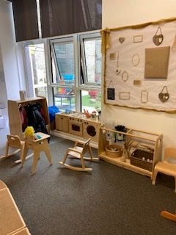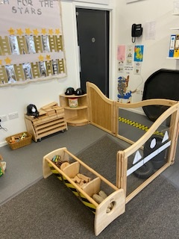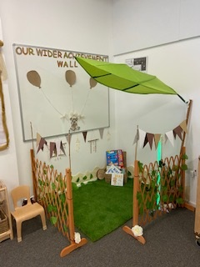

**Outdoor Area**

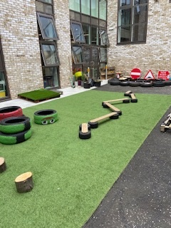 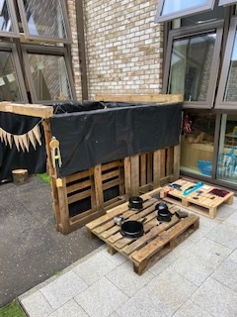

**Rainbow Room (3-5’s)**

To ensure the safety of all of our children and staff within the centre we have created 3 new zones within the Rainbow playroom. These are called the Star, Sun and Moon Zones. The Star Zone can accommodate up to 32 children and Sun/Moon Zones can accommodate up to 20 children. To minimise the number of contacts within the centre each child and staff member have been allocated a specific zone.

Each zone consists of the following areas – Literacy, Numeracy, Art and Science, Imaginative, Construction, Outdoors. The children will be provided with a range of learning experiences which supports their development as well as taking into account their interests.

Please see below for details of staff and groups in each zone as well as photographs of our new zones.

**Star Zone** **Sun Zone** **Moon Zone**

Louise C (Senior) Natalie (Senior) Louise C (Senior)

Krysty Gail Amy W

Rebecca Aimee Ashley

Lindsey Louise M Anne

Tracy M Tracey C Leonna

Lauren R

Alistair

**Additional Support – Angela, Danielle Nancy (AM), Lauren H (PM)**

**Star Zone**

**Outdoors**

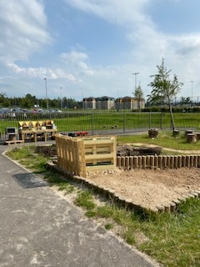 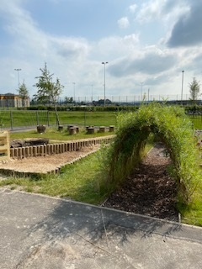 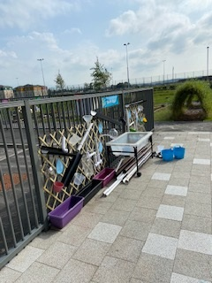

**Literacy/Imaginative**

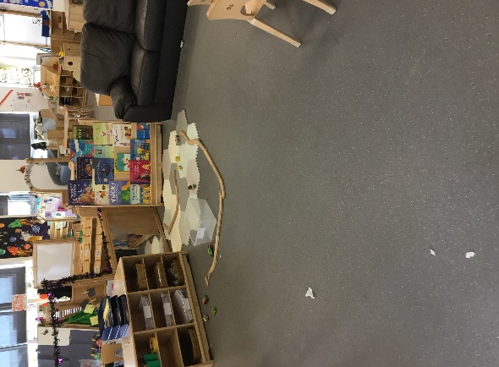 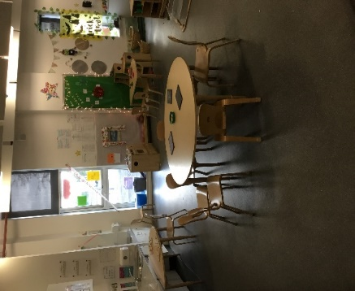 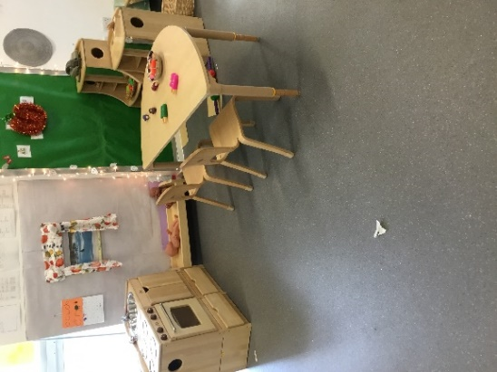

**Numeracy/STEM Art**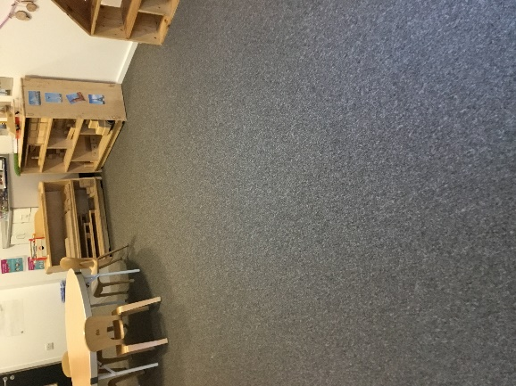 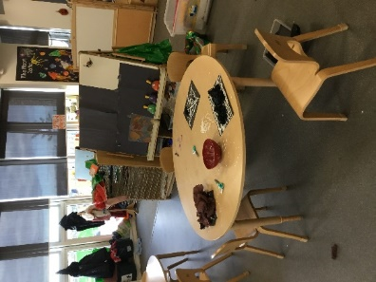

**Sun Zone**

**Outdoor**

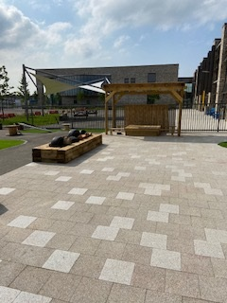 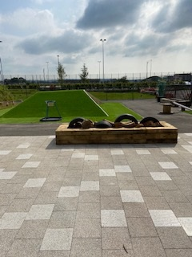

**Literacy/Imaginative**

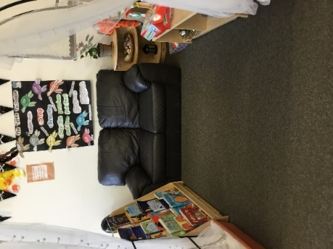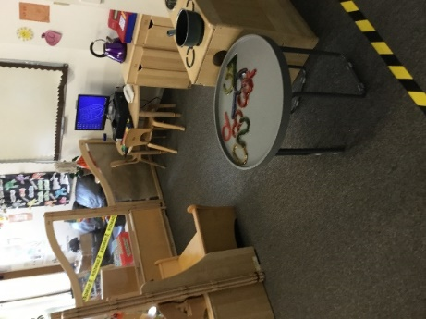

**Numeracy Art**

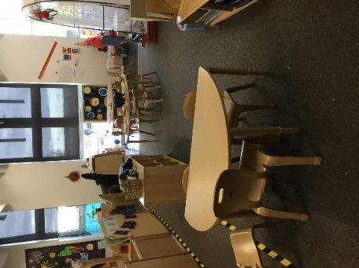 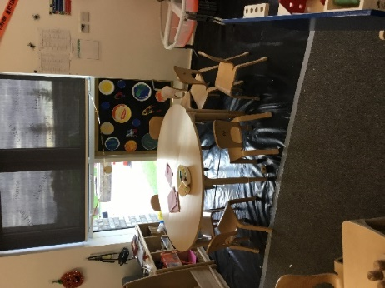

**Moon Zone**  

**Outdoors**

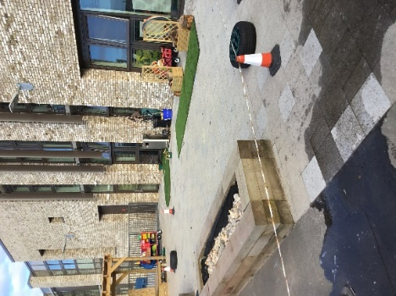 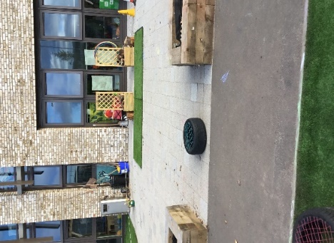

**Literacy/Imaginative**

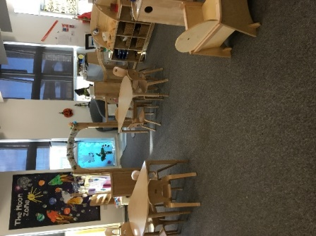 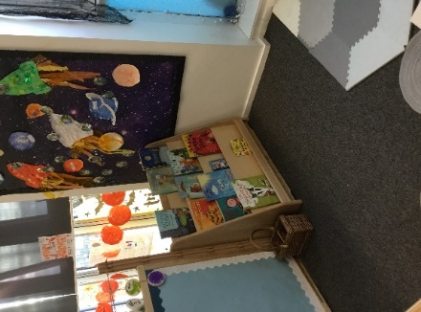

**Numeracy Art & STEM**

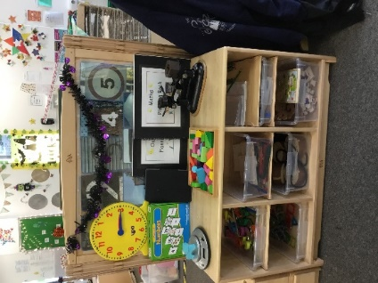 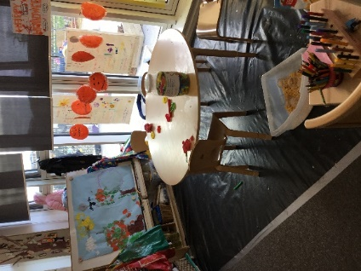 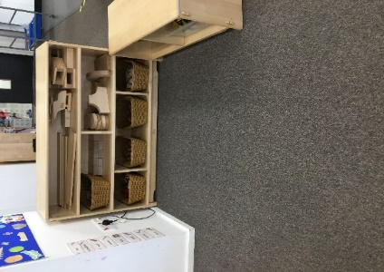

**Curriculum**

**Playroom Planning**

The implementation of Planning for Play (2-3’s), Realising the Ambition (2-3’s/3-5’s) and a Curriculum for Excellence (3-5’s) within the playrooms assist staff in providing a range of learning opportunities which supports their stage of development. Staff encourage the children to lead their own learning and plan learning experiences which reflects their interests. Learning within each playroom is documented in floor books. The children are encouraged and supported to contribute to the floor books through mark making and scribing.

**Tracking Learning**

Through observations key workers track the children’s development and put in place strategies to further support and enhance their learning. Each child has their own learning journal which consists of photographs, observations and pieces of work. Learning journals highlight the children’s individual learning targets and show progression. The children are provided the opportunity to express their views and opinions of their learning through the use of visual aids.

Within the Caterpillar Room key workers use the Teaching Talking document to track the children’s development. Key workers within the Rainbow Room use an electronic document to track the children’s Literacy, Numeracy and Health & Wellbeing development. Staff use the evidence gathered from tracking documents to plan next steps which reflect the children’s stage of development.



**Communication**

To support us in communicating effectively with others we use a range of digital platforms. This enables us to share important information as well as keep you updated on learning which is happening within the centre.

**Please see below for further details.**



**School App for Parents**

This allows us to send out messages and links to information important to our centre.

Download the app via the Apple / Android store then add **James Hamilton ECC.**



**Twitter**

This allows us to share our successes and achievements.

Follow us **@JamesHamiltECC**



**GLOW**

We also use our GLOW site which allows us to share newsletters, photos and achievements by posting links to GLOW on our Twitter and School app.

**GLOW link to information** - https://glowconnect.org.uk/about-glow/glow-for-parents/

**Achievements**

We are continually evaluating our practice and looking for ways to make improvements to the service which we provide. Please see below for details on our achievements for 2019/20.

**Numeracy**

* Numeracy trackers implemented to track development of 3-5 children.
* Numeracy targets created which reflected the individual needs of each children.
* Learning journals implemented which showed progression of learning across numeracy.
* Home link bags introduced which linked to the children’s numeracy targets where applicable.
* Importance of Play workshops provided which focused on numeracy within the home.
* Stay and Play sessions provided parents/carers to take part in learning experiences which developed the children’s numeracy skills i.e. play dough making.
* STEM Leadership Group have purchased resources and provided learning experiences to further develop the children’s numeracy skills. This will be ongoing during academic year 2020/21.
* Weekly challenges set via our app focused on numeracy. Parents/carers sent in photographs to the centre showing their child taking part in the activities.

**Literacy**

* Literacy trackers implemented to track development of 3-5 children.
* Literacy targets created which reflected the individual needs of each child.
* Learning journals implemented which showed progression of learning across literacy.
* Home link bags introduced which linked to the children’s literacy targets where applicable
* Monthly Book Bug sessions provided for parents/carers to attend with their child. These were led by Anne our Communication Champion and Lindsey.
* Big Bed Time read initiative launched. This allowed stories to be shared at home.
* Targeted support groups for communication were created. Our Communication Champion tracked the children’s development and provided learning opportunities to support their communication and language skills.
* Coffee and Chat sessions provided which provided the parents/carers with strategies to support their child’s communication skills.
* Digital Technology launched. During lockdown we were able to communicate effectively with our parents/carers using our App Central and Twitter accounts.

**Health & Wellbeing**

* Weekly outdoor learning days at Dean Park Country Estate were implemented for all 4 year old children. This allowed them to explore and develop an understanding of the world around them. It also enable the children to develop their independence skills as well as risk assess.
* Building the Ambition training was delivered which further developed staff knowledge and understanding of how to create a rich and stimulating outdoor learning environment.
* Outdoor Leadership Group developed the outdoor area and created various areas for the children to explore i.e. water station, mud kitchen. This will be ongoing for academic year 2020/21.
* 2 to 3 room staff worked in collaboration with the Gaelic ECC to further develop the outdoor area and create various areas for the children to freely explore. The area is now suitable for all children aged 2 to 5 years.
* Health & Wellbeing Leadership Group participated in PATHS training which they shared with the full staff team. This resulted in Timmy the Turtle calming technique being implemented within the Rainbow Room. They also purchased resources and created calming/cosy spaces within both playrooms.

James Hamilton Early Childhood Centre

Improvement Plan 2020/21

**Please see below for our 3 main improvement priorities and how we aim** **to** **achieve** **them.**

**Priority 2 – Staff to take a lead role in driving forward improvements within the centre by being proactive and implementing positive changes by participating in leadership groups**

* Each member of staff within the group to be given the opportunity to share views/opinions and be clear on their role and responsibilities within it.
* Monthly leadership group meetings to discuss progress and improvements required.
* Each leadership group to set a monthly SMART target.
* Leadership groups to be allocated time off the floor to access training relevant and gather resources required to implement SMART target.
* Each group to measure impact of SMART targets i.e. through observations, and Leuven’s Scale of Wellbeing and Involvement. Staff will gather evidence before and after target implementation.
* All staff to be trained in using the Leuven’s Scale of Wellbeing and Involvement
* Each group will record improvements and evidence progress via meeting minutes and leadership floor books.
* SLT member responsible for overseeing each group to monitor staff participation.

**Priority 1 – 70% of parents/carers across the centre will participate in joint activities**

* Consultation with parents/carers to establish activities they would like to share with their child.
* Virtual/socially distanced workshops on areas identified through consultation with parents/carers **(all sessions will adhere to guidelines set out by the Scottish Government and Public Health Scotland)**.
* Outdoor stay and play sessions **(all sessions will adhere to guidelines set out by the Scottish Government and Public Health Scotland)**.
* Virtual book bug sessions.
* Lynn Kerr (Equity & Excellence Lead) to undertake Parents Early Education Partnership (PEEP) training.
* Home link bags and personalised videos directly linked to individual targets to be implemented for all children within the centre.
* Implementation of GLOW to communicate with parents/carers and share learning. This will include fortnightly blogs and videos.
* Relaunch and fully embed the use of digital technology platforms – App Central/Twitter/YouTube to communicate with parents/carers and share learning.
* Lynn Kerr (Equity & Excellence Lead) to undertake Parents Early Education Partnership (PEEP) training.
* Home link bags and personalised videos directly linked to individual targets to be implemented for all children within the centre.
* Implementation of GLOW to communicate with parents/carers and share learning. This will include fortnightly blogs and videos.
* Relaunch and fully embed the use of digital technology platforms – App Central/Twitter/YouTube to communicate with parents/carers and share learning.
* Parents/carers to join their child at Dean Park County Estate during their outdoor learning days **(visits will adhere to guidelines set out by Scottish Government and Public Health Scotland)**

**To fully embed the following nurture principles within the centre:**

**The classroom offers a safe base**

**The importance of nurture for the development of wellbeing**

* Staff knowledge of the nurture principles to be developed through training.
* Staff to be trained in using the Early Childhood Environment Rating Scale (ECERS) and Infant/Todder Environment Rating Scale (ITERS) to assess the environment.
* Staff within each zone (3-5’s) and caterpillar room (2-3’s) to use ECERS/ITERS to gather a baseline for improvement on areas identified.
* Staff to reflect on evidence gathered from ECERS/ITERS to make improvements to their zone/playroom.
* Impact of changes to the environment to be measured using ECERS/ITERS.
* Children to be provided the opportunity to score their learning environment before and after improvements are made through the use of visual aids i.e. traffic light system/emoji’s.
* Children to be provided the opportunity to share their thoughts on what improvements could be made using mind maps.
* Realising the Ambition training to be provided to further develop staff knowledge on the interactions, experiences and spaces the children should be provided.
* Monthly playroom monitoring to be carried out by the Senior Leadership Team to ensure equity for all.
* Leuven Scale of Wellbeing and Involvement to be used to assess interactions/experiences provided by staff.

Promoting Alternative Thinking Strategies (PATHS) to be implemented to support children to express feelings and regulate their emotions.