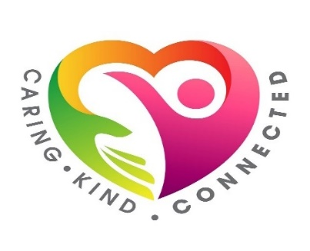
FINDING INNER CALM PROGRAMME

Our mental wellbeing affects how we feel about all areas of our lives and looking after it can really improve the way we feel every day. This can be helpful when we are not feeling our best but it’s also important to ensure we look after ourselves during the good times; it can improve our overall wellbeing and help us to be more able to cope when we do face difficult times.
Although we no longer have the Breathe Believe Achieve Programme, we are delighted to be able to offer a new 4 week programme – Finding Inner Calm – which will be delivered by our fully trained Wellbeing Co-ordinator.
This programme will help you to understand and manage anxiety and stress and help quieten your busy mind. You will be provided with the tools and skills required to help maintain a more balanced life.
The 4 week programme will commence Monday 23rd August 2021 at 3.30pm –5pm and will cover:
- Understanding and Managing Anxiety
- How we can quieten the Monkey Mind
- Improving Mindset
- Movement and Sleep
The programme will be delivered via MS Teams and if you would like to join, please book your place within the Wellbeing section of the Learning Academy
If you have any questions or need further information, please email HSCPhealth&wellbeing@east-ayrshire.gov.uk.
For further wellbeing support and advice, go to Healthy Working Lives.

