
Hurlford Primary School
The Excellent Lesson

Active Learning
- Pupils learn by carrying out a variety of stimulating activities
- Pupils find their learning challenging, engaging and motivating
- Pupils are encouraged to think creatively, investigate and solve problems
- Teachers ensure a balance of pupils working on their own, in groups and as a whole class, as appropriate.
- Pupils and teachers use a variety of resources, including digital
- technologies
- Pupils have opportunities for personalisation and choice
- Pupils often learn outdoors
- Learning is linked to real life and work
- Links across the curriculum are evident
- Learning is enhanced through engagement with partners

Assessment is for Learning
- Teachers discuss previous learning with pupils.
- Learning intentions and Success criteria are clear, meaningful and understood by all.
- Teachers and pupils ask challenging questions.
- Verbal and written feedback is given to praise, improve and identify next steps.
- Plenaries are used to discuss and evaluate learning.
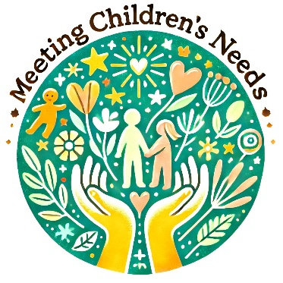 | Meeting Children’s Needs  - High expectations and aspirations for all.  - A nurturing ethos is evident, where pupils are comfortable asking for help and recognising ‘mistakes help us learn’.  - A Class charter is evident to ensure a shared understanding of expected behaviour and relationships.  - Pupils learn at an appropriate level and pace  - Teachers challenge and support all pupils.  - Adaptive teaching is evident and is matched to the pupil needs and learning styles.  - Pupils can reflect on and share their learning in different ways.  - Pupils feel safe, healthy, achieving, nurtured, active, respected, responsible and included.
Skills for Development
- Skills for Learning: Creating, Evaluating, Analysing, Applying, Understanding, Remembering
- Skills for Life: Literacy, Numeracy, Health & Wellbeing, Enterprise and STEM
- Skills for Work: Managing time, Planning and Organising, Communicating, Solving Problems, Undertaking tasks at short notice, Working with others, Thinking critically and creatively, Learning and continuing to learn, Taking responsibility for own development, Managing and being managed by others.

