HURLFORD PRIMARY & EARLY CHILDHOOD CENTRE



**VISIBLE**

**CONSISTENCY**

Warm Welcomes

Magic Movement

Instant Initiatives

Recognition Boards

Mutual Respect



**OVER AND ABOVE AWARDS**

Star Worker Badges

Star Writer Certificates

Hot Chocolate Friday

House Points

House Reward Party

**RESPECTFUL RELATIONSHIPS**

**Our Vision**

We work together to create a nurturing and inclusive environment, where everyone is encouraged to become the best we can be.

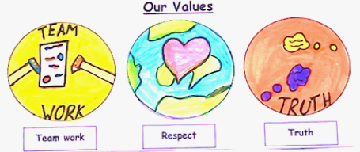

**Our Aims**

We aim to:

* Create a nurturing, safe and inclusive environment
* Provide a broad, challenging and stimulating curriculum, developing the four capacities – successful learner, responsible citizen, effective contributor and confident individual
* Provide high quality learning and teaching, developing

skills for learning, life and work

* Recognise and celebrate progress, achievement and success
* Promote partnership with Parents and the wider community



**STEPPED BOUNDARIES**

Non-verbal reminder

Verbal reminder

Yellow warning

Orange warning

Cool down time with SLT

Red slip issued

**Sanctions in place** 

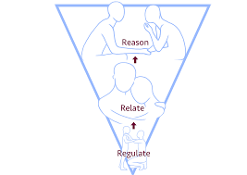

**REGULATE** – calm child – breathe!

**RELATE** – connect & empathise

**REASON** - conversation

* What happened?
* What were you thinking at the time?
* What have you thought about since?
* Who has been affected and how?
* How can we make sure this does not happen again?
* What can we do to put things right?

**REPAIR –** apologise and move on