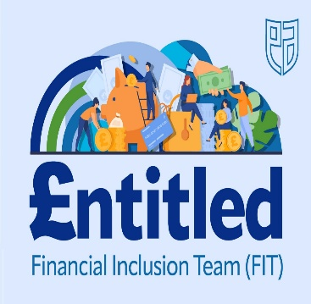
Child Benefit Change 6 April 2024- higher income earners
There are tax implications if you (or your partner’s) individual income is over a certain limit. In 2023/24, this limit was £50,000, from 6 April 2024, this increased to £60,000.
You can choose to opt out of payment. See link below on opting out of child benefit payments if your income is above the threshold. Also information on how to restart payments if your income is below the new threshold.
https://www.gov.uk/child-benefit-tax-charge
If you do not have a current claim for child benefit

- You can claim in the HMRC app or online. Child Benefit is backdated automatically for 3 months, or to the date of birth of the child if later.

New Child Benefit claims made on or after 6 April 2024 and before 8 July 2024 will result in payments being backdated but will only be subject to a tax charge in the 2024 to 2025 tax year, if your income exceeds the new threshold of £60,000.

E.g. if you make a new claim on 6 May 2024, your Child Benefit payment will be backdated to 6 February 2024. You will only pay the tax charge in the 2024 to 2025 tax year if income exceeds £60,000.You or your partner will need to file and pay any 2024 to 2025 charge via Self-Assessment by 31 January 2026.

Child Benefit: Make a claim - GOV.UK (www.gov.uk)

If you have received child benefit payments but your income was previously over the threshold of £50,000

- HMRC can provide advice on what action you require to take, to account for the tax charge. See below link

High Income Child Benefit Charge: Pay the tax charge - GOV.UK (www.gov.uk)

